Ex. No. 8 | Searching Information in Google Firestore Database
Date of Exercise | 01 November 2026
Github Code Link(Keep as public) | https://github.com/ASWIN2006SK/Flutter-lab/tree/main/Experiment_08
Aim
To develop a Flutter application that retrieves information from Google Cloud Firestore based on user search input and displays the relevant student information on the screen.
Description
Google Cloud Firestore is a cloud-hosted NoSQL database that stores data in collections and documents. In this experiment, a Flutter application named Student Search is developed to search for student information stored in the 'students' collection created in Experiment 7. The application provides a text field in which the user enters a student's name. When the Search button is pressed or the Enter key is submitted, the application performs a Firestore query using the where() method with isGreaterThanOrEqualTo and isLessThanOrEqualTo conditions. The query retrieves names beginning with the entered search text. The get() method fetches the matching documents from Firestore. The results are stored in a list and displayed using ListView.builder and ListTile widgets. If no matching document is found, the application displays an appropriate message. A clear button resets the search field and removes the displayed results. Firebase is initialized using Firebase.initializeApp() and the configuration generated by the FlutterFire CLI. The application was executed in Google Chrome and successfully retrieved the student record for the search term 'Santhosh'.
Program

import 'package:flutter/material.dart';
import 'package:firebase_core/firebase_core.dart';
import 'package:cloud_firestore/cloud_firestore.dart';
import 'firebase_options.dart';

void main() async {
WidgetsFlutterBinding.ensureInitialized();

await Firebase.initializeApp(
options: DefaultFirebaseOptions.currentPlatform,
);

runApp(const MyApp());
}

class MyApp extends StatelessWidget {
const MyApp({super.key});

@override
Widget build(BuildContext context) {
return MaterialApp(
debugShowCheckedModeBanner: false,
title: 'Student Search',
theme: ThemeData(
primarySwatch: Colors.indigo,
useMaterial3: true,
),
home: const SearchPage(),
);
}
}

class SearchPage extends StatefulWidget {
const SearchPage({super.key});

@override
State<SearchPage> createState() => _SearchPageState();
}

class _SearchPageState extends State<SearchPage> {
final TextEditingController searchController =
TextEditingController();

List<QueryDocumentSnapshot> results = [];
bool isLoading = false;
bool hasSearched = false;

Future<void> searchStudents(String value) async {
if (value.trim().isEmpty) {
setState(() {
results = [];
hasSearched = false;
});
return;
}

setState(() {
isLoading = true;
hasSearched = true;
});

try {
final query = await FirebaseFirestore.instance
.collection('students')
.where('name',
isGreaterThanOrEqualTo: value.trim())
.where('name',
isLessThanOrEqualTo: '${value.trim()}\uf8ff')
.get();

setState(() {
results = query.docs;
isLoading = false;
});
} catch (e) {
setState(() {
isLoading = false;
});

if (!mounted) return;

ScaffoldMessenger.of(context).showSnackBar(
SnackBar(content: Text('Search failed: $e')),
);
}
}

@override
void dispose() {
searchController.dispose();
super.dispose();
}

@override
Widget build(BuildContext context) {
return Scaffold(
appBar: AppBar(
title: const Text('Student Search'),
backgroundColor: Colors.indigo,
foregroundColor: Colors.white,
),
body: Padding(
padding: const EdgeInsets.all(20),
child: Column(
children: [
TextField(
controller: searchController,
decoration: InputDecoration(
labelText: 'Search student by name',
hintText: 'Enter student name',
prefixIcon: const Icon(Icons.search),
suffixIcon: IconButton(
icon: const Icon(Icons.clear),
onPressed: () {
searchController.clear();
searchStudents('');
},
),
border: const OutlineInputBorder(),
),
onSubmitted: searchStudents,
),

const SizedBox(height: 12),

ElevatedButton.icon(
onPressed: () =>
searchStudents(searchController.text),
icon: const Icon(Icons.search),
label: const Text('Search'),
),

const SizedBox(height: 20),

const Text(
'Search Results',
style: TextStyle(
fontSize: 20,
fontWeight: FontWeight.bold,
),
),

const SizedBox(height: 10),

Expanded(
child: isLoading
? const Center(
child: CircularProgressIndicator(),
)
: !hasSearched
? const Center(
child: Text(
'Enter a student name to search',
),
)
: results.isEmpty
? const Center(
child: Text(
'No matching students found',
),
)
: ListView.builder(
itemCount: results.length,
itemBuilder: (context, index) {
final data = results[index].data()
as Map<String, dynamic>;

return Card(
child: ListTile(
leading: const CircleAvatar(
child: Icon(Icons.person),
),
title: Text(data['name']),
subtitle: Text(
'Register No: ${data['registerNumber']}\n'
'Department: ${data['department']}\n'
'Email: ${data['email']}',
),
isThreeLine: true,
),
);
},
),
),
],
),
),
);
}
}
Output Screenshots
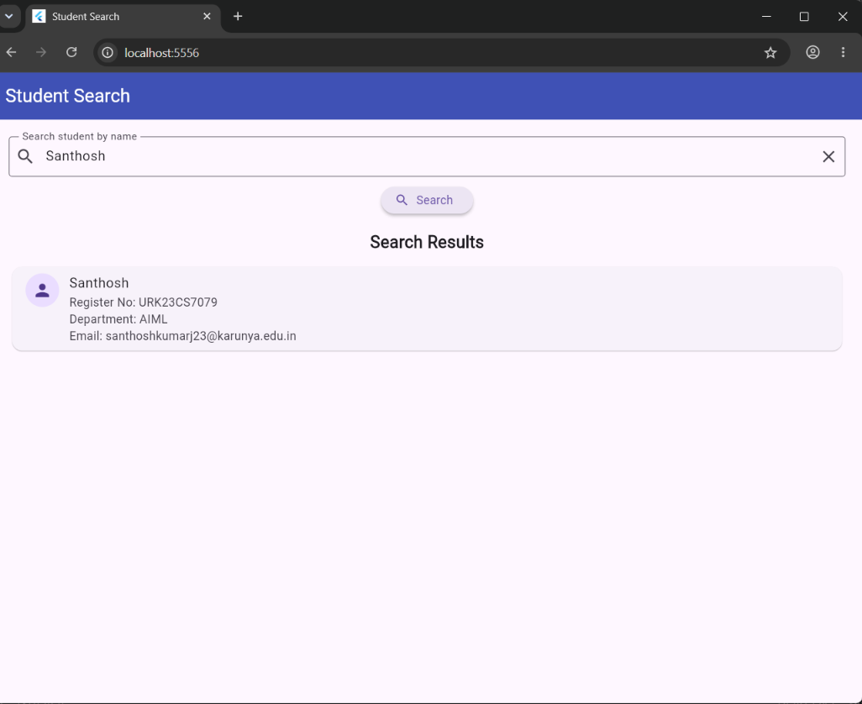
Figure 1: Student Search application displaying the student record retrieved from Google Cloud Firestore for the search term 'Santhosh'.
// Output of the program
Result
Thus, the Flutter application for searching information in Google Cloud Firestore was successfully developed and executed. The application accepted a search term, queried the 'students' collection, retrieved the matching student document and displayed the student's name, register number, department and email address on the screen.

