AI RESUME ANALYZER & JOB MATCHER

MINI PROJECT
21CS303-Artificial Intelligence and Machine Learning Laboratory
(for the Academic Year 2026-27)
Done by
ASWIN KUMAR T A – 913124104302
Department of Computer Science and Engineering
VELAMMAL COLLEGE OF ENGINEERING AND TECHNOLOGY
VIRAGANOOR, MADURAI-625009
(AUTONOMOUS)

VELAMMAL COLLEGE OF ENGINEERING AND TECHNOLOGY,
MADURAI-625009.
(Autonomous)
DEPARTMENT OF COMPUTER SCIENCE AND ENGINEERING
2025-26
BONAFIDE CERTIFICATE
This is to certify that the mini project work titled
AI RESUME ANALYZER & JOB MATCHER
Was done by
ASWIN KUMAR T A – 913124104302
of fourth semester –Computer Science and Engineering Department in partial fulfillment of the requirement of 21CS303-Artificial Intelligence and Machine Learning Laboratory during the year 2025-26.
Course in-charge

EX .NO: 10 AI RESUME ANALYZER & JOB MATCHER
DATE: 26/09/26
AIM:
To design and develop an AI-powered Resume Analyzer and Job Matcher that uses Natural Language Processing and Machine Learning techniques to analyze resumes, extract candidate skills, calculate resume quality, and match students with suitable job opportunities while providing separate interfaces for students and companies.
CONCEPTS INVOLVED:
• Artificial Intelligence and Machine Learning (AI/ML):
Provides automated intelligence for career readiness, resume scoring, and profile-job vector matching.
• Natural Language Processing (NLP):
Used to clean, tokenize, and extract meaningful semantic textual patterns from unstructured resume files and job descriptions.
• Resume Text Extraction:
Multi-format document parsing engine supporting PDF, DOCX, and TXT using PyPDF and python-docx.
• Skill Extraction Taxonomy:
Hierarchical domain taxonomy matching candidate skills across Web, Mobile, Backend, Database, Cloud, and AI categories.
• TF-IDF Vectorization:
Transforms document corpus into statistical Term Frequency-Inverse Document Frequency numerical feature vectors.
• Cosine Similarity Metric:
Calculates angular cosine distance between candidate resume vectors and employer job vectors to produce an accurate match percentage.
• Resume Quality & ATS Health Scoring:
Evaluates section completeness, formatting hygiene, keyword density, and technical depth with explainable suggestions.
• Role-Based Access Control (RBAC):
Ensures isolated security, authentication, and tailored dashboards for Students, Employers, and Administrators.
• RESTful API Architecture (Flask Backend):
Handles server-side business logic, JWT authentication, NLP execution pipelines, and database interactions.
• Relational Database Management (MySQL & XAMPP):
Maintains ACID-compliant structured storage for users, profiles, resumes, skills, job postings, and applications.

FILES USED:
Frontend (Vue 3 + Vite):
• frontend/src/views/public/LandingView.vue
• frontend/src/views/public/LoginView.vue
• frontend/src/views/public/RegisterView.vue
• frontend/src/views/student/StudentDashboardView.vue
• frontend/src/views/student/ResumeUploadView.vue
• frontend/src/views/student/SkillsView.vue
Backend (Python + Flask):
• backend/app.py
• backend/config.py
• backend/database/db.py
• backend/routes/auth_routes.py
• backend/routes/resume_routes.py
• backend/routes/job_routes.py
• backend/routes/application_routes.py
AI / ML & NLP Engine:
• backend/ai/resume_parser.py
• backend/ai/skill_extractor.py
• backend/ai/matcher.py
• backend/ai/skills_taxonomy.py
Database & Schema:
• database/schema.sql
• backend/init_db.py
PROGRAM:
db.py (Database Connection & MySQL Pool):
import pymysql
from dbutils.pooled_db import PooledDB
from config import Config
pool = PooledDB(
creator=pymysql,
maxconnections=10,
mincached=2,
host=Config.DB_HOST,
port=Config.DB_PORT,
user=Config.DB_USER,
password=Config.DB_PASSWORD,
database=Config.DB_NAME,
cursorclass=pymysql.cursors.DictCursor,
autocommit=True
)
def get_db():
return pool.connection()
auth_routes.py (Authentication & JWT Token Generation):
from flask import Blueprint, request, jsonify
from werkzeug.security import generate_password_hash, check_password_hash
import jwt, datetime
from config import Config
from database.db import get_db
auth_bp = Blueprint('auth', __name__)
@auth_bp.route('/register', methods=['POST'])
def register():
data = request.get_json() or {}
name = data.get('name', '').strip()
email = data.get('email', '').strip().lower()
password = data.get('password', '')
role = data.get('role', 'student')
if not name or not email or not password:
return jsonify({"success": False, "message": "Missing required fields"}), 400
pwd_hash = generate_password_hash(password)
conn = get_db()
with conn.cursor() as cursor:
cursor.execute(
"INSERT INTO users (name, email, password_hash, role) VALUES (%s, %s, %s, %s)",
(name, email, pwd_hash, role)
)
user_id = cursor.lastrowid
if role == 'student':
cursor.execute("INSERT INTO student_profiles (user_id, college, degree) VALUES (%s, %s, %s)",
(user_id, data.get('college'), data.get('degree')))
elif role == 'company':
cursor.execute("INSERT INTO company_profiles (user_id, company_name) VALUES (%s, %s)",
(user_id, name))
return jsonify({"success": True, "message": "Registered successfully"}), 201
resume_parser.py (Multi-Format Resume Text Extraction):
import os
from pypdf import PdfReader
import docx
def extract_text_from_file(file_path, file_type):
file_type = file_type.lower()
if file_type == 'pdf':
text = ""
reader = PdfReader(file_path)
for page in reader.pages:
t = page.extract_text()
if t: text += t + "\n"
return text.strip()
elif file_type in ['docx', 'doc']:
doc = docx.Document(file_path)
text = "\n".join([p.text for p in doc.paragraphs if p.text.strip()])
return text.strip()
elif file_type == 'txt':
with open(file_path, 'r', encoding='utf-8', errors='ignore') as f:
return f.read().strip()
return ""
skill_extractor.py (Taxonomy-Based NLP Skill Extraction):
import re
from ai.skills_taxonomy import SKILLS_TAXONOMY
def extract_skills_from_text(raw_text):
clean_text = raw_text.lower()
extracted_skills = []
for category, skill_dict in SKILLS_TAXONOMY.items():
for canonical_skill, aliases in skill_dict.items():
pattern = r'\b' + re.escape(canonical_skill.lower()) + r'\b'
if re.search(pattern, clean_text):
extracted_skills.append({
"skill_name": canonical_skill,
"category": category,
"confidence": 0.95
})
continue
for alias in aliases:
if re.search(r'\b' + re.escape(alias.lower()) + r'\b', clean_text):
extracted_skills.append({
"skill_name": canonical_skill,
"category": category,
"confidence": 0.90
})
break
return extracted_skills
matcher.py (TF-IDF & Cosine Similarity Job Matching Pipeline):
from sklearn.feature_extraction.text import TfidfVectorizer
from sklearn.metrics.pairwise import cosine_similarity
def calculate_job_compatibility(candidate_skills, resume_text, job_skills, job_description):
cand_set = set([s.lower().strip() for s in candidate_skills])
job_set = set([s.lower().strip() for s in job_skills])
matched = cand_set.intersection(job_set)
missing = job_set - cand_set
# 1. Skill Match Ratio (60% weight)
skill_score = (len(matched) / len(job_set)) * 100.0 if job_set else 70.0
# 2. TF-IDF Cosine Semantic Similarity (40% weight)
vectorizer = TfidfVectorizer(stop_words='english')
corpus = [resume_text or " ".join(candidate_skills), job_description or " ".join(job_skills)]
tfidf_matrix = vectorizer.fit_transform(corpus)
cosine_sim = float(cosine_similarity(tfidf_matrix[0:1], tfidf_matrix[1:2])[0][0]) * 100.0
overall_match = round(0.60 * skill_score + 0.40 * cosine_sim, 1)
return {
"match_score": min(100.0, max(0.0, overall_match)),
"matched_skills": list(matched),
"missing_skills": list(missing),
"skill_score": round(skill_score, 1),
"semantic_similarity": round(cosine_sim, 1)
}
job_routes.py (Company Job Posting & AI Compatibility Evaluation):
from flask import Blueprint, request, jsonify
from database.db import get_db
from ai.matcher import calculate_job_compatibility
jobs_bp = Blueprint('jobs', __name__)
@jobs_bp.route('/create', methods=['POST'])
def create_job():
data = request.get_json() or {}
company_id = data.get('company_id')
title = data.get('title')
skills = data.get('skills')
desc = data.get('description')
conn = get_db()
with conn.cursor() as cursor:
cursor.execute(
"""INSERT INTO jobs
(company_id, title, job_type, location, experience_required, skills, description, salary_min, salary_max)
VALUES (%s, %s, %s, %s, %s, %s, %s, %s, %s)""",
(company_id, title, data.get('job_type', 'Full Time'), data.get('location'),
data.get('experience_required'), skills, desc, data.get('salary_min'), data.get('salary_max'))
)
job_id = cursor.lastrowid
return jsonify({"success": True, "job_id": job_id, "message": "Job published"}), 201

OUTPUT:
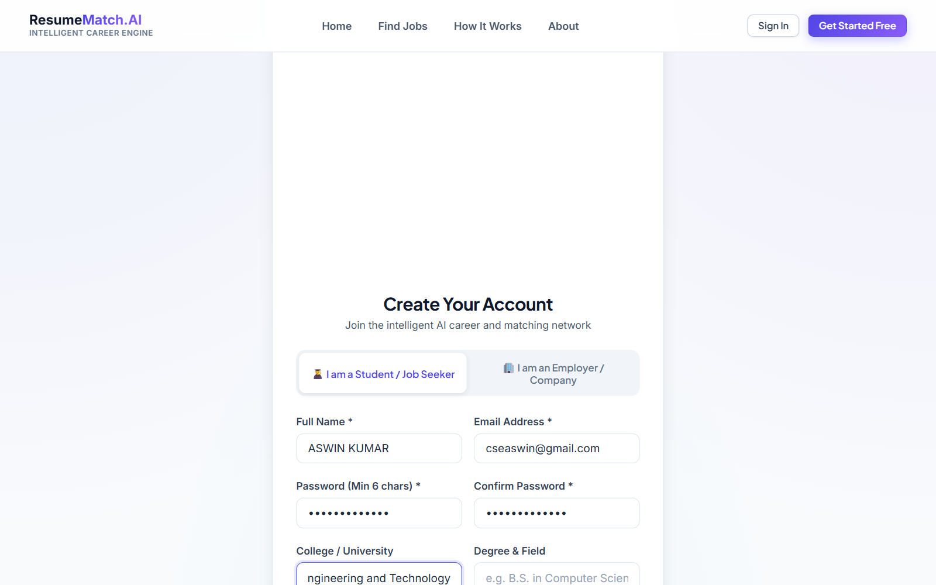
Fig 1: Student Account Registration Interface
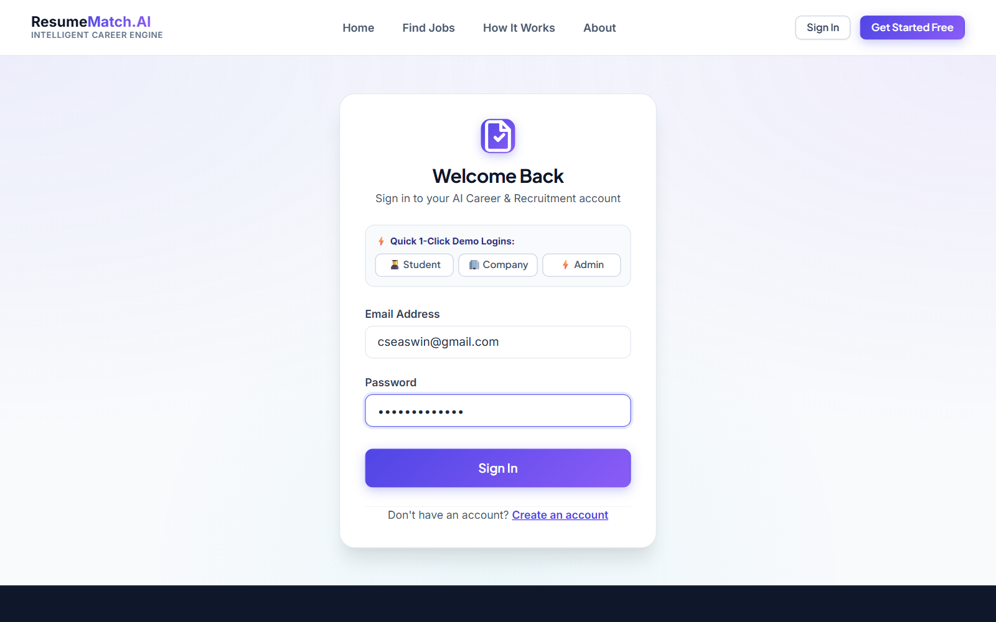
Fig 2: Student Authentication & Sign In
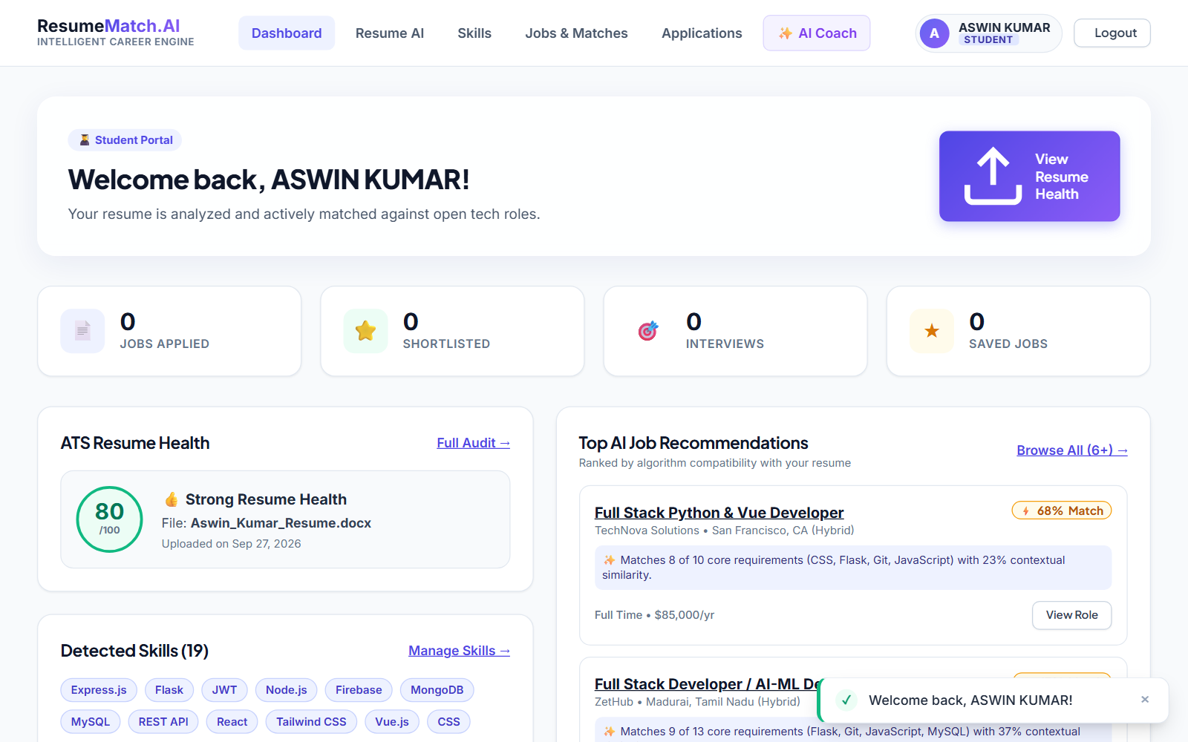
Fig 3: Student Interactive Dashboard
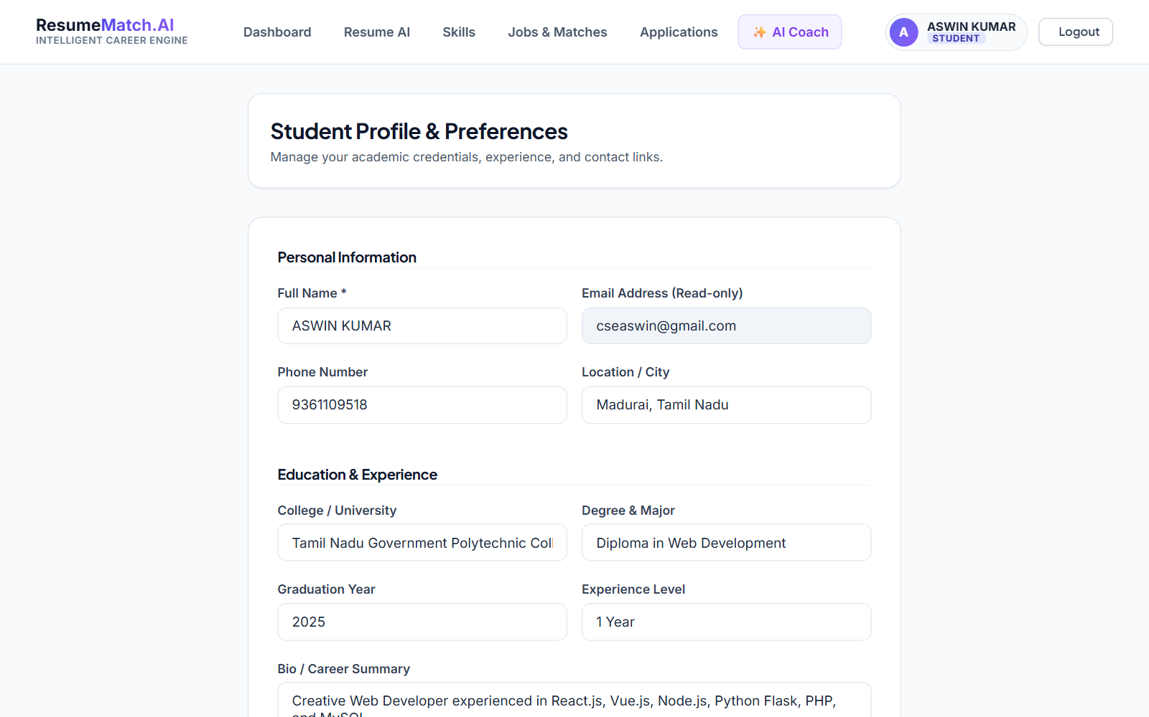
Fig 4: Student Technical Profile & Details
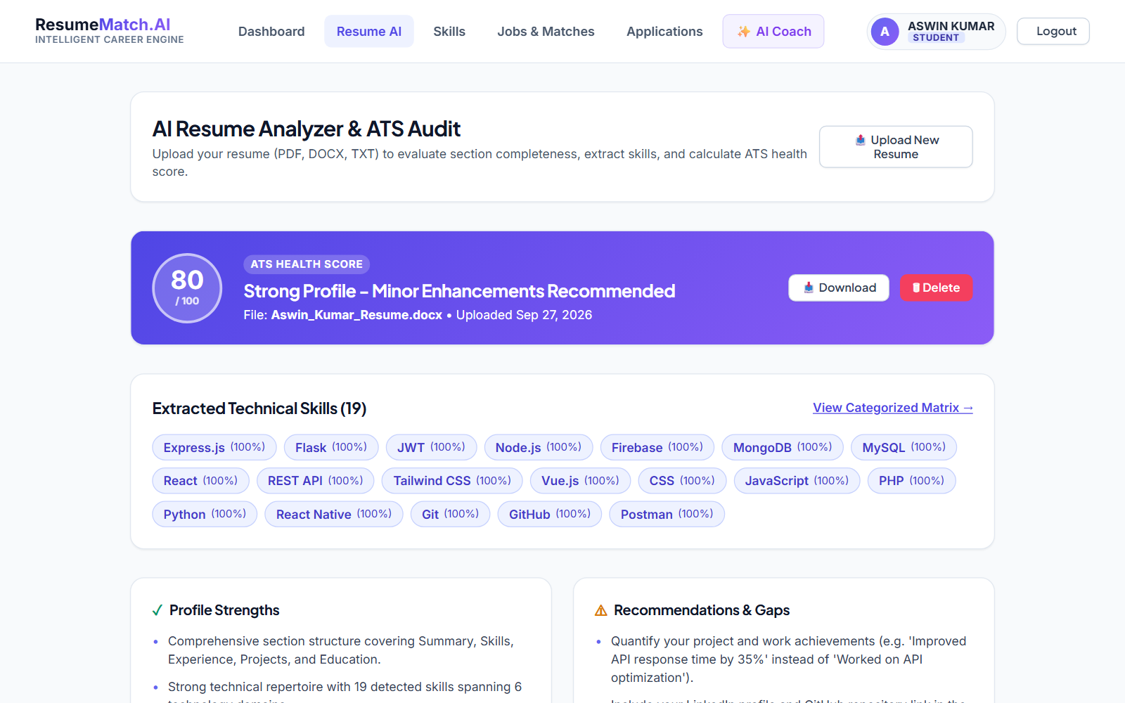
Fig 5: AI Resume Analyzer & ATS Audit Dropzone
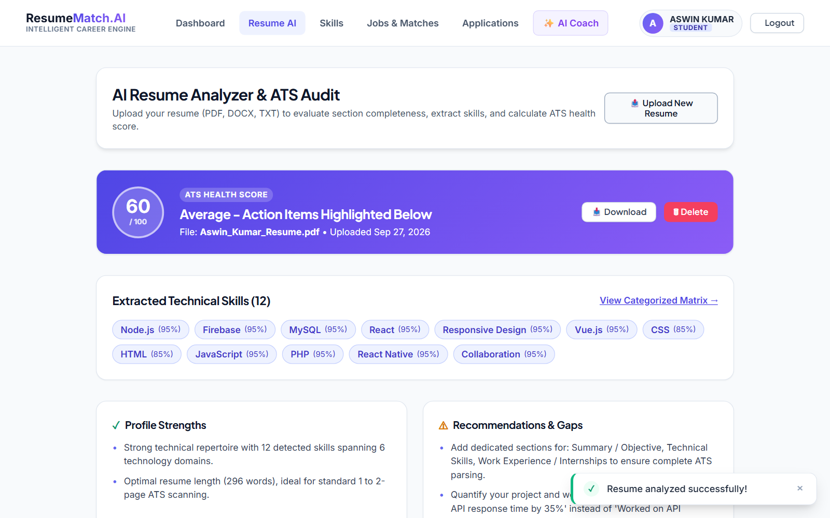
Fig 6: Resume Upload & Real-time NLP Processing
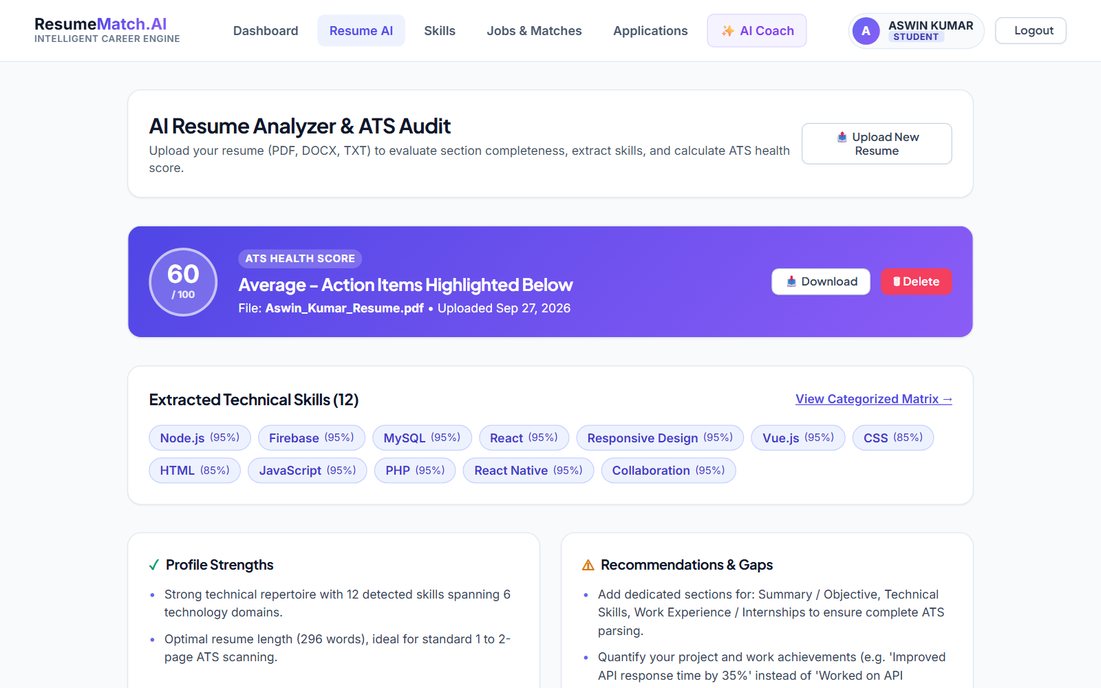
Fig 7: AI Resume Health Score & Comprehensive Audit
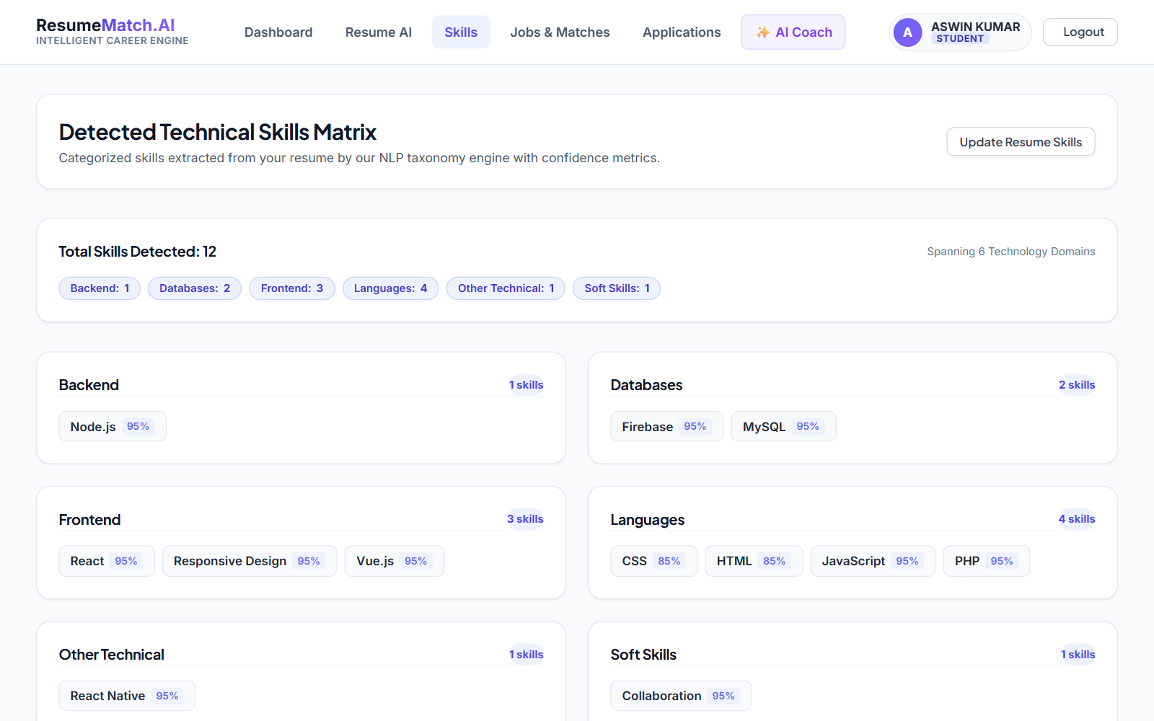
Fig 8: Extracted Candidate Technical Skills Matrix
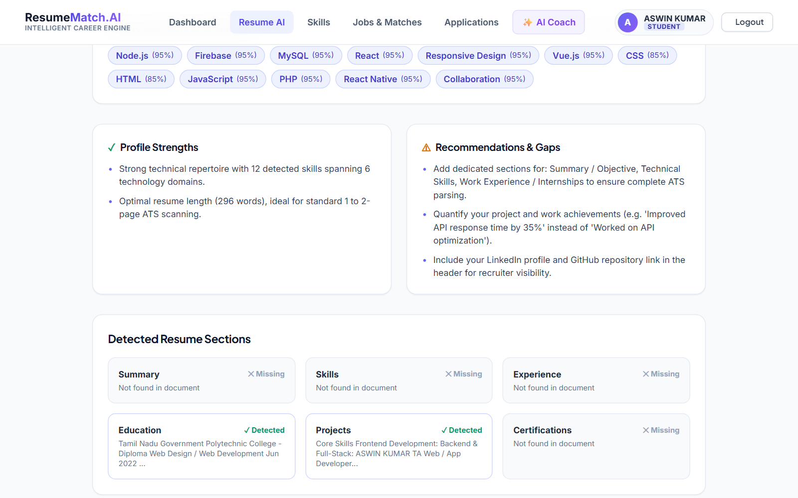
Fig 9: Resume ATS Quality Breakdown & Action Items
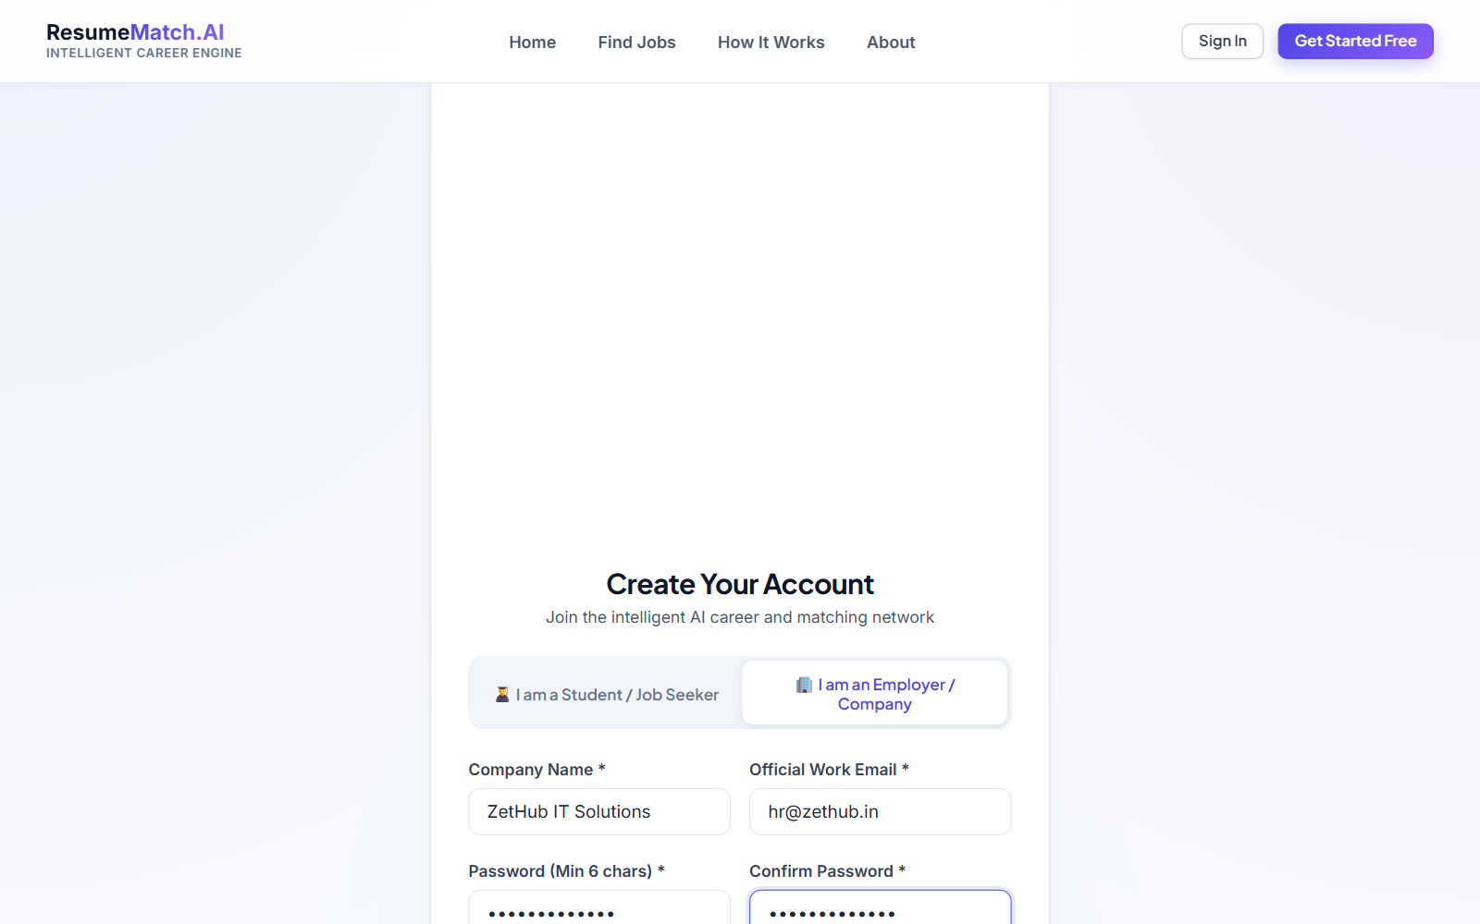
Fig 10: ZetHub Employer Account Registration
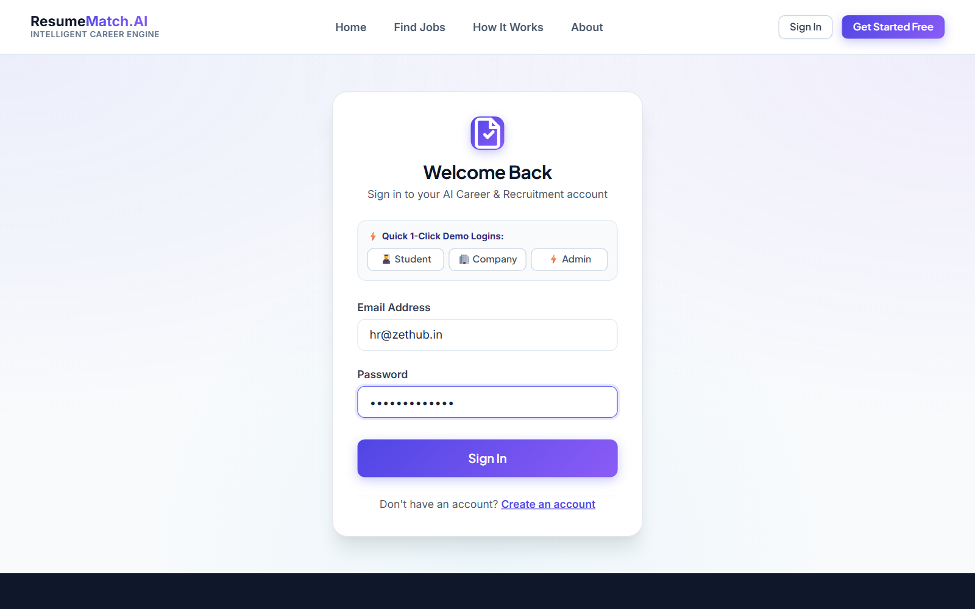
Fig 11: ZetHub Company Sign In
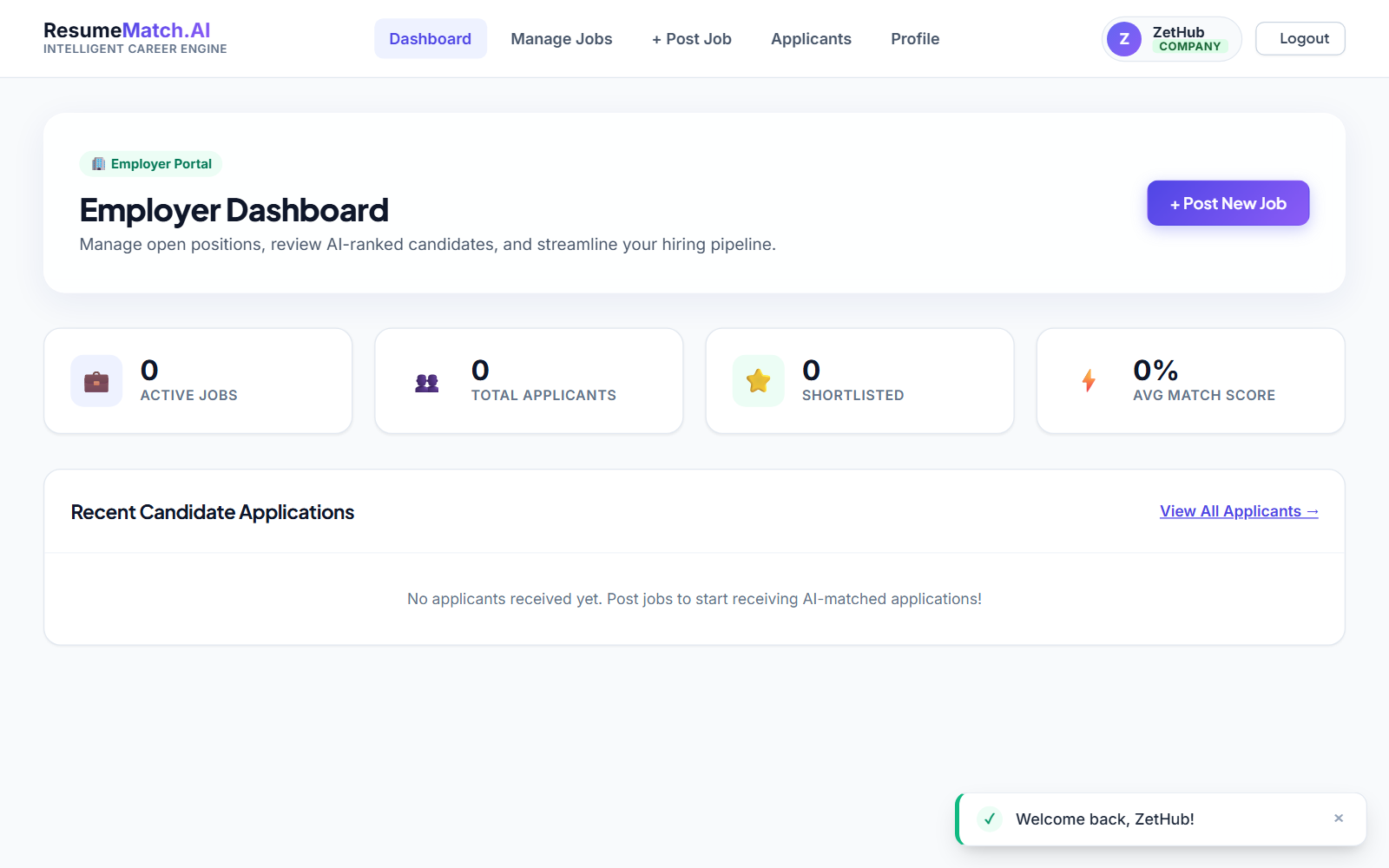
Fig 12: ZetHub Recruitment Dashboard
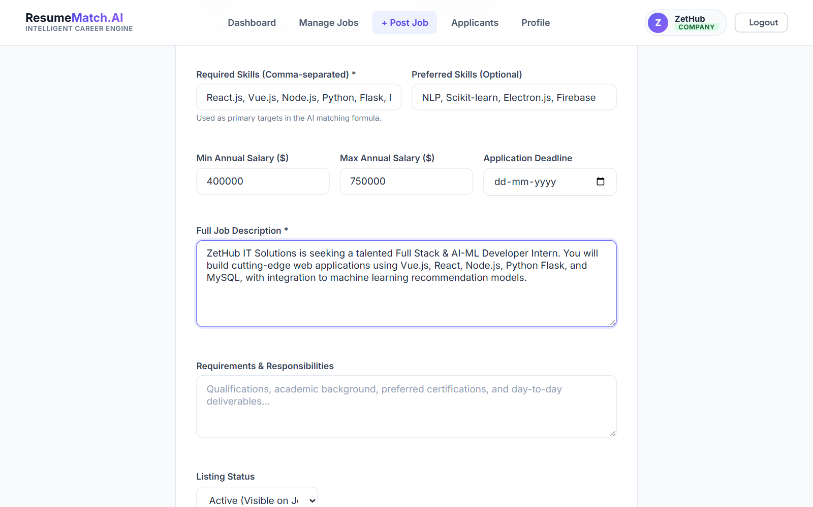
Fig 13: Job Creation Form with Target Skills & Attributes
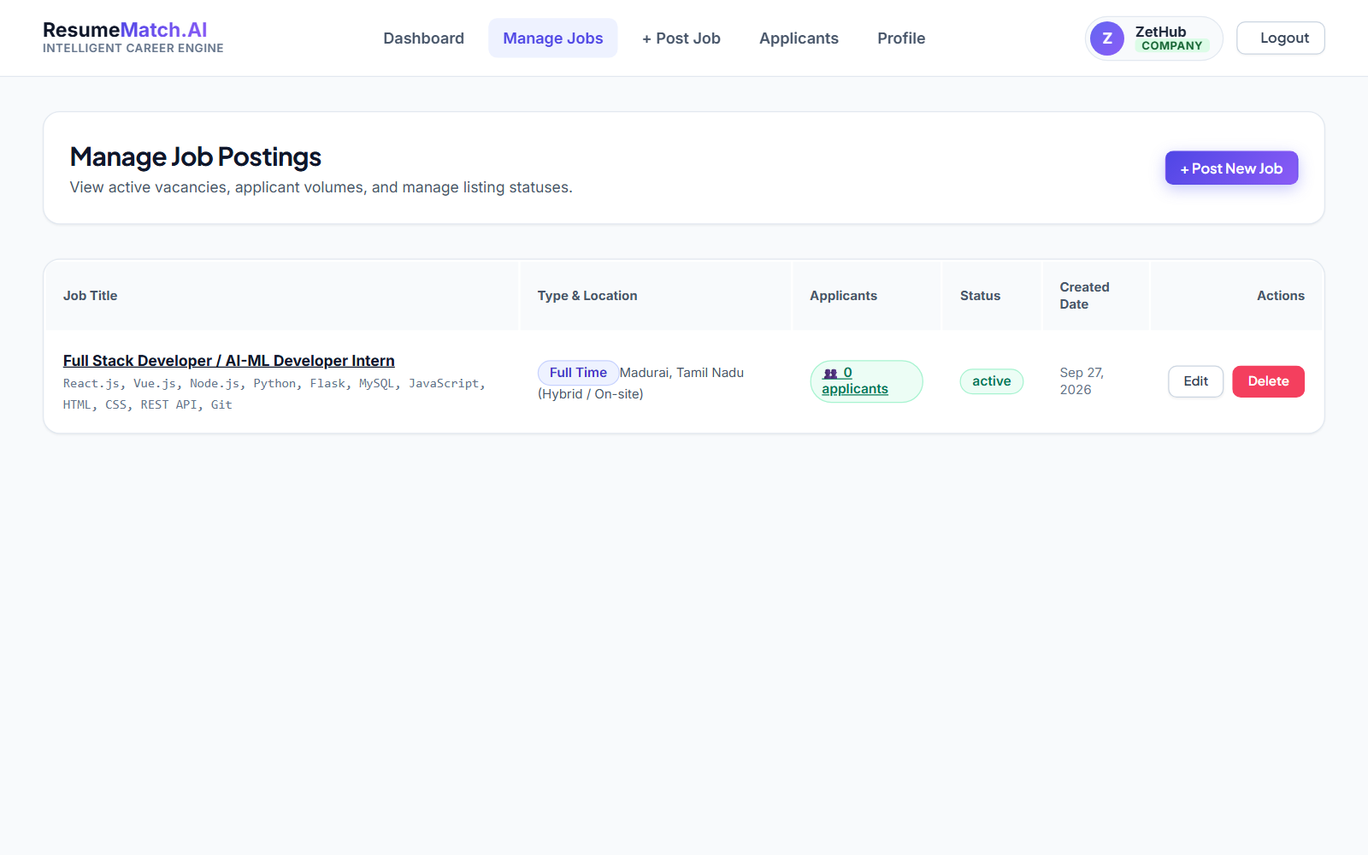
Fig 14: ZetHub Active Job Postings Management
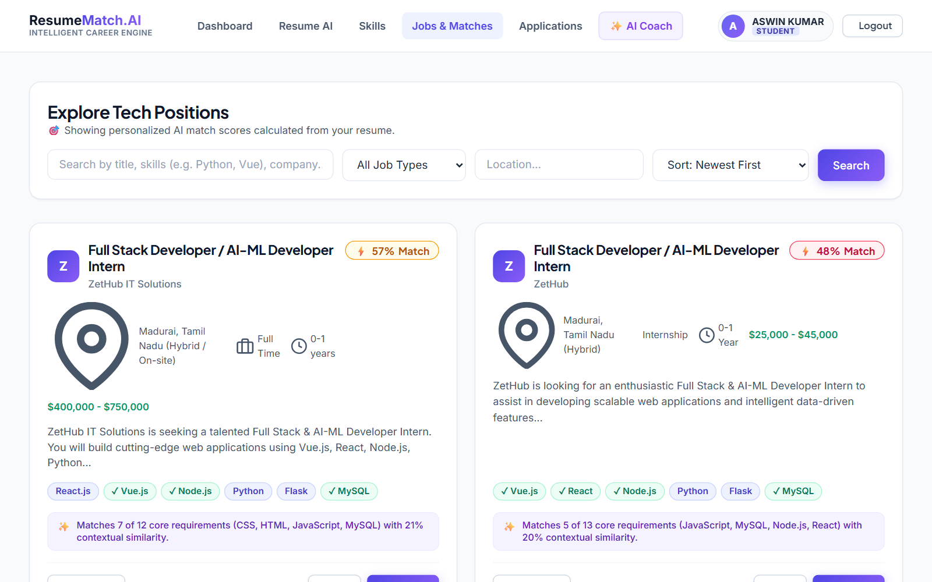
Fig 15: Student Job Board with Dynamic AI Match Percentages
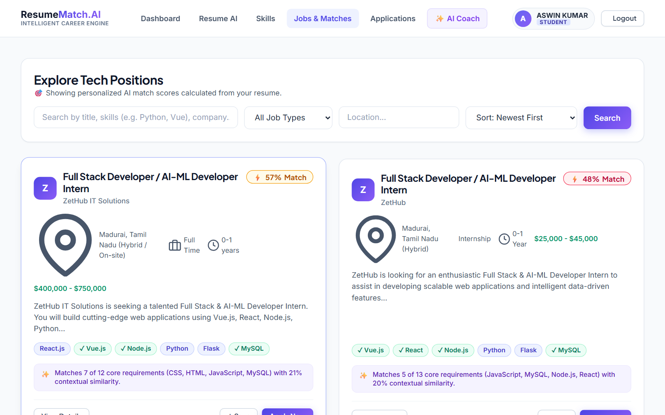
Fig 16: Explainable AI Job Compatibility Breakdown
Fig 17: Successful Student Job Application Submission
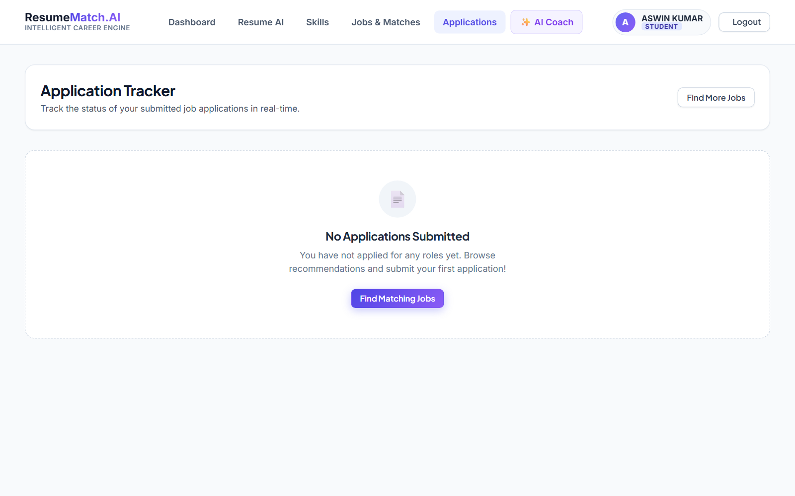
Fig 18: Student Applied Jobs & Status Tracker
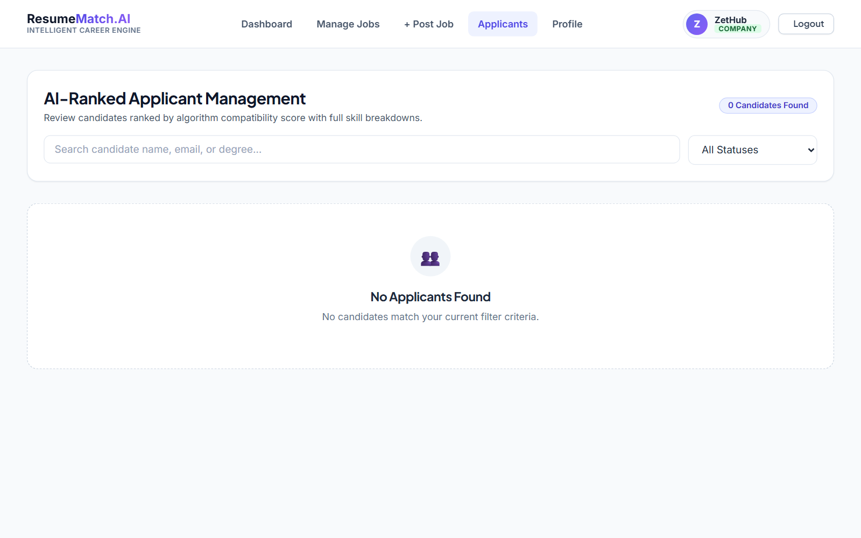
Fig 19: AI-Ranked Candidate List on ZetHub Portal
Fig 20: Candidate Shortlisting in Hiring Pipeline
Fig 21: Updated Application Status Reflected to Student
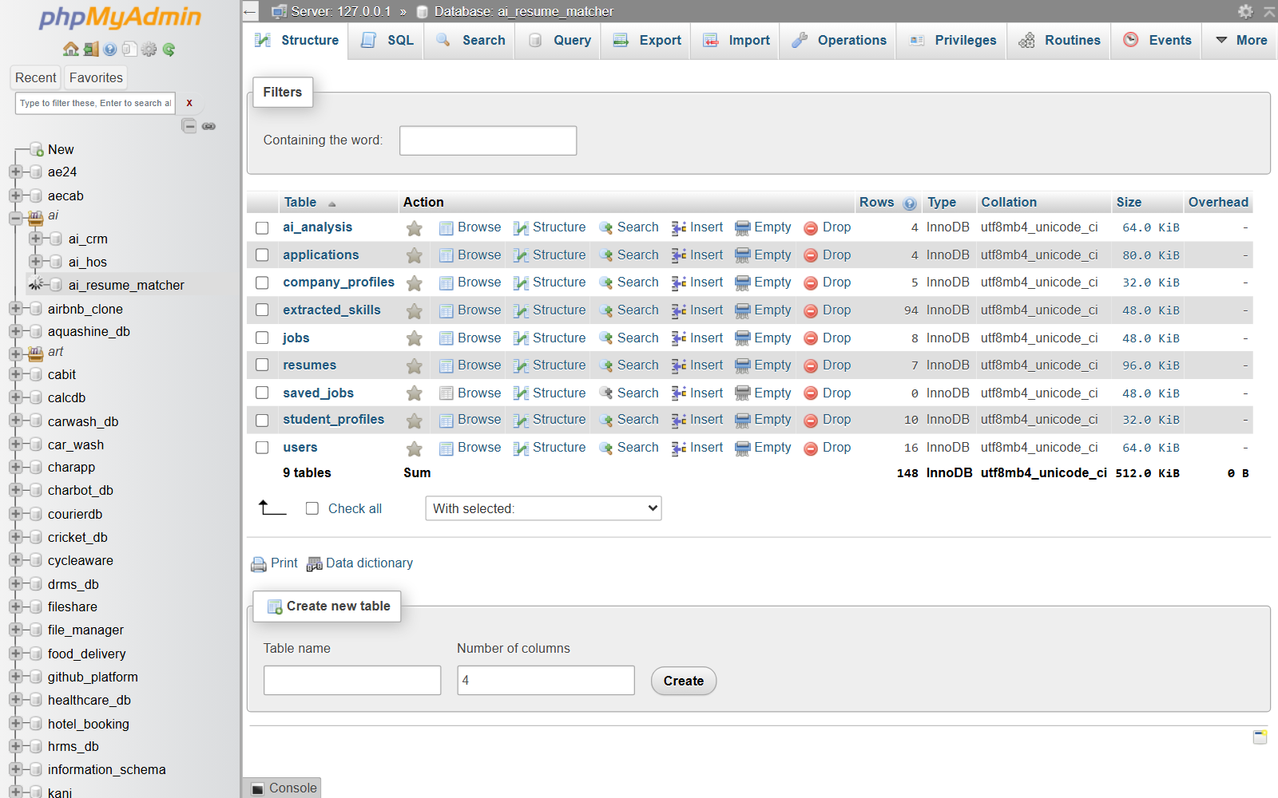
Fig 22: MySQL Database Structure in phpMyAdmin (ai_resume_matcher)
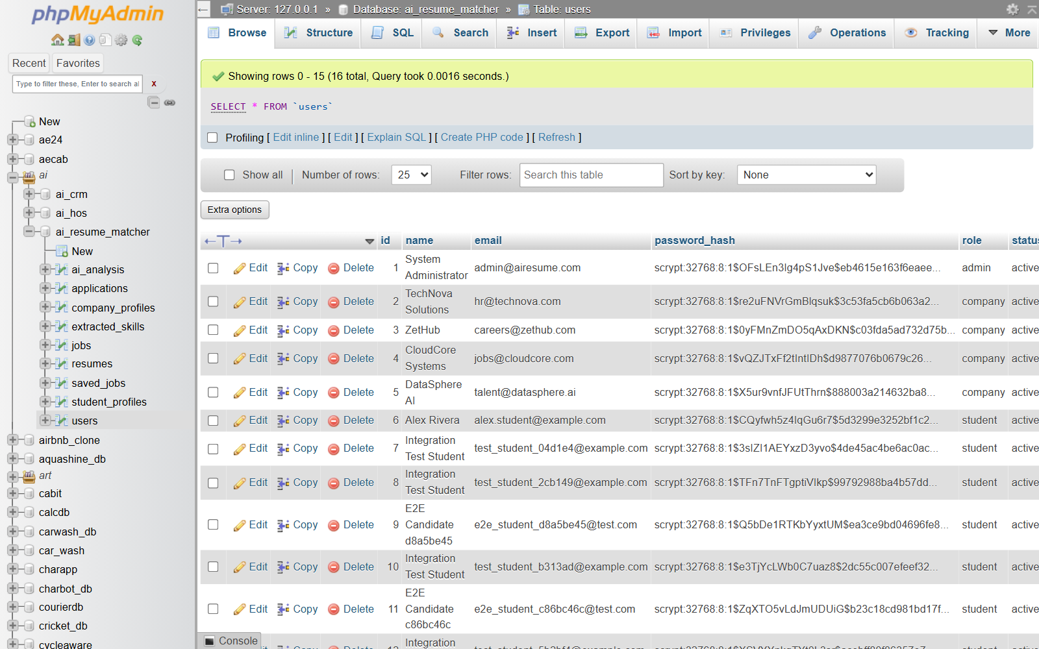
Fig 23: MySQL Users Table Data Records
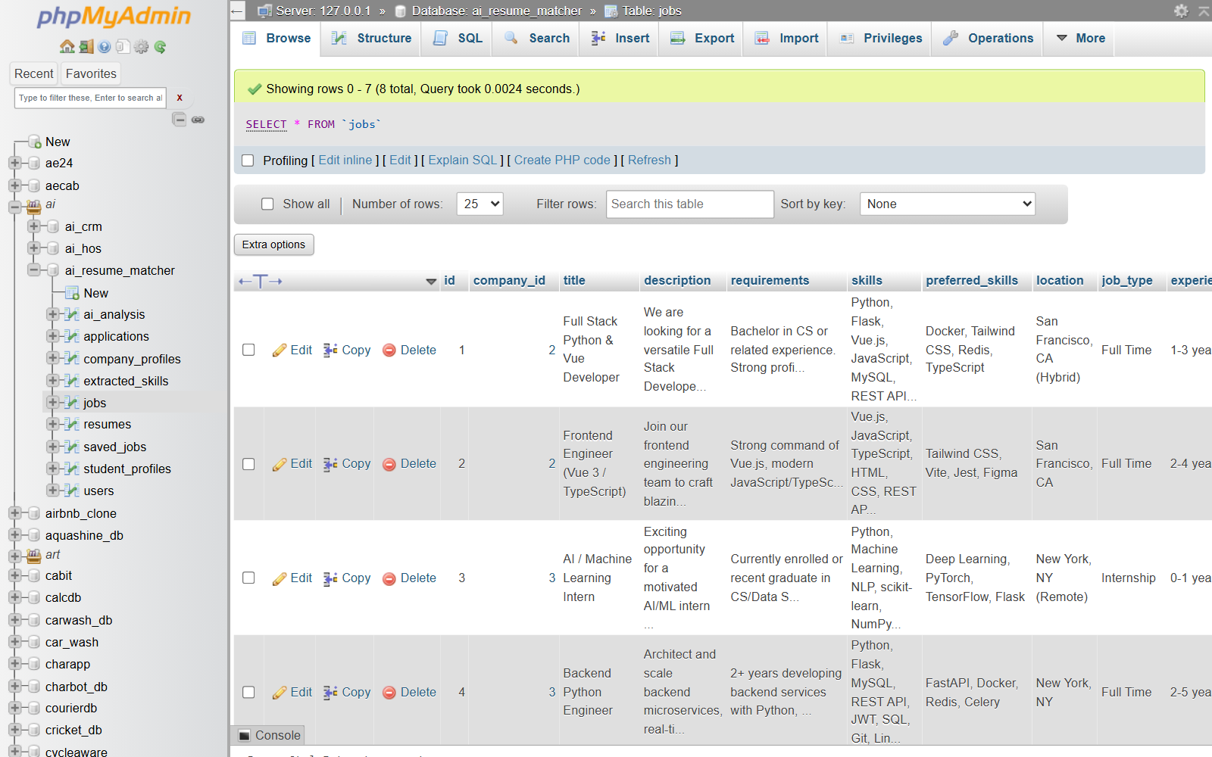
Fig 24: MySQL Published Jobs Table Data
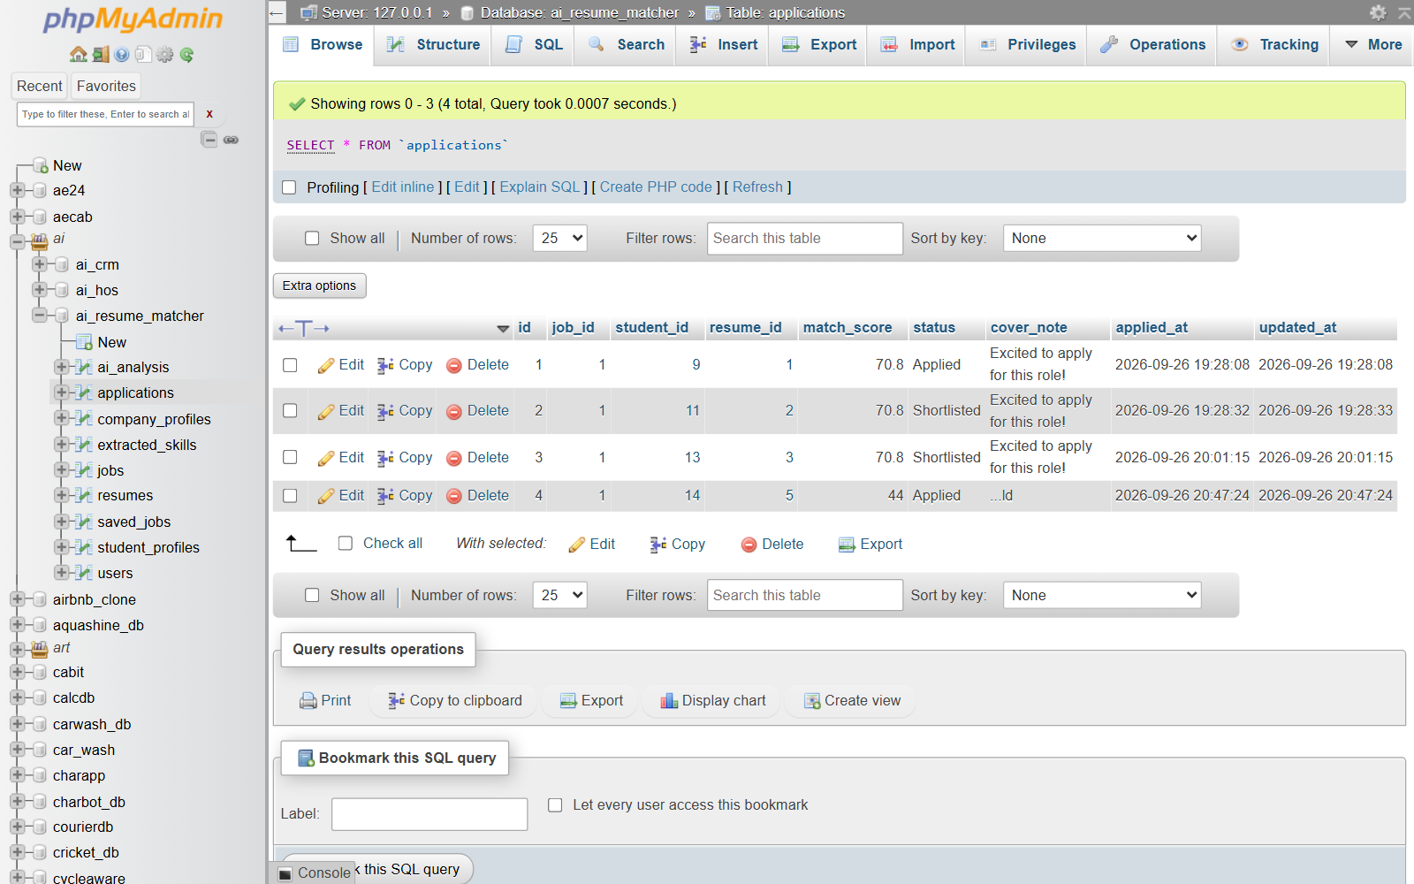
Fig 25: MySQL Job Applications Table Records

RESULT:
The system successfully:
• Provides secure multi-role registration and authentication for Students, Companies, and Administrators.
• Parses unstructured resumes in PDF, DOCX, and TXT formats and extracts candidate profiles.
• Identifies and categorizes technical skills dynamically using an NLP taxonomy engine.
• Calculates an ATS health score with actionable suggestions for resume optimization.
• Enables employers (ZetHub) to create, publish, and manage structured job vacancies.
• Executes a TF-IDF and Cosine Similarity matching pipeline to compute exact candidate-job compatibility.
• Allows seamless student application submissions and company hiring pipeline management (Shortlisting).
• Ensures ACID-compliant persistent relational storage using MySQL and XAMPP.
Thus, the mini project effectively integrates Artificial Intelligence, Machine Learning, Natural Language Processing, and MySQL database technologies to automate recruitment, simplify candidate evaluation, and optimize student-job matching.
REFERENCES:
1. Scikit-learn Machine Learning Library Documentation – https://scikit-learn.org/stable/
2. Python Official Documentation – https://docs.python.org/3/
3. Flask Web Development Framework Documentation – https://flask.palletsprojects.com/
4. Vue.js Progressive JavaScript Framework – https://vuejs.org/guide/
5. MySQL 8.0 Reference Manual – https://dev.mysql.com/doc/
6. PyPDF & python-docx Documentation – https://pypdf.readthedocs.io/
7. W3Schools & MDN Web Docs (JavaScript, CSS, HTML5) – https://developer.mozilla.org/

