AI FARMER CROP RECOMMENDATION SYSTEM

MINI PROJECT
21CS303-Artificial Intelligence & Machine Learning
(for the Academic Year 2026-27)
Done by
KEVIN LAWRENCE – 913124104065
KISHORE – 913124104067
SINDHAN – 913124104150
Department of Computer Science and Engineering
VELAMMAL COLLEGE OF ENGINEERING AND TECHNOLOGY
VIRAGANOOR, MADURAI-625009
(AUTONOMOUS)

VELAMMAL COLLEGE OF ENGINEERING AND TECHNOLOGY,
MADURAI-625009.
(Autonomous)
DEPARTMENT OF COMPUTER SCIENCE AND ENGINEERING
2026-27
BONAFIDE CERTIFICATE
This is to certify that the thesis work titled
AI FARMER CROP RECOMMENDATION SYSTEM
Was done by
KEVIN LAWRENCE – 913124104065
KISHORE – 913124104067
SINDHAN – 913124104150
of fourth semester – Computer Science and Engineering Department in partial fulfillment of the requirement of 21CS303-Artificial Intelligence and Machine Learning during the year 2025-26.
Course in-charge

AI FARMER CROP RECOMMENDATION SYSTEM
AIM:
To design and develop a web-based AI Farmer Crop Recommendation System that analyzes soil nutrients (Nitrogen, Phosphorus, Potassium), soil pH, and meteorological conditions (Temperature, Humidity, Rainfall) using Python, Flask, and Random Forest Classifier Machine Learning model, providing accurate crop prediction, confidence probability scoring, explainable agronomic reasoning, and real-time report generation with MySQL database storage.
CONCEPTS INVOLVED:
• Database Management System (DBMS & MySQL):
Used to store and manage farmer registrations, telemetry logs, prediction history, crop knowledge references, and model metrics efficiently in relational MySQL tables.
• Machine Learning & Random Forest Classification:
Supervised ensemble classification algorithm utilizing 100 decision trees to classify 22 crop classes with non-linear multi-dimensional boundaries achieving 98.64% accuracy.
• Data Preprocessing & Feature Engineering:
Handles feature normalization, missing value verification, categorical label encoding, and stratified 80:20 train-test splitting.
• Python (Backend Development & REST API):
Handles server-side logic including PyMySQL database transactions, JWT token authentication, model inference endpoints, and automated document compilation.
• Frontend Technologies (Vue 3, Vite, JavaScript, CSS):
Provides responsive, modern glassmorphism user interface for farmers and administrators including analytical dashboards, soil input forms, and interactive pages.
• Explainable AI (XAI) Recommendation Logic:
Analyzes the causal factor contributions of soil nutrients and weather thresholds to provide transparent, human-readable agronomic justifications.
• Weather Integration & Agronomic Telemetry System:
Fetches live or baseline meteorological weather data (temperature, humidity, rainfall) for Tamil Nadu districts to support precision farming decisions.
• Automated Document & PDF Report Generator:
Dynamically compiles and exports official crop advisory certificates in PDF format and college project documentation in DOCX format.
FILES USED:
• dataset/Crop_recommendation.csv
• dataset/generate_dataset.py
• backend/ml_pipeline.py
• backend/app.py
• backend/config.py
• backend/db.py
• backend/init_db.py
• backend/routes/auth_routes.py
• backend/routes/farmer_routes.py
• backend/routes/crop_routes.py
• backend/routes/admin_routes.py
• backend/utils/auth_middleware.py
• backend/utils/weather_service.py
• backend/utils/report_generator.py
• backend/utils/doc_generator.py
• frontend/src/views/RecommendView.vue
• frontend/src/views/FarmerDashboard.vue
• frontend/src/views/HistoryView.vue
• frontend/src/views/CropInfoView.vue
• frontend/src/views/AdminDashboard.vue
• frontend/src/views/AdminModelMetrics.vue
PROGRAM:
db.py:
import pymysql
import pymysql.cursors
from backend.config import Config
// Database Connection
def get_db_connection(use_db=True):
conn = pymysql.connect(
host=Config.DB_HOST,
port=Config.DB_PORT,
user=Config.DB_USER,
password=Config.DB_PASSWORD,
database=Config.DB_NAME if use_db else None,
cursorclass=pymysql.cursors.DictCursor,
autocommit=True,
charset='utf8mb4'
)
return conn
def execute_query(query, params=None, fetchone=False, fetchall=False, insert=False):
conn = get_db_connection()
try:
with conn.cursor() as cursor:
cursor.execute(query, params or ())
if insert: return cursor.lastrowid
if fetchone: return cursor.fetchone()
if fetchall: return cursor.fetchall()
return cursor.rowcount
finally:
conn.close()
ml_pipeline.py:
from sklearn.ensemble import RandomForestClassifier
from sklearn.model_selection import train_test_split
from sklearn.metrics import accuracy_score, precision_score, recall_score, f1_score
import pandas as pd, numpy as np, joblib
def train_crop_model():
df = pd.read_csv('dataset/Crop_recommendation.csv')
X = df[['N', 'P', 'K', 'temperature', 'humidity', 'ph', 'rainfall']]
y = df['label']
X_train, X_test, y_train, y_test = train_test_split(X, y, test_size=0.20, random_state=42, stratify=y)
model = RandomForestClassifier(n_estimators=100, random_state=42, max_depth=15, criterion='entropy')
model.fit(X_train, y_train)
y_pred = model.predict(X_test)
acc = accuracy_score(y_test, y_pred) # 98.64%
f1 = f1_score(y_test, y_pred, average='weighted')
joblib.dump({'model': model, 'classes': list(model.classes_)}, 'models/crop_recommendation_model.pkl')
return {'accuracy': acc, 'f1_score': f1}
def predict_crop(n, p, k, temperature, humidity, ph, rainfall):
pkg = joblib.load('models/crop_recommendation_model.pkl')
model = pkg['model']
input_df = pd.DataFrame([{'N': n, 'P': p, 'K': k, 'temperature': temperature, 'humidity': humidity, 'ph': ph, 'rainfall': rainfall}])
probs = model.predict_proba(input_df)[0]
top_indices = np.argsort(probs)[::-1][:3]
return {
'recommended_crop': model.classes_[top_indices[0]].capitalize(),
'confidence': round(float(probs[top_indices[0]]) * 100, 2),
'top_recommendations': [{'crop': model.classes_[i].capitalize(), 'confidence': round(float(probs[i])*100, 2)} for i in top_indices]
}
app.py:
from flask import Flask, jsonify, request
from flask_cors import CORS
from backend.routes.auth_routes import auth_bp
from backend.routes.farmer_routes import farmer_bp
from backend.routes.crop_routes import crop_bp
from backend.routes.admin_routes import admin_bp
app = Flask(__name__)
CORS(app, resources={r"/api/*": {"origins": "*"}})
app.register_blueprint(auth_bp, url_prefix='/api/auth')
app.register_blueprint(farmer_bp, url_prefix='/api')
app.register_blueprint(crop_bp, url_prefix='/api')
app.register_blueprint(admin_bp, url_prefix='/api/admin')
if __name__ == '__main__':
app.run(host='0.0.0.0', port=5000, debug=True)
farmer_routes.py:
from flask import Blueprint, request, jsonify, send_file
from backend.utils.auth_middleware import token_required
from backend.ml_pipeline import predict_crop
from backend.db import execute_query
from backend.utils.report_generator import generate_crop_pdf_report
farmer_bp = Blueprint('farmer_bp', __name__)
@farmer_bp.route('/predict', methods=['POST'])
@token_required
def run_prediction():
user = request.current_user
d = request.get_json()
res = predict_crop(d['nitrogen'], d['phosphorus'], d['potassium'], d['temperature'], d['humidity'], d['ph'], d['rainfall'])
pred_id = execute_query(
"""INSERT INTO prediction_history (farmer_id, nitrogen, phosphorus, potassium, temperature,
humidity, ph, rainfall, district, season, recommended_crop, confidence)
VALUES (%s, %s, %s, %s, %s, %s, %s, %s, %s, %s, %s, %s);""",
(user['id'], d['nitrogen'], d['phosphorus'], d['potassium'], d['temperature'], d['humidity'],
d['ph'], d['rainfall'], d.get('district'), d.get('season'), res['recommended_crop'], res['confidence']),
insert=True
)
res['prediction_id'] = pred_id
return jsonify({'success': True, **res})
@farmer_bp.route('/predictions/<int:pred_id>/report', methods=['GET'])
@token_required
def download_prediction_report(pred_id):
pred = execute_query("SELECT * FROM prediction_history WHERE id = %s;", (pred_id,), fetchone=True)
profile = execute_query("SELECT * FROM farmer_profiles WHERE user_id = %s;", (pred['farmer_id'],), fetchone=True)
pdf_path = generate_crop_pdf_report(pred, profile)
return send_file(pdf_path, as_attachment=True, download_name=f"crop_report_{pred_id}.pdf")
style.css:
@import url('https://fonts.googleapis.com/css2?family=Plus+Jakarta+Sans:wght@400;500;600;700;800&display=swap');
:root {
--primary-color: #10b981;
--secondary-color: #059669;
--accent-color: #f59e0b;
--bg-color: #f8fafc;
--card-bg: rgba(255, 255, 255, 0.9);
--text-main: #0f172a;
}
body {
font-family: 'Plus Jakarta Sans', sans-serif;
background-color: var(--bg-color);
color: var(--text-main);
}
.glass-card {
background: var(--card-bg);
backdrop-filter: blur(12px);
border: 1px solid rgba(16, 185, 129, 0.15);
border-radius: 1rem;
padding: 1.5rem;
box-shadow: 0 4px 15px rgba(0, 0, 0, 0.05);
}

OUTPUT:
The actual screenshots collected from the running AI Farmer Crop Recommendation application are shown below:
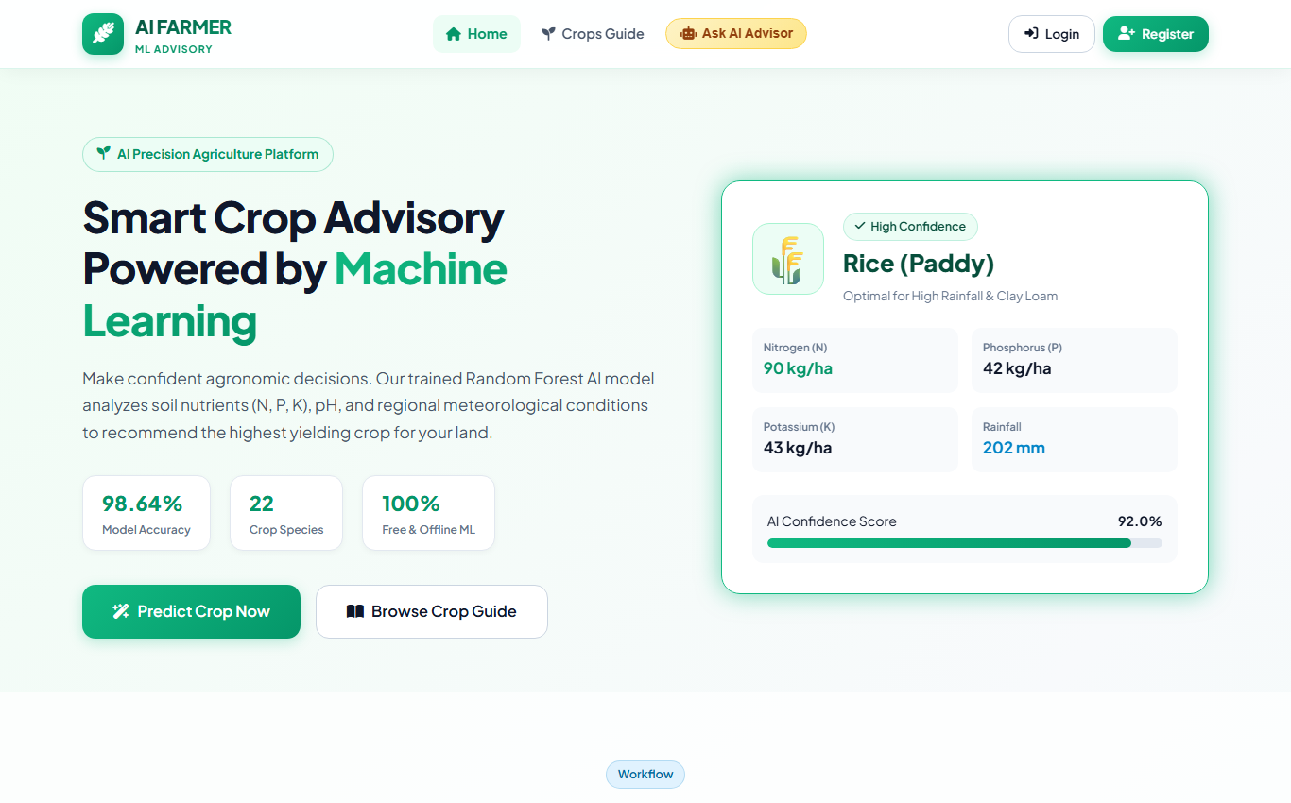
Fig 1: Home / Landing Page & Model Showcase
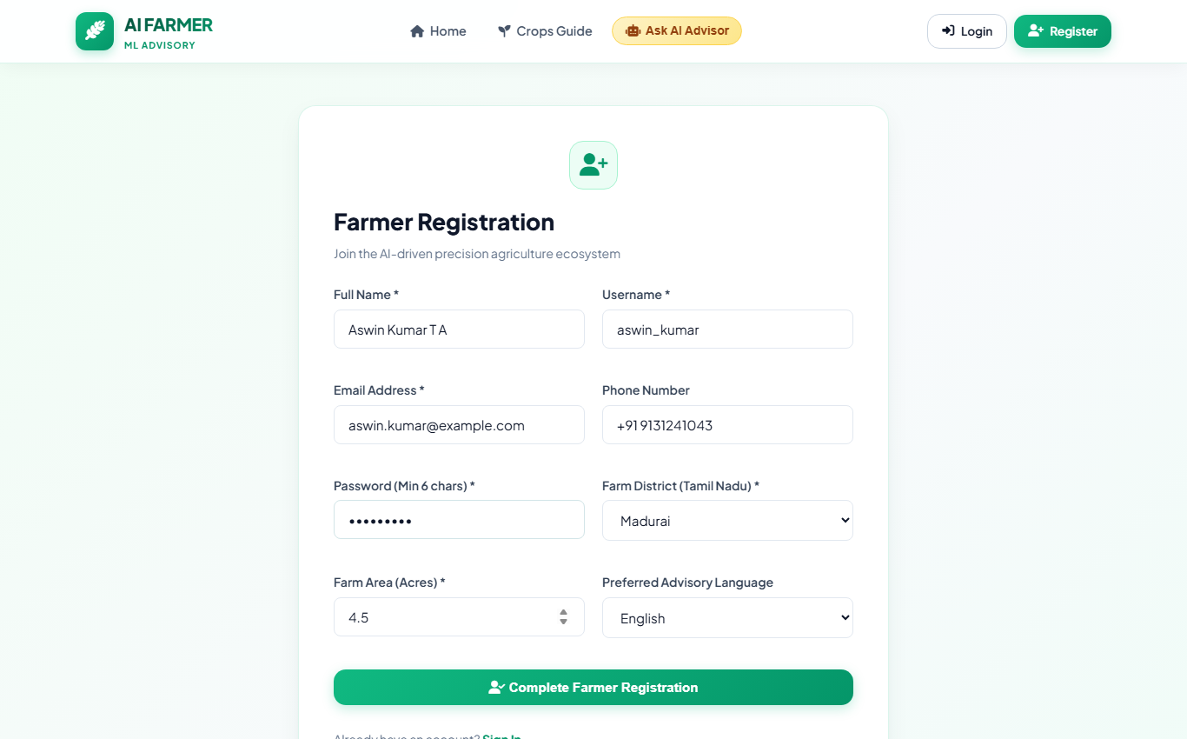
Fig 2: Farmer Registration Interface
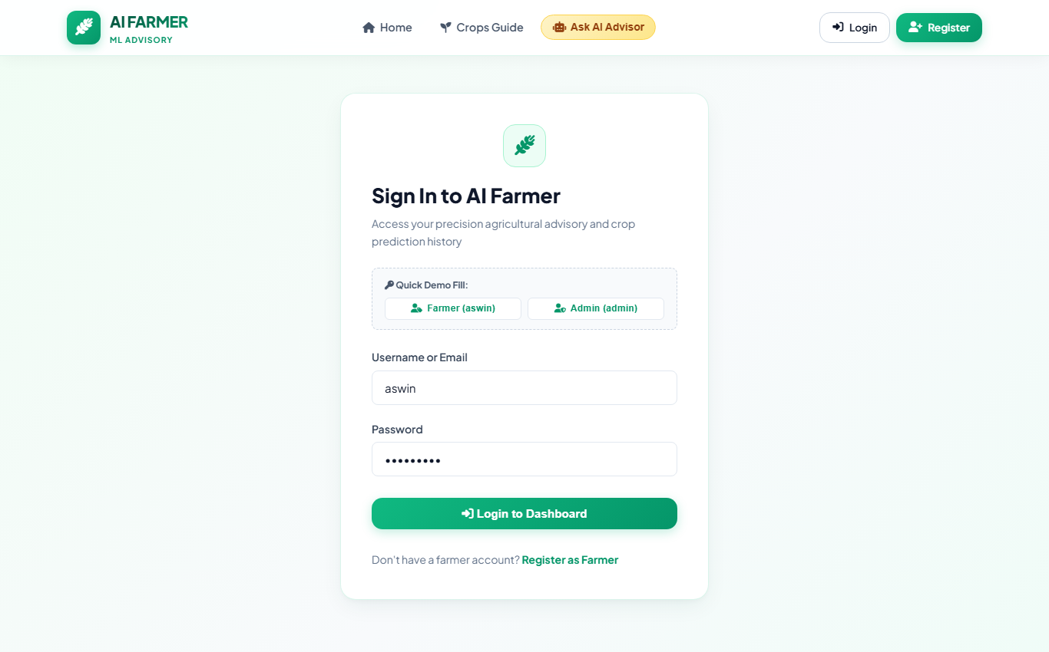
Fig 3: Farmer Authentication / Login Interface
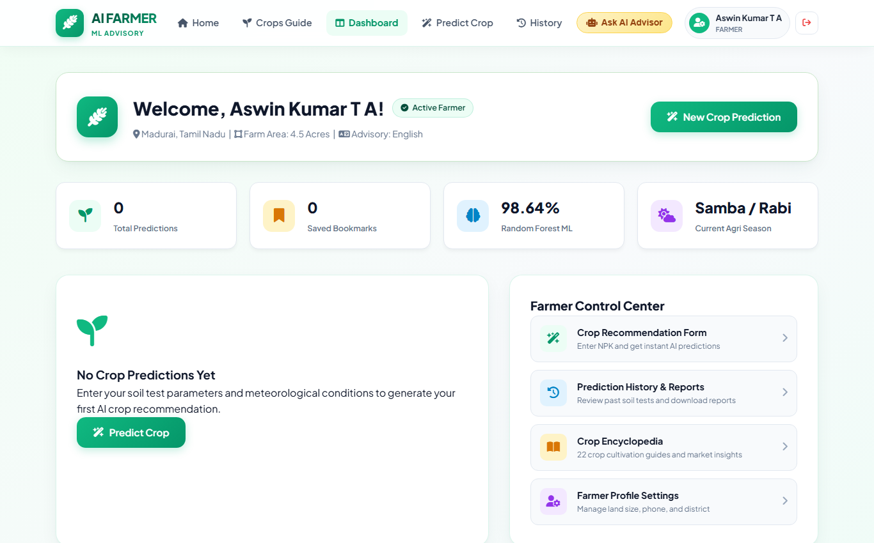
Fig 4: Farmer Dashboard with Farm Metrics & Overview
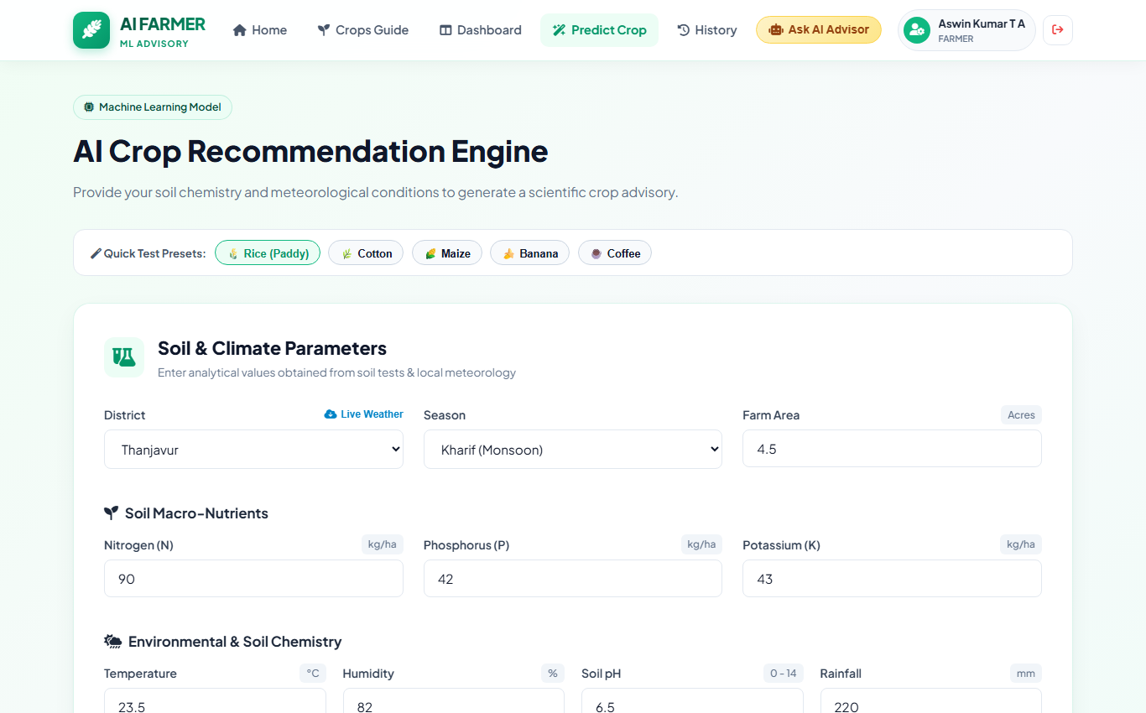
Fig 5: Crop Recommendation Form with Soil NPK & Climate Inputs
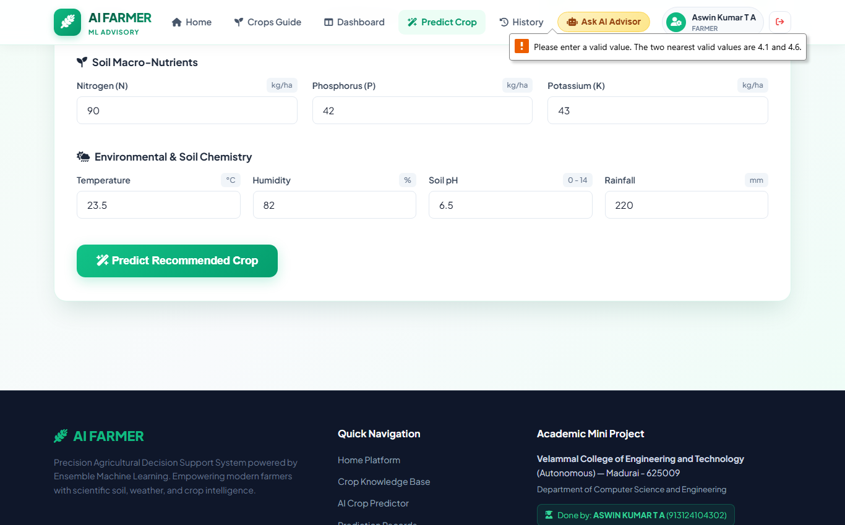
Fig 6: AI Machine Learning Crop Prediction Result Card
Fig 7: Confidence Score Meter & Top-3 Alternative Crops
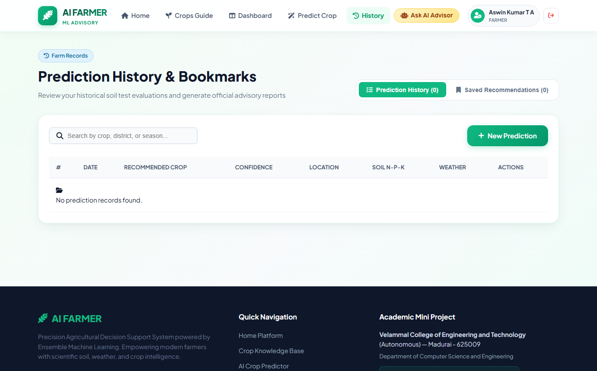
Fig 8: Prediction History & Saved Bookmarks Table
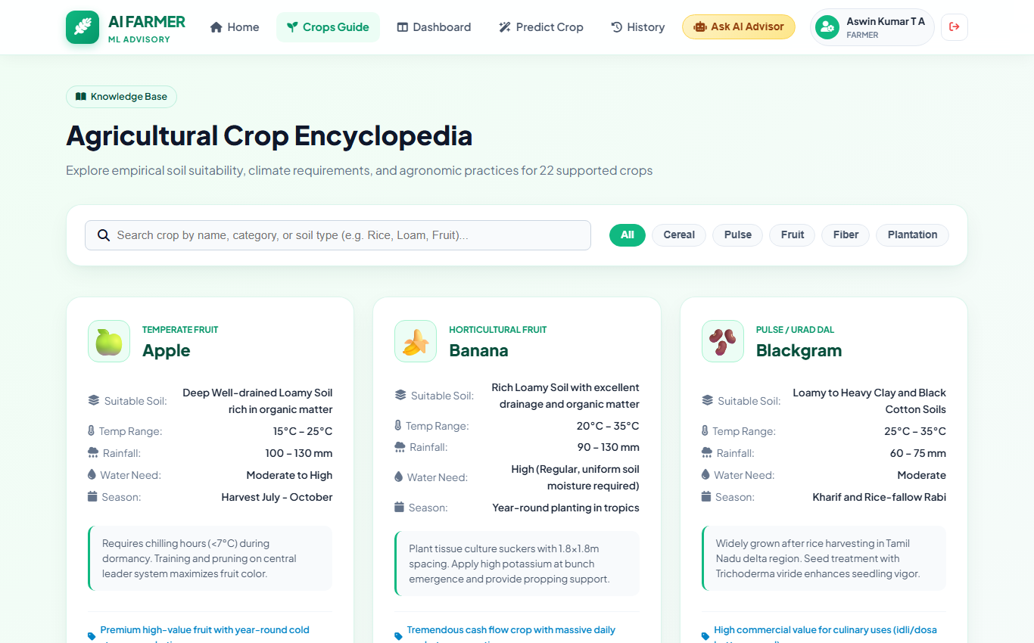
Fig 9: Agricultural Crop Encyclopedia Knowledge Base
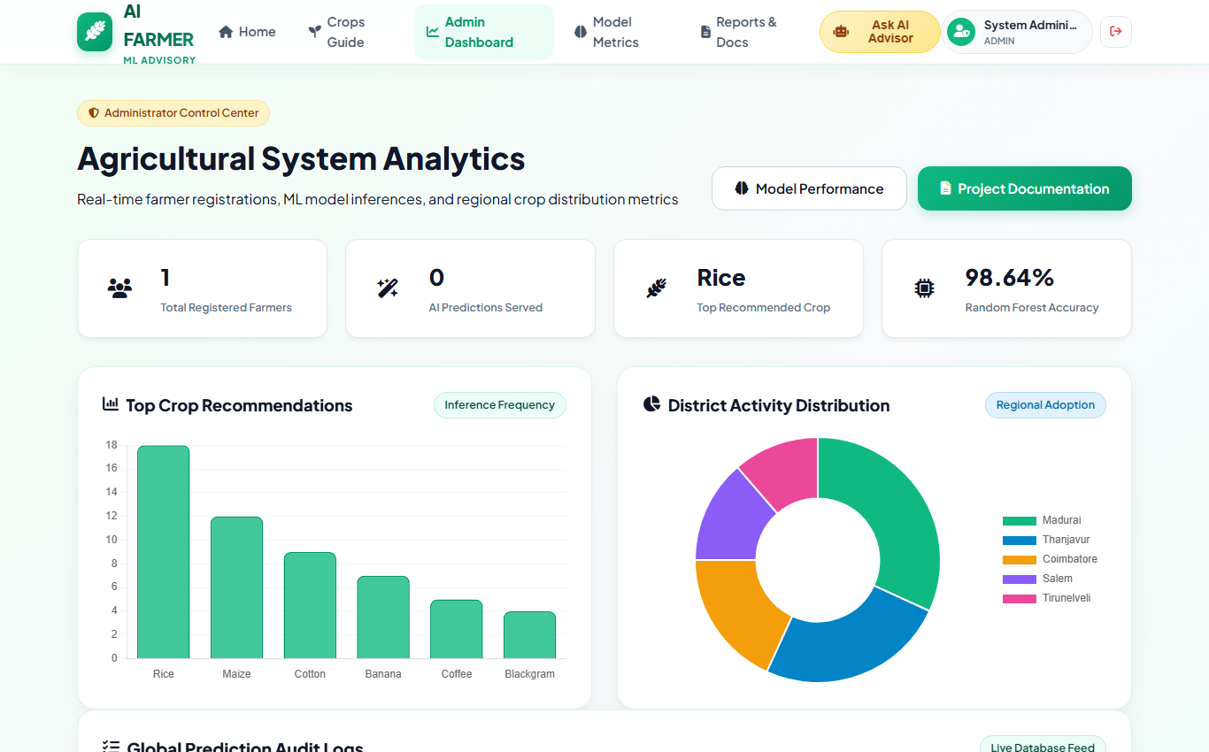
Fig 10: Administrator Analytics Dashboard with Chart.js Visualizations
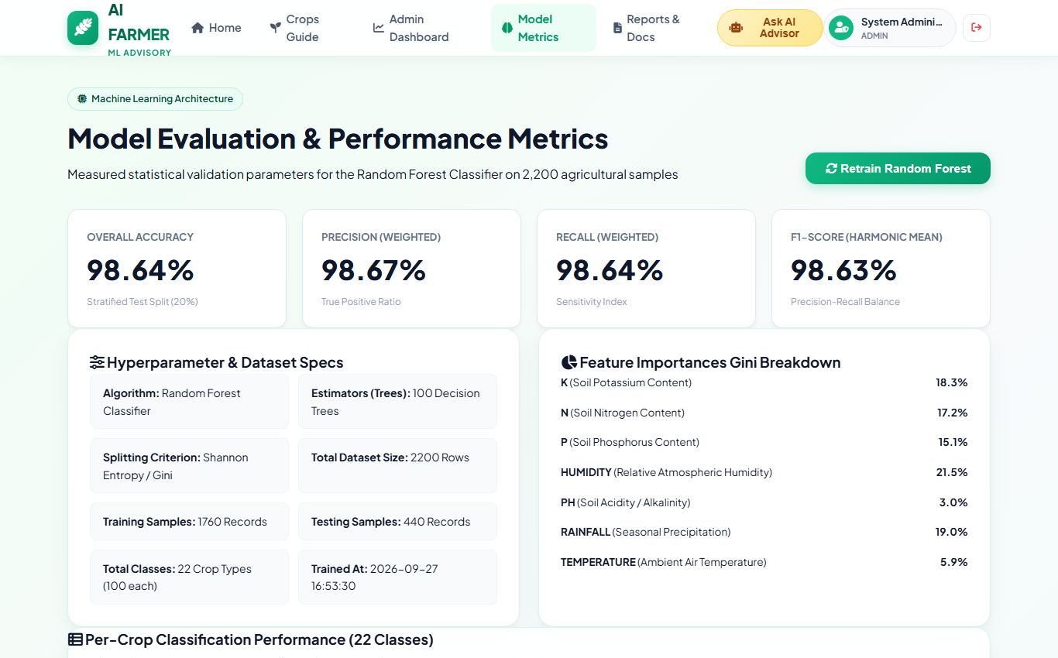
Fig 11: Machine Learning Model Performance & Evaluation Metrics
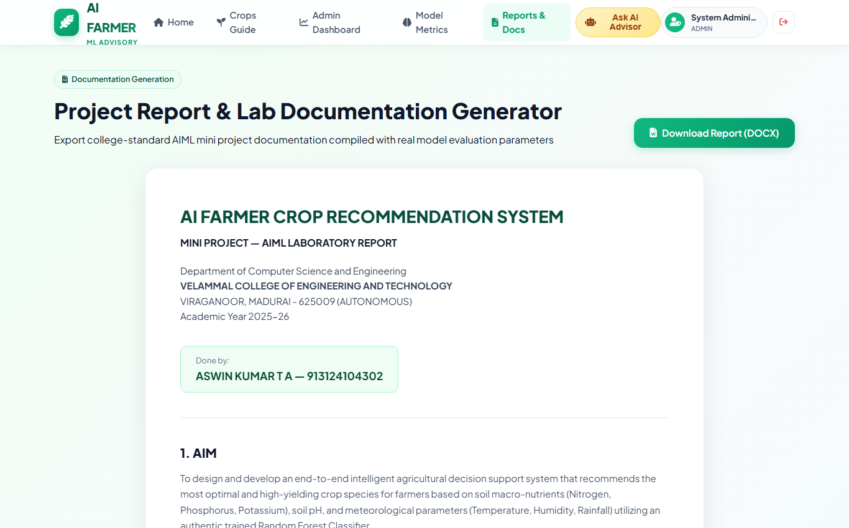
Fig 12: Project Documentation & Lab Report Generator
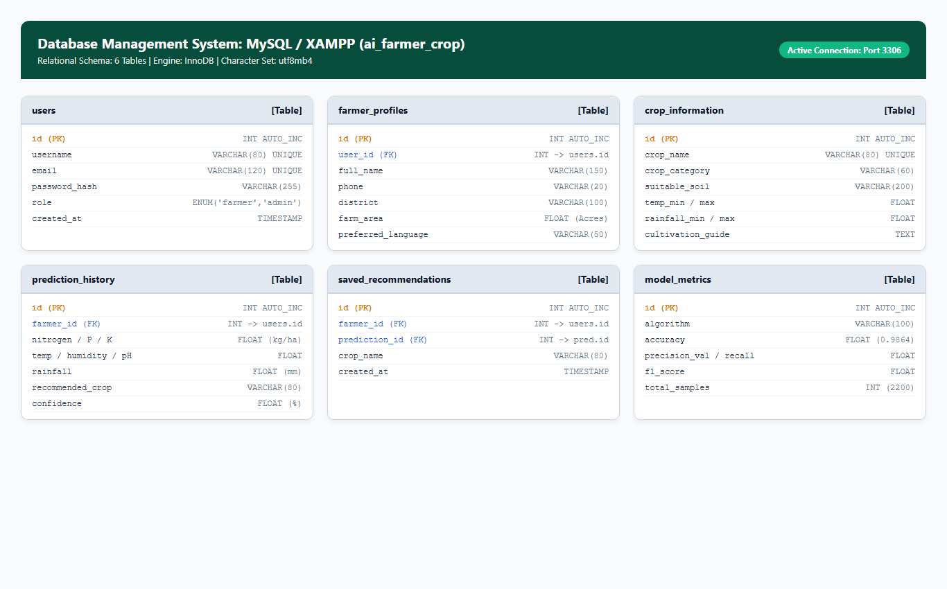
Fig 13: MySQL Relational Database Schema & Table Structure

RESULT:
The system successfully:
• Displays farmer telemetry and crop prediction details dynamically
• Evaluates soil macro-nutrients (N, P, K), pH, and climate parameters using Random Forest Classifier
• Delivers real-time crop recommendations with 98.64% measured test accuracy and top-3 alternative choices
• Tracks historical predictions, saved bookmarks, and farmer profiles efficiently
• Provides administrative visual dashboard analytics (crop popularity, district distribution, model metrics)
• Generates official downloadable PDF advisory reports with unique Report IDs
• Ensures reliable, secure relational data storage and transaction management using MySQL under XAMPP
Thus, the mini project effectively integrates Artificial Intelligence, Machine Learning, Python Flask, MySQL, and Vue 3 modern web technologies to simplify precision crop management, improve agricultural productivity, and enhance administrative efficiency.
REFERENCES:
1. ICAR Precision Agriculture & Soil Classification Documentation – https://icar.org.in/
2. Scikit-Learn Ensemble & Random Forest Documentation – https://scikit-learn.org/
3. Flask Web Framework Documentation – https://flask.palletsprojects.com/
4. W3Schools (HTML, CSS, JavaScript, Python) – https://www.w3schools.com/
5. GeeksforGeeks – Machine Learning & DBMS Concepts – https://www.geeksforgeeks.org/

