- Theater, Science
- Manhattan
- gorl
- Height: 5'8
- Hair: Violent Violet, it is shorter at her chin and incredibly wirey 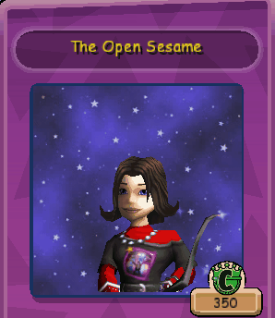
- 3 Quotes:
  - "My medusa sings to the gods tonight.”
  - “Did my performance send its intended shiver up your spinal column?"
  - "Cripes, that's one for the corpses!"
- Story Arc: Player helps her get over her stage fright, she is very talented once she is confident and aware that people respect her seriousness as an actress. Her mom is dying from brain cancer and it puts her in a depression.
- Mannerisms: She's spooky. She loves scary novels. She takes herself very seriously. It is very fun to try and get her to laugh, but it is a little too easy to go too far. If the image she wants to exude is insulted, she goes quiet. She has hobbies other than theater, such as taxidermy, taxonomy, and field studies in biology. She also loves to knit, but only items for her taxidermied specimens. She has two separate registers, one is soprano and when she does this she mimics the theatrics of young Kate Bush. Her other register is contralto, and to activate this register she must drink five shots of “Bang” before performing. She really likes weird cadavers and creepy foetuses, sort of like the "crazy scientist" in a lab aesthetic, not in reality but in aesthetics. She is willowy and lanky, when one side of her body moves, the other matches it in reverse (if one hand moves up, the other goes down). She loves Mary Shelly and Ada Lovelace.
- Appearance: Gangly, a long, orthodox dress, a little emo, maybe a chain somewhere? Think Kate Bush from Wuthering Heights energy, less appearance, more mannerism

