Harvel Electric

It is the best company which provides you the best electric appliances all over the world.

Our Products

Our products are geniune we import our products from malysia, nigerya, japan, indonesia, america & much more.

Claim Warranty

You can claim waranty at your nearest shop we provide our best make you satisfy for our products. Broken appliances will not be claimed.

Information Technology Solutions

Harvel-Electric

Life is easy with harvel

Harvel - Electric

GREE – AC A36CMHF

HSU1HNF

|  |  |
| --- | --- |
| FEATURES  * Elegant 2 Tone Black/Gray Textured Finish * 1st European Compliant Heat and Cool AC * Latest Powerful G-10 Inverter * Ultra Low Frequency Torque Control * State of the Art High Speed DSP Chip * Precise Tempreture Control * Faster Cooling And Heating * Wide Frequency Precise Control * Ultra Low Noise Control * Ceiling Cooling and Floor Heating System * Integrated Design * Dual Installation (Both sides option) * Auto Restart * Fire Proof Electric Box * High Temperature Resistence |  |

.

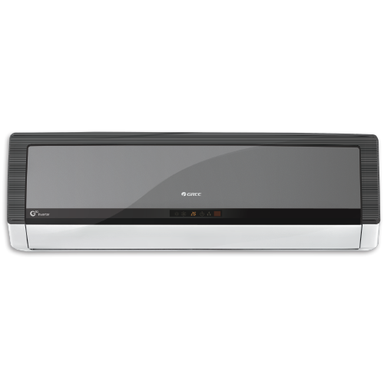

|  |  |
| --- | --- |
| **Weight** | 55 kg |
| **Technology** | [Inverter](https://www.alfatah.com.pk/technology/inverter/) |
| **Air Conditioner Type** | [Wall Mounted Split](https://www.alfatah.com.pk/air-conditioner-type/wall-mounted-split/) |
| **Cooling Capacity** | [1.5 Ton](https://www.alfatah.com.pk/cooling-capacity/1-5-ton/) |
| **Cooling Type** | [Heat & Cool](https://www.alfatah.com.pk/cooling-type/heat-cool/) |

Presenting the new eInverter A36CMHF in a metallic grey finish, that is designed to enhance the decor of your room. This model is the perfect combination of advanced technology complimented by its modern design. With up to 75% energy efficiency, heat and cool function, this model is ideal choice for your space without compromising on quality.