Harvel Electric

It is the best company which provides you the best electric appliances all over the world.

Our Products

Our products are geniune we import our products from malysia, nigerya, japan, indonesia, america & much more.

Claim Warranty

You can claim waranty at your nearest shop we provide our best make you satisfy for our products. Broken appliances will not be claimed.

Information Technology Solutions

Harvel-Electric

Life is easy with harvel

Harvel - Electric

GREE – AC B16CHF

HSU1HNF

|  |  |
| --- | --- |
| **FEATURES**   * Wall mounted split type air-conditioner * Heat and Cool * Stylish flat panel * Comfortable air flow * Low noise level * Auto restart * Filters to purify air * Malaysian compressor * Copper condensor * Control * Ceiling Cooling and Floor Heating System * Integrated Design * Dual Installation (Both sides option) * Auto Restart   **FEATURES**   * Champagne Fawn Ultra Slim U Shaped Body * Three Layer Condenser * Cold Plasma Generator * High Density Filters * 1st European Compliant Heat and Cool AC * Latest Powerful G-10 Inverter * Ultra Low Frequency Torque Control * State of the Art High Speed DSP Chip * Precise Tempreture Control * Faster Cooling And Heating * Wide Frequency Precise Control * Ceiling Cooling and Floor Heating System * Integrated Design * Dual Installation (Both sides option) * Auto Restart   **FEATURES**   * Champagne Fawn Ultra Slim U Shaped Body * Three Layer Condenser * Cold Plasma Generator * High Density Filters * 1st European Compliant Heat and Cool AC * Latest Powerful G-10 Inverter * Ultra Low Frequency Torque Control * State of the Art High Speed DSP Chip * Precise Tempreture Control * Faster Cooling And Heating * Wide Frequency Precise Control * Ceiling Cooling and Floor Heating System * Integrated Design * Dual Installation (Both sides option) * Auto Restart   **FEATURES**   * Champagne Fawn Ultra Slim U Shaped Body * Three Layer Condenser * Cold Plasma Generator * High Density Filters * 1st European Compliant Heat and Cool AC * Latest Powerful G-10 Inverter * Ultra Low Frequency Torque Control * State of the Art High Speed DSP Chip * Precise Tempreture Control * Faster Cooling And Heating * Wide Frequency Precise Control * Ceiling Cooling and Floor Heating System * Integrated Design * Dual Installation (Both sides option) * Auto Restart   **FEATURES**   * Champagne Fawn Ultra Slim U Shaped Body * Three Layer Condenser * Cold Plasma Generator * High Density Filters * 1st European Compliant Heat and Cool AC * Latest Powerful G-10 Inverter * Ultra Low Frequency Torque Control * State of the Art High Speed DSP Chip * Precise Tempreture Control * Faster Cooling And Heating * Wide Frequency Precise Control * Ceiling Cooling and Floor Heating System * Integrated Design * Dual Installation (Both sides option) * Auto Restart |  |

.

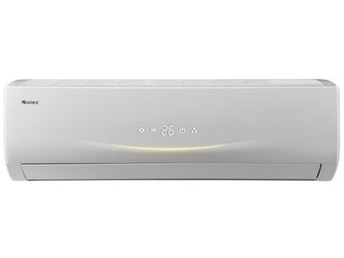

|  |  |
| --- | --- |
| **Weight** | 60 kg |
| **Air Conditioner Type** | [Wall Mounted Split](https://www.alfatah.com.pk/air-conditioner-type/wall-mounted-split/) |
| **Cooling Capacity** | [1.0 Ton](https://www.alfatah.com.pk/cooling-capacity/1-0-ton/) |
| **Technology** | [Inverter](https://www.alfatah.com.pk/technology/inverter/) |
| **Cooling Type** | [Heat & Cool](https://www.alfatah.com.pk/cooling-type/heat-cool/) |

Presenting the New eInverter Eco in a metallic gray finish that is designed to enhance the décor of your room. This model is the perfect combination of advanced technology complimented by its modern design .With up to 75% energy efficiency, heating and cooling function, this model is the ideal choice for your space without compromising on quality