Harvel Electric

It is the best company which provides you the best electric appliances all over the world.

Our Products

Our products are geniune we import our products from malysia, nigerya, japan, indonesia, america & much more.

Claim Warranty

You can claim waranty at your nearest shop we provide our best make you satisfy for our products. Broken appliances will not be claimed.

Information Technology Solutions

Harvel-Electric

Life is easy with harvel

Harvel - Electric

LG – AC GAF956SA

HSU1HNF

|  |  |
| --- | --- |
| **FEATURES** | **FEATURES** |
| * Wall mounted split type air-conditioner | * Wall mounted split type air-conditioner |
| * Inverter technology | * Inverter technology |
| * Heat & Cool | * Heat & Cool |
| * Stylish flat panel | * Stylish flat panel |
| * Inverter technology | * Heat and Cool |
| * Double Layer Condenser | * R-410A Eco Friendly |

* .

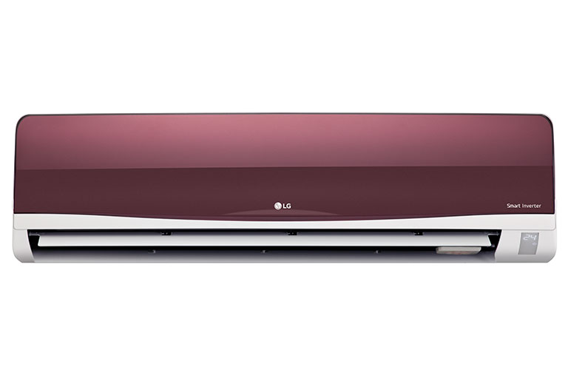

|  |  |  |
| --- | --- | --- |
| **Weight** | | 70 kg |
| **Air Conditioner Type** | | [Wall Mounted Split](https://www.alfatah.com.pk/air-conditioner-type/wall-mounted-split/) |
| **Operating Current** | | [3.5 amperes](https://www.alfatah.com.pk/operating-current/3-5-amperes/) |
| **Cooling Capacity** | | [1.5 Ton](https://www.alfatah.com.pk/cooling-capacity/1-5-ton/) |
| **Cooling Type** | | [Cool Only](https://www.alfatah.com.pk/cooling-type/cool-only/) |
| **Technology** | [Conventional](https://www.alfatah.com.pk/technology/conventional/) |

### Dual Inverter Compressor™

Compressors on typical air conditioners turn off and on in order to adjust temperature, consuming a great deal of energy. Dual Inverter Compressor™ constantly adjusts a compressor’s speed to maintain desired temperature levels. This minimal fluctuation saves energy and ensures greater cooling comfort.