Harvel Electric

It is the best company which provides you the best electric appliances all over the world.

Our Products

Our products are geniune we import our products from malysia, nigerya, japan, indonesia, america & much more.

Claim Warranty

You can claim waranty at your nearest shop we provide our best make you satisfy for our products. Broken appliances will not be claimed.

Information Technology Solutions

Harvel-Electric

Life is easy with harvel

Harvel - Electric

LG – AC SK99M5

HSU1HNF

|  |  |
| --- | --- |
| Key Features | **FEATURES** |
| * 65°C Dual Inverter Compressor™ | * Wall mounted split type air-conditioner |
| * 10 Year Warranty | * Inverter technology |
| * 60% Faster Cooling | * Heat & Cool |
| * 65% Energy Saving | * Stylish flat panel |
| * Comfort Sleep | * Heat and Cool |
| * Double Layer Condenser | * R-410A Eco Friendly |

* .

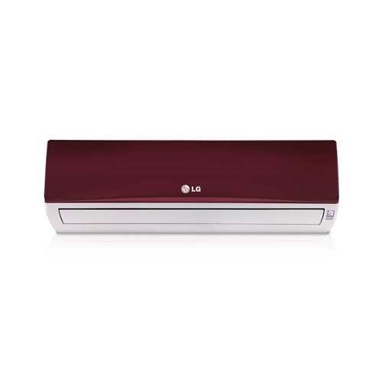

|  |  |  |
| --- | --- | --- |
| **Weight** | | 55 kg |
| **Technology** | | [Inverter](https://www.alfatah.com.pk/technology/inverter/) |
| **Air Conditioner Type** | | [Wall Mounted Split](https://www.alfatah.com.pk/air-conditioner-type/wall-mounted-split/) |
| **Cooling Capacity** | | [2.0 Ton](https://www.alfatah.com.pk/cooling-capacity/2-0-ton/) |
| **Cooling Type** | | [Heat & Cool](https://www.alfatah.com.pk/cooling-type/heat-cool/) |
| **Weight** | 70 kg |

### Fast Cooling & Energy Saving

Inverter Compressor constantly adjusts a compressor’s speed to maintain desired temperature levels. Moreover, Dual Inverter Compressor™ with power saving operation range frequency saves more energy than conventional compressor. Thanks to the Dual Inverter compressor, air is expelled farther and faster.