Harvel Electric

It is the best company which provides you the best electric appliances all over the world.

Our Products

Our products are geniune we import our products from malysia, nigerya, japan, indonesia, america & much more.

Claim Warranty

You can claim waranty at your nearest shop we provide our best make you satisfy for our products. Broken appliances will not be claimed.

Information Technology Solutions

Harvel-Electric

Life is easy with harvel

Harvel - Electric

|  |  |
| --- | --- |
| FEATURES: | **FEATURES** |
| * Dual Invertor Split AC | * Full Money Back in 1 Year |
| * Heat & Cool 1.5 Ton | * Bigger Outdoor |
| * 10 Years Warranty | * 50 Feet long Air Throw |
| * 65% Energy Saving | * Low Voltage Operation (Startup at 140V) |
| * Copper Condenser with Gold Fin | * Heat and Cool |
| * Double Layer Condenser | * R-410A Eco Friendly |

* .

LG – AC QAS596IM

HSU1HNF

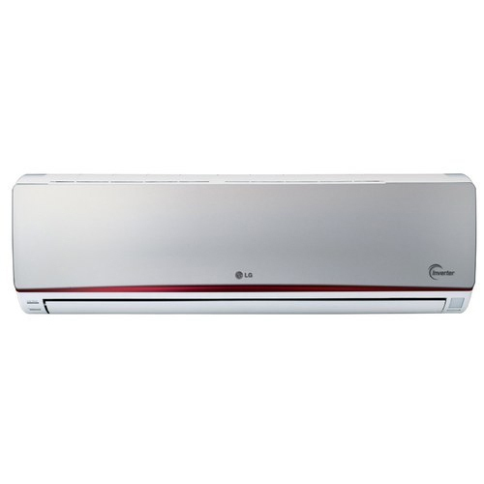

|  |  |  |
| --- | --- | --- |
| **Weight** | | 70 kg |
| **Cooling Capacity** | | [1.5 Ton](https://www.alfatah.com.pk/cooling-capacity/1-5-ton/) |
| **Cooling Type** | | [Heat & Cool](https://www.alfatah.com.pk/cooling-type/heat-cool/) |
| **Technology** | | [Inverter](https://www.alfatah.com.pk/technology/inverter/) |
| **Air Conditioner Type** | | [Wall Mounted Split](https://www.alfatah.com.pk/air-conditioner-type/wall-mounted-split/) |
| **Weight** | 70 kg |

### Dual Inverter Compressor™ With 10 Year Warranty

LG’s Dual Inverter CompressorTM solves improper, ineffective and noisy problems, resulting in an air conditioner that cools faster, lasts longer, and runs quieter. With the 10year warranty on the compressor, users can enjoy the benefits of LG air conditioner for a longer period of time.