Harvel Electric

It is the best company which provides you the best electric appliances all over the world.

Our Products

Our products are geniune we import our products from malysia, nigerya, japan, indonesia, america & much more.

Claim Warranty

You can claim waranty at your nearest shop we provide our best make you satisfy for our products. Broken appliances will not be claimed.

Information Technology Solutions

Harvel-Electric

Life is easy with harvel

Harvel - Electric

LG – AC A24CMH

HSU1HNF

|  |  |
| --- | --- |
| Key Features | **FEATURES** |
| * Inverter Compressor | * Full Money Back in 1 Year |
| * Energy Saving | * Bigger Outdoor |
| * Faster Cooling | * 50 Feet long Air Throw |
| Key Features | * Low Voltage Operation (Startup at 140V) |
| * Inverter Compressor | * Heat and Cool |
| * Energy Saving | * R-410A Eco Friendly |

* .

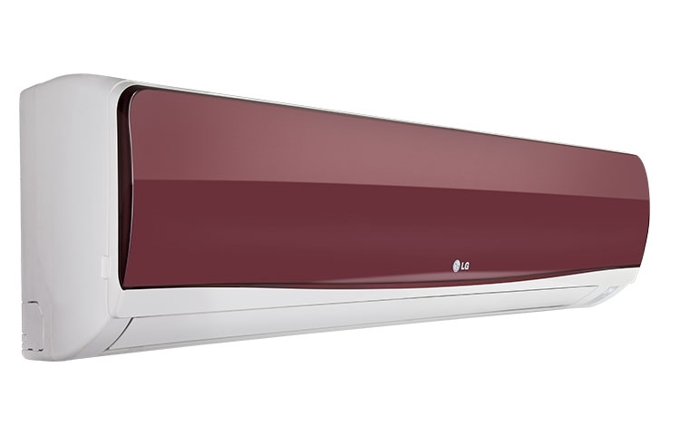

|  |  |
| --- | --- |
| **Weight** | 70 kg |
| **Cooling Type** | [Cool Only](https://www.alfatah.com.pk/cooling-type/cool-only/) |
| **Cooling Capacity** | [1.5 Ton](https://www.alfatah.com.pk/cooling-capacity/1-5-ton/) |
| **Technology** | [Conventional](https://www.alfatah.com.pk/technology/conventional/) |
| **Air Conditioner Type** | [Wall Mounted Split](https://www.alfatah.com.pk/air-conditioner-type/wall-mounted-split/) |
| **Operating Current** | [7.5-8.0 amperes](https://www.alfatah.com.pk/operating-current/7-5-8-0-amperes/) |

### Energy Saving

Inverter Compressor constantly adjusts a compressor’s speed to maintain desired temperature levels. Moreover, Dual Inverter Compressor™ with power saving operation range frequency saves more energy than conventional compressor.