Harvel Electric

It is the best company which provides you the best electric appliances all over the world.

Our Products

Our products are geniune we import our products from malysia, nigerya, japan, indonesia, america & much more.

Claim Warranty

You can claim waranty at your nearest shop we provide our best make you satisfy for our products. Broken appliances will not be claimed.

Information Technology Solutions

Harvel-Electric

Life is easy with harvel

Harvel - Electric

DAWLANCE – AC NHL18-HNF

HSU1HNF

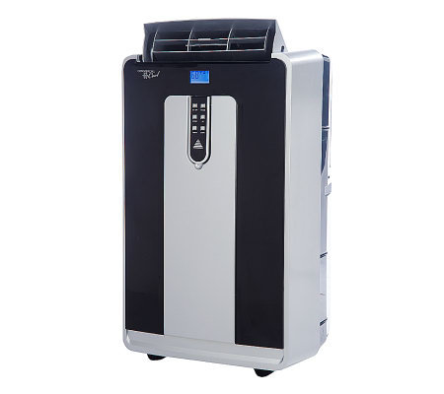

|  |  |
| --- | --- |
| **Brand** | dawlance |
| **Model ID** | NHL18-HNF |
| **Product Code** | FAFHAIE5Y55 |
| **Type** | portable AC |
| **Capacity** | 0.5 Ton |
| **Energy Rating** | 5 Star |
| **Inverter AC** | No |

* .

|  |  |
| --- | --- |
| **Weight** | 40 kg |
| **Cooling Type** | Cooling only |
| **Cooling Capacity** | [0.5 Ton](https://www.alfatah.com.pk/cooling-capacity/1-5-ton/) |
| **Technology** | [Conventional](https://www.alfatah.com.pk/technology/conventional/) |
| **Air Conditioner Type** | portable AC |

There NHL18-HNF is the AC you should probably get, especially if it’s for an office, den, or other room where you won’t be sleeping. For some people, it’ll be fine in a bedroom, too. It’s widely available and the price is fair, so you shouldn’t have any trouble finding it on short notice