Harvel Electric

It is the best company which provides you the best electric appliances all over the world.

Our Products

Our products are geniune we import our products from malysia, nigerya, japan, indonesia, america & much more.

Claim Warranty

You can claim waranty at your nearest shop we provide our best make you satisfy for our products. Broken appliances will not be claimed.

Information Technology Solutions

Harvel-Electric

Life is easy with harvel

Harvel - Electric

DAWLANCE – AC HSY18-9FL

HSU1HNF

|  |  |
| --- | --- |
| **Brand** | dawlance |
| **Model ID** | HSY18-9FL |
| **Product Code** | LAFHAIE5Y55 |
| **Type** | SPLIT AC |
| **Capacity** | 2 Ton |
| **Energy Rating** | 5 Star |
| **Inverter AC** | No |

* .

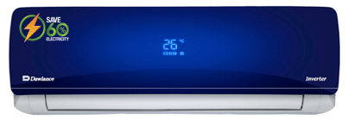

|  |  |
| --- | --- |
| **Weight** | 75 kg |
| **Cooling Type** | Cooling only |
| **Cooling Capacity** | [2 Ton](https://www.alfatah.com.pk/cooling-capacity/1-5-ton/) |
| **Technology** | [Conventional](https://www.alfatah.com.pk/technology/conventional/) |
| **Air Conditioner Type** | SPLIT AC |

Most air conditioners are loud, but the HSY18-9FL is the least-worst of the $250-ish, 8,000 Btu ACs. It’s a bit quieter overall and sounds lower-pitched. At its absolute loudest, with the compressor on and the fan at full speed, we measured it running at 66 dBC (that is the C-weighted decibel scale).