Harvel Electric

It is the best company which provides you the best electric appliances all over the world.

Our Products

Our products are geniune we import our products from malysia, nigerya, japan, indonesia, america & much more.

Claim Warranty

You can claim waranty at your nearest shop we provide our best make you satisfy for our products. Broken appliances will not be claimed.

Information Technology Solutions

Harvel-Electric

Life is easy with harvel

Harvel - Electric

DAWLANCE – AC FGRQ08L3T1

HSU1HNF

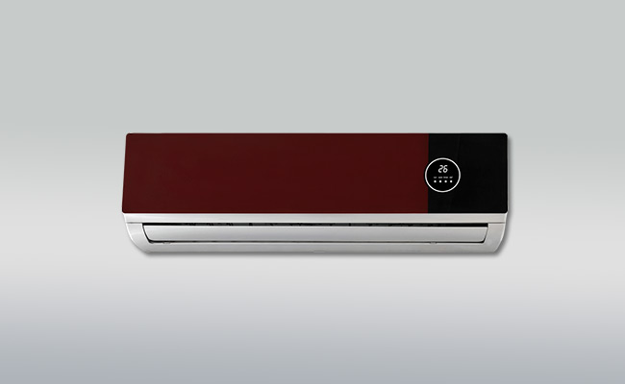

|  |  |
| --- | --- |
| **Brand** | dawlance |
| **Model ID** | FGRQ08L3T1 |
| **Product Code** | LAFHAIE5Y52 |
| **Type** | SPLIT AC |
| **Capacity** | 1 Ton |
| **Energy Rating** | 5 Star |
| **Inverter AC** | No |

* .

|  |  |
| --- | --- |
| **Weight** | 60 kg |
| **Cooling Type** | Cooling only |
| **Cooling Capacity** | [1 Ton](https://www.alfatah.com.pk/cooling-capacity/1-5-ton/) |
| **Technology** | [Conventional](https://www.alfatah.com.pk/technology/conventional/) |
| **Air Conditioner Type** | SPLIT AC |

If you’re installing an air conditioner in your bedroom, or if you just value peace and quiet in any other room, treat yourself to the (relatively) hushed performance of the **Frigidaire Gallery FGRQ08L3T1**. It usually costs $50 to $80 more than our main pick or our runner-up, but it runs very quietly, and you’ll sleep better all summer.