Harvel Electric

It is the best company which provides you the best electric appliances all over the world.

Our Products

Our products are geniune we import our products from malysia, nigerya, japan, indonesia, america & much more.

Claim Warranty

You can claim waranty at your nearest shop we provide our best make you satisfy for our products. Broken appliances will not be claimed.

Information Technology Solutions

Harvel-Electric

Life is easy with harvel

Harvel - Electric

DAWLANCE – AC FGRQ08L3T1

HSU1HNF

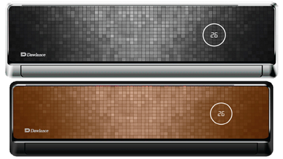

|  |  |
| --- | --- |
| **Brand** | dawlance |
| **Model ID** | GRQAS19 |
| **Product Code** | LYFfAIE5Y52 |
| **Type** | SPLIT AC |
| **Capacity** | 1.5 Ton |
| **Energy Rating** | 5 Star |
| **Inverter AC** | No |

* .

## Key Features

http://www.dawlance.com.pk/assets/images/icons/1.Energy-Saver.png

Energy Saver technology-saves upto Rs. 4000 per year

http://www.dawlance.com.pk/assets/images/icons/2.-fashionable-design.png

Fashionable design to match your interior

http://www.dawlance.com.pk/assets/images/icons/3.Sleep-Mode.png

Sleep mode function- for comfortable sleep

http://www.dawlance.com.pk/assets/images/icons/4.Auto-Restart.png

Auto-restart function

Are high electricity bills disturbing your monthly budget? Are you looking for appliances that have minimal impact on your bills? Look no further because Dawlance’s Energy Saver series give you the cooling comfort par excellence while going easy on your pocket