Harvel Electric

It is the best company which provides you the best electric appliances all over the world.

Our Products

Our products are geniune we import our products from malysia, nigerya, japan, indonesia, america & much more.

Claim Warranty

You can claim waranty at your nearest shop we provide our best make you satisfy for our products. Broken appliances will not be claimed.

Information Technology Solutions

Harvel-Electric

Life is easy with harvel

Harvel - Electric

DAWLANCE – AC FGRQ08L3T1

HSU1HNF

|  |  |
| --- | --- |
| **Brand** | dawlance |
| **Model ID** | GRQAS19 |
| **Product Code** | LYFfAIE5Y52 |
| **Type** | SPLIT AC |
| **Capacity** | 1.5 Ton |
| **Energy Rating** | 5 Star |
| **Inverter AC** | No |

* .

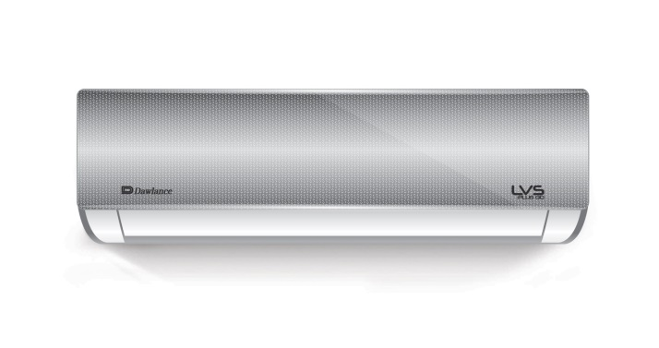

**Inverter Compressor**

(upto PKR 30,000 annual Savings Key features **Inverter Compressor**

. 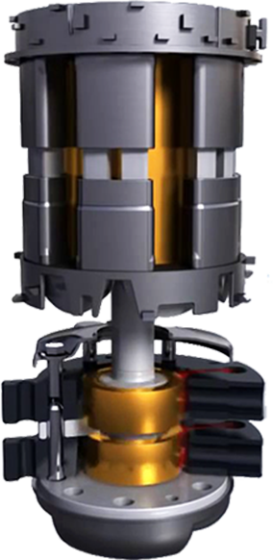(upto PKR 30,000

annual Savings

.

**100% Copper**

Connecting Pipes.

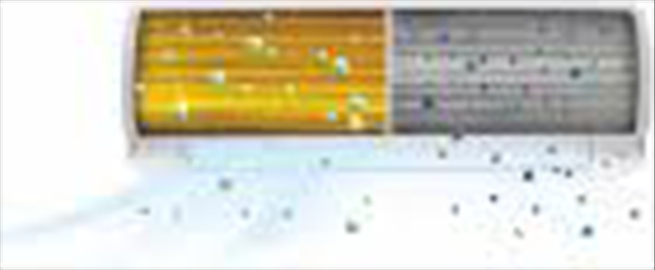

**self cleaning**

Function

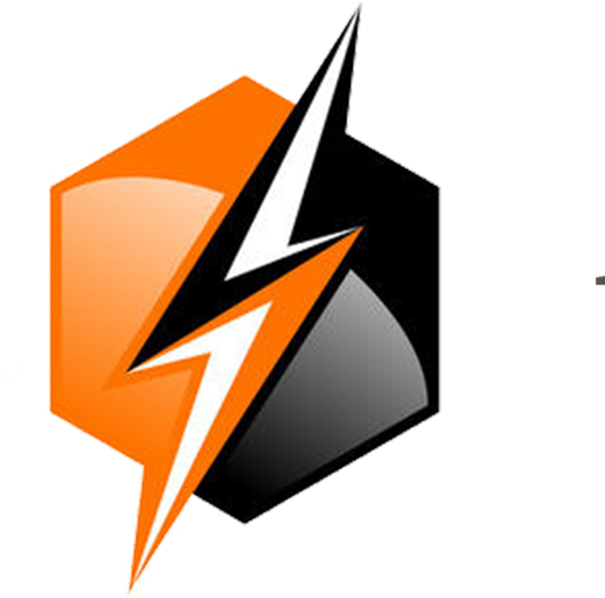

**150 to 260 V**

voltage range

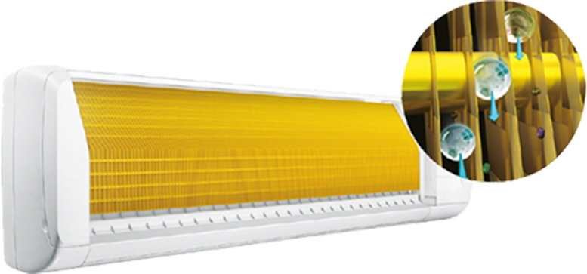

**Anti-F**

Feature



Typhoon air technology

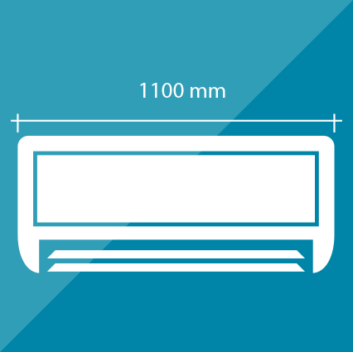

1100mm Bigger indoor



Large air throw

Dawlance has got you covered this season with its Advanced Typhoon Air Technology and beautifully designed Split AC range. Active Cool Inverter with Typhoon Air Technology, Self cleaning and Anti F feature offers complete solution of savings, hygiene, comfort and convenience for you.

## Key Features