Harvel Electric

It is the best company which provides you the best electric appliances all over the world.

Our Products

Our products are geniune we import our products from malysia, nigerya, japan, indonesia, america & much more.

Claim Warranty

You can claim waranty at your nearest shop we provide our best make you satisfy for our products. Broken appliances will not be claimed.

Information Technology Solutions

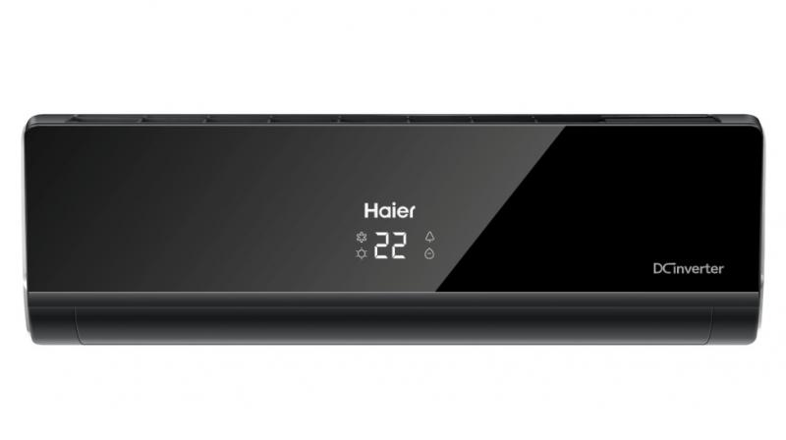

Haier - AC LW8016ER

The LW8016ER also offers extra controls that seem really minor, but can make a huge difference. For example, the fan blades are as effective as any at directing air where you’d like it to go, and stop it from going where you wouldn’t. That can come in handy if you sleep near the AC, so you can direct the cold air away from your head at night. Some window units struggle with fan direction and have cold spots where they can’t stop blowing air—not a problem with the LG.

.

Harvel-Electric

|  |  |
| --- | --- |
| **Weight 55KG** | 70 kg |
| **Cooling Type COOL ONLY** | [Cool Only](https://www.alfatah.com.pk/cooling-type/cool-only/) |
| **Cooling Capacity 1 TON** | [1.5 Ton](https://www.alfatah.com.pk/cooling-capacity/1-5-ton/) |
| **Technology CONVENTIONAL** | [Conventional](https://www.alfatah.com.pk/technology/conventional/) |
| **Air Conditioner Type WALL MOUNTED SPLIT** | [Wall Mounted Split](https://www.alfatah.com.pk/air-conditioner-type/wall-mounted-split/) |

* Haier has launched its first self-cleaning inverter technology air conditioners in India. These air conditioners feature the self-cleaning technology, which is a patented technology by Haier and allows users to automatically clean the evaporator of the air conditioner with the tap of a button. It is a common phenomenon for the dust to accumulate on the evaporator unit of the air conditioner while it is in use.

Life is easy with harvel

Harvel - Electric