Harvel Electric

It is the best company which provides you the best electric appliances all over the world.

Our Products

Our products are geniune we import our products from malysia, nigerya, japan, indonesia, america & much more.

Claim Warranty

You can claim waranty at your nearest shop we provide our best make you satisfy for our products. Broken appliances will not be claimed.

Information Technology Solutions

Harvel-Electric

Life is easy with harvel

Harvel - Electric

Haier – AC HSU-19NRS4

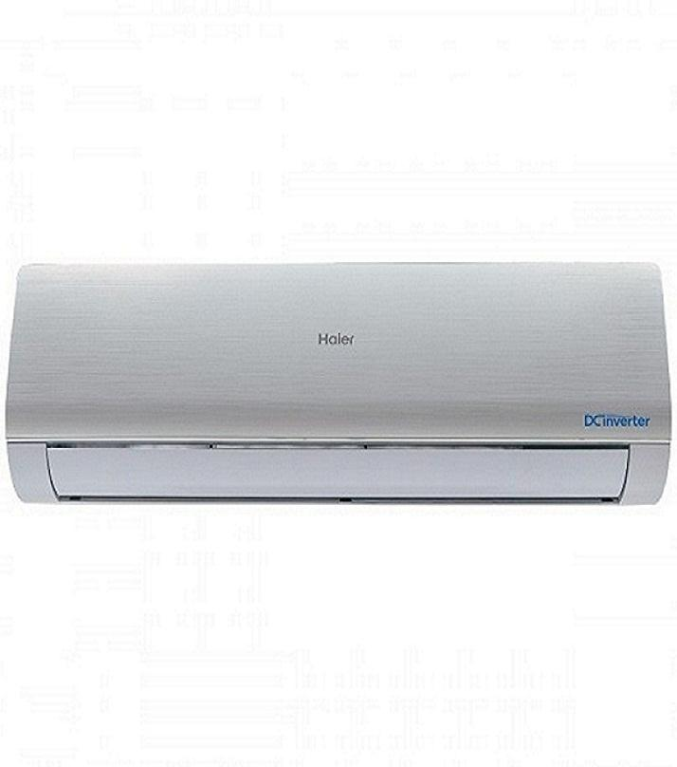

|  |  |
| --- | --- |
| **Brand** | Haier |
| **Model ID** | HSU-19NRS4 |
| **Product Code** | LARHAIE376 |
| **Type** | Split AC |
| **Capacity** | 1.5 Ton |
| **Energy Rating** | 4 Star |
| **Inverter AC** | No |

* .

|  |  |
| --- | --- |
| **Weight** | 65 kg |
| **Cooling Type** | [Cool Only](https://www.alfatah.com.pk/cooling-type/cool-only/) |
| **Cooling Capacity** | [1.5 Ton](https://www.alfatah.com.pk/cooling-capacity/1-5-ton/) |
| **Technology** | [Conventional](https://www.alfatah.com.pk/technology/conventional/) |
| **Air Conditioner Type** | SPLIT DC INVENTER AC |

Haier Innovative "One Touch Cleaning" system that self-cleans your Air Conditioner proficiently. Its Cold Compression Technology Effectively Clean the Evaporator by Simply pressing a "Self Clean" button starts the self-cleaning process and takes away all your regular cleaning and maintenance worries. It also features a Healthy Air Flow option that allows the airflow to be adjusted so as not to blow directly on your body.