Harvel Electric

It is the best company which provides you the best electric appliances all over the world.

Our Products

Our products are geniune we import our products from malysia, nigerya, japan, indonesia, america & much more.

Claim Warranty

You can claim waranty at your nearest shop we provide our best make you satisfy for our products. Broken appliances will not be claimed.

Information Technology Solutions

Harvel-Electric

Life is easy with harvel

Harvel - Electric

Haier – AC HSU18-HNF

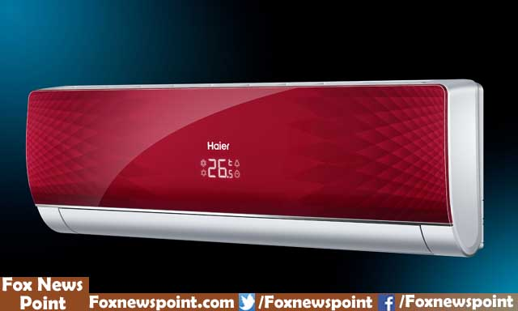

|  |  |
| --- | --- |
| **Brand** | Haier |
| **Model ID** | HSU18-HNF |
| **Product Code** | LARHAIE376 |
| **Type** | Split AC |
| **Capacity** | 1.5 Ton |
| **Energy Rating** | 4 Star |
| **Inverter AC** | No |

* .

|  |  |
| --- | --- |
| **Weight** | 42 kg |
| **Cooling Type** | DC INVENTER |
| **Cooling Capacity** | [1 Ton](https://www.alfatah.com.pk/cooling-capacity/1-5-ton/) |
| **Technology** | [Conventional](https://www.alfatah.com.pk/technology/conventional/) |
| **Air Conditioner Type** | SPLIT AC |

### Key Features

* 66% Power saving
  + A-PAM DC Inverter technology
  + Solar Panel Compatibility
  + Turbo Cooling and Heating
  + 4 ways Air Flow
  + R410a refrigerant
* Golden fin condenser and evaporator
* T3 working Condition tested and approved

### Specifications