Harvel Electric

It is the best company which provides you the best electric appliances all over the world.

Our Products

Our products are geniune we import our products from malysia, nigerya, japan, indonesia, america & much more.

Claim Warranty

You can claim waranty at your nearest shop we provide our best make you satisfy for our products. Broken appliances will not be claimed.

Information Technology Solutions

Harvel-Electric

Life is easy with harvel

Harvel - Electric

Haier – AC HSU18-HNF

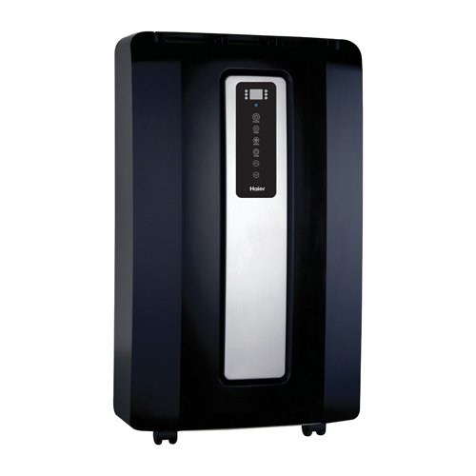

|  |  |
| --- | --- |
| **Brand** | Haier |
| **Model ID** | HSU18-HNF |
| **Product Code** | FARHAIE376 |
| **Type** | portable AC |
| **Capacity** | 1 Ton |
| **Energy Rating** | 5 Star |
| **Inverter AC** | No |

* .

|  |  |
| --- | --- |
| **Weight** | 80 kg |
| **Cooling Type** | Only cooling |
| **Cooling Capacity** | [1.5 Ton](https://www.alfatah.com.pk/cooling-capacity/1-5-ton/) |
| **Technology** | [Conventional](https://www.alfatah.com.pk/technology/conventional/) |
| **Air Conditioner Type** | Dc inventer AC |

* The best air conditioner makes you the most comfortable in your home. For most people, that means picking a quiet AC without jarring whines, whooshes, or whirs, and with as much control over climate settings and air direction as possible. Ideally, the best air conditioner will pass the bedroom test: If it’s good enough to sleep near, it’s good enough for any other room in your house