Harvel Electric

It is the best company which provides you the best electric appliances all over the world.

Our Products

Our products are geniune we import our products from malysia, nigerya, japan, indonesia, america & much more.

Claim Warranty

You can claim waranty at your nearest shop we provide our best make you satisfy for our products. Broken appliances will not be claimed.

Information Technology Solutions

Harvel-Electric

Life is easy with harvel

Harvel - Electric

ORIENT – AC FGRQS005D

HSU1HNF

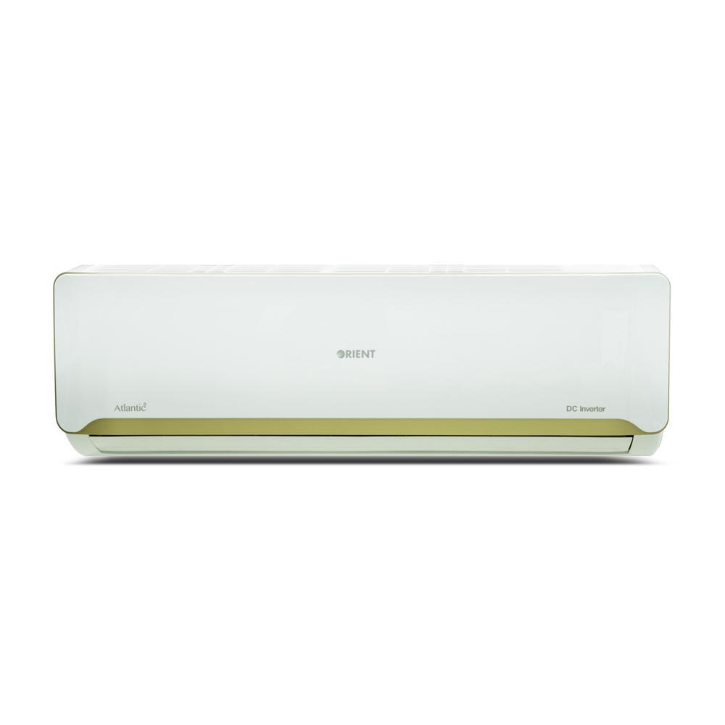

|  |  |
| --- | --- |
| **Brand** | orient |
| **Model ID** | ATLANTIC DC  INVENTER |
|  |  |
| **Type** | SPLIT AC |
| **Capacity** | 1.5 Ton |
| **Energy Rating** | 5 Star |
| **Inverter AC** | No |

* .

**Electrical Data**

|  |  |
| --- | --- |
| **RATED VOLTAGE 220-240V** | 220-240V |
| **RATED FREQUENCY 1PH,50HZ** | 1PH, 50HZ |

**Cooling**

|  |  |
| --- | --- |
| **RATED CAPACITY (COOLING) 18000BTU/H** | 18000 Btu/h |
| **RATED POWER CONSUMPTION (C) 1650W** | 1650 W |
| **RUNNING CURRENT (C) 7.2A** | 7.2 A |
| **SEER (C) 3.6** | 3.6 |

## The inverter technology based 1.5 Ton Atlantic DC Inverter AC not only offers efficient cooling performance under all weather conditions but draws minimum energy enabling you to enjoy reduction of bills by up to 50%. Atlantic’s elegant design is centered on enhancing the overall look of your dwelling and its eco-friendly R410A refrigerant ensures optimum cooling results while keeping the environment safe.