Harvel Electric

It is the best company which provides you the best electric appliances all over the world.

Our Products

Our products are geniune we import our products from malysia, nigerya, japan, indonesia, america & much more.

Claim Warranty

You can claim waranty at your nearest shop we provide our best make you satisfy for our products. Broken appliances will not be claimed.

Information Technology Solutions

Harvel-Electric

Life is easy with harvel

Harvel - Electric

ORIENT – AC AFGS9500M

HSU1HNF

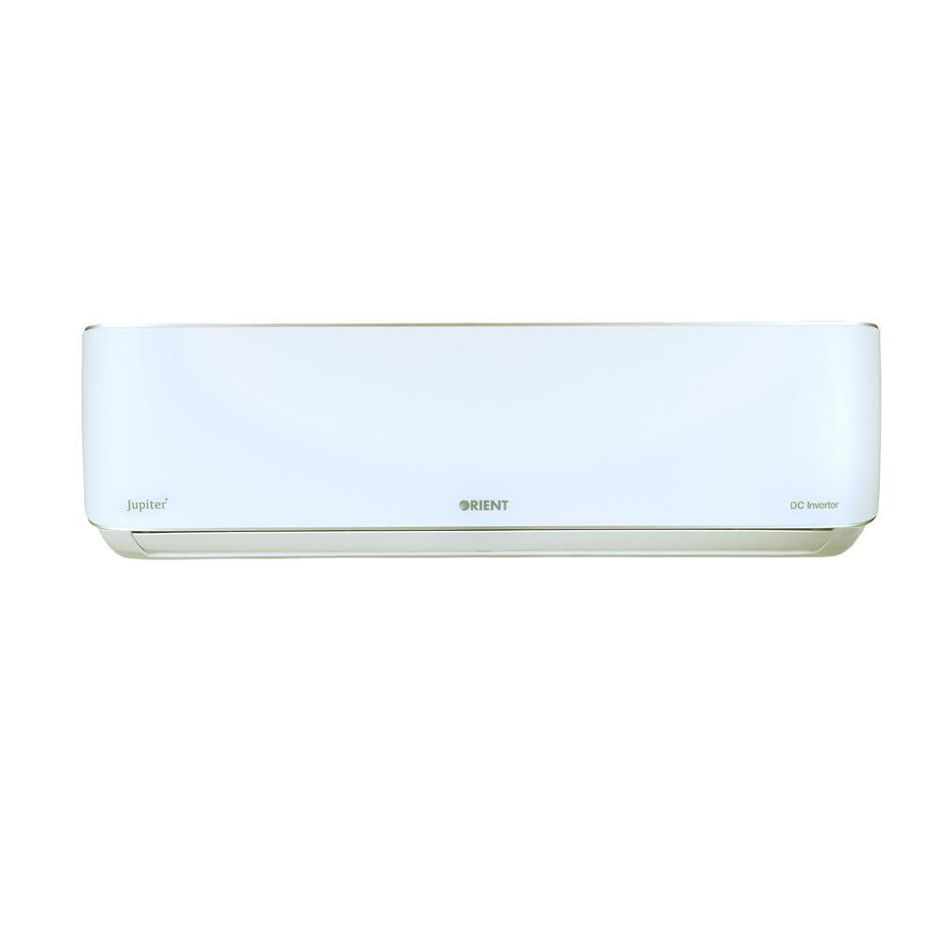

**Cooling**

|  |  |
| --- | --- |
| **RATED CAPACITY (COOLING) 12000BTU/H** | 12000 Btu/h |
| **RATED POWER CONSUMPTION (C) 1100W** | 1100 W |
| **RUNNING CURRENT (C) 4.8A** | 4.8 A |
| **SEER (C) 3.6** | 3.6 |
|  |  |
|  |  |

Need an air conditioner that cools quicker, farther and wider than ever before? Orient presents the all-new Jupiter DC Inverter AC whose exceptional design is tailor-made for greater efficiency and dynamic cooling. Jupiter’s comfortable cooling system ensures that he temperature remains stable at precisely the number you want, preventing under-cooling as well as over-cooling. While using the minimum amount of energy, Jupiter ensures you enjoy a relaxed and pleasant atmosphere. Jupiter’s built to last a lifetime, with the AC’s interior and exterior units built from tough constituents that’re able to withstand wear and tear over time. Bring home Orient’s latest innovation and change your life for the better.