Harvel Electric

It is the best company which provides you the best electric appliances all over the world.

Our Products

Our products are geniune we import our products from malysia, nigerya, japan, indonesia, america & much more.

Claim Warranty

You can claim waranty at your nearest shop we provide our best make you satisfy for our products. Broken appliances will not be claimed.

Information Technology Solutions

Harvel-Electric

Life is easy with harvel

Harvel - Electric

ORIENT – AC FAS55RE

sds

HSU1HNF

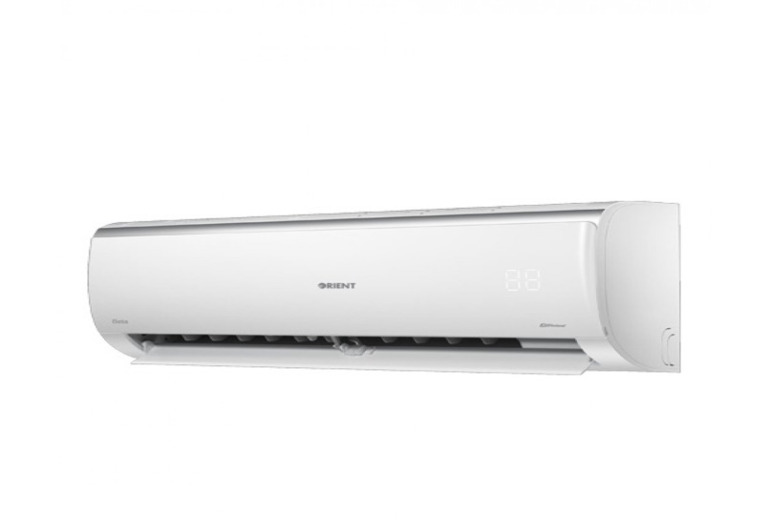

|  |  |
| --- | --- |
| **FEATURES** | **FEATURES** |
| * Full Money Back in 1 Year | * Full Money Back in 1 Year |
| * Bigger Outdoor | * Bigger Outdoor |
| * 50 Feet long Air Throw | * 50 Feet long Air Throw |
| * Low Voltage Operation (Startup at 140V) | * Low Voltage Operation (Startup at 140V) |
| * Heat and Cool | * Heat and Cool |
| * R-410A Eco Friendly | * R-410A Eco Friendly |

* .

|  |  |  |
| --- | --- | --- |
| **Weight** | | 40 kg |
| **Cooling Type** | | [ONLY Cool](https://www.alfatah.com.pk/cooling-type/heat-cool/) |
| **Cooling Capacity** | | [1.5 Ton](https://www.alfatah.com.pk/cooling-capacity/1-5-ton/) |
| **Technology** | | [Inverter](https://www.alfatah.com.pk/technology/inverter/) |
| **Air Conditioner Type** | | [Wall Mounted Split](https://www.alfatah.com.pk/air-conditioner-type/wall-mounted-split/) |
|  |  |

Taste a slice of the future with the Smart Edition of Ultron Plus 1.5. It’s company-fitted Smart Wi-Fi Kit gives you immediate access to the AC’s online control system. You can easily schedule when you want to turn the AC’s cooling/heating functions on and off via voice and text control. Moreover, it comes with all the features that its original edition has. International level PCB circuitry ensures the SC functions smoothly and reliably. A 50-feet long air throw ensures that even the remotest corners of your room are cooled to perfection. In short, this is the perfect Orient Inverter AC, powered with Smart capabilities, to help you relax for longer periods of time.