Harvel Electric

It is the best company which provides you the best electric appliances all over the world.

Our Products

Our products are geniune we import our products from malysia, nigerya, japan, indonesia, america & much more.

Claim Warranty

You can claim waranty at your nearest shop we provide our best make you satisfy for our products. Broken appliances will not be claimed.

Information Technology Solutions

Key Features

AddWash

Bubble Soak

Bubble technology

Child Lock

HOME CLEANER-PANASONIC-MC-325

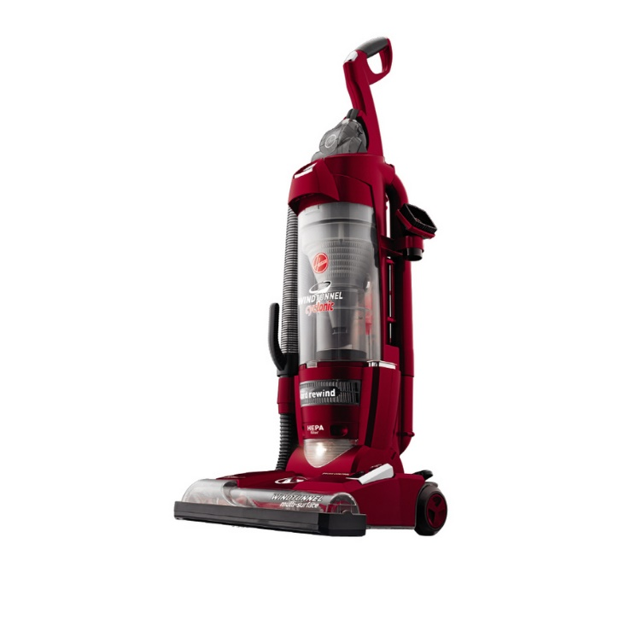Delay End

Diamond Drum

Last Memory

## Key Features

* SmartThinQ® Technology
* Cleaning Diary
* HomeGuard™
* HomeView™
* Magnetic Wall
* 7 Smart Cleaning Modes

Inverter Motor

Quick Wash

Smart Check

Spin Speed 1400 rpm

Super SpeedSmartphone App

Think she'll see your dirty floor? Think Again.

PANASONIC Hom-Bot vacuums come equipped with SmartThinQ® technology, so you can control them using an app on your smartphone, or using voice commands with the Google Assistant or Amazon Alexa. Now you can start and stop cleaning, check the status of a cleaning cycle and be ready for any last-minute guests with the push of a button.

Harvel-Electric

Life is easy with harvel

|  |
| --- |
| The Smarter, Quietest Clean. |
| PANASONIC Hom-Bot is a truly intelligent robotic vacuum with wi-fi capabilities, giving users total control using a smartphone. And while Hom-Bot’s cleaning technology makes people take notice, thanks to an innovative design that absorbs vibrations and reduces noise, it’s the quietest robot vacuum on the market on non-carpeted floors.* |  |
| The Smarter, Quietest Clean. | [1.5 Ton](https://www.alfatah.com.pk/cooling-capacity/1-5-ton/) |
| LG Hom-Bot is a truly intelligent robotic vacuum with wi-fi capabilities, giving users total control using a smartphone. And while Hom-Bot’s cleaning technology makes people take notice, thanks to an innovative design that absorbs vibrations and reduces noise, it’s the quietest robot vacuum on the market on non-carpeted floors.* | [C onventional](https://www.alfatah.com.pk/technology/conventional/) |
| The Smarter, Quietest Clean. | [Wall Mounted Split](https://www.alfatah.com.pk/air-conditioner-type/wall-mounted-split/) |

Harvel - Electric