Harvel Electric

It is the best company which provides you the best electric appliances all over the world.

Our Products

Our products are geniune we import our products from malysia, nigerya, japan, indonesia, america & much more.

Claim Warranty

You can claim waranty at your nearest shop we provide our best make you satisfy for our products. Broken appliances will not be claimed.

Information Technology Solutions

Key Features

AddWash

Bubble Soak

Bubble technology

Child Lock

JUCIER MACHINE-PANASONIC-MJ-J1760P

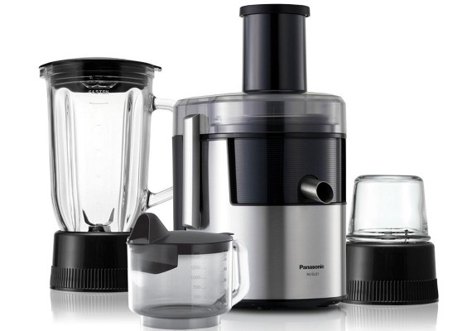Delay End

Diamond Drum

Last Memory

Inverter Motor

Quick Wash

Smart Check

Spin Speed 1400 rpm

* **Juicer Blender:**
* 3-in-1 Functions (Juicer/Blender/Mill). Full Metal Stainless Steel Spinner. Titanium Saber Cutter. Self-Ventilating Inner Cap. Built-In Circuit Breaker. Clear Glass Container.
* **Full Metal Stainless Steel Spinner:**
* Because it is made entirely of stainless steel,it can rotate at high speed to extract more juice than ever before. The metal design also means there is minimal clogging and nicking of blades so they stay sharp longer.

Super SpeedSmartphone App

|  |  |
| --- | --- |
| **Base** | Dry |
| **Capacity** | 50 g |
| **Material** | Glass |
| **Cutter Material** | Titanium  Coated  Cutter |
| **Power Control** | 2 Speed  + Pulse |
| **Switch Type** | Piano |
| **Juicer** | Yes |
| **Blender Safety Lock** | Yes |
| **Circuit Breaker** | Yes |

|  |  |  |  |
| --- | --- | --- | --- |
|  | |  | |
| **Power** | | [400W](https://www.alfatah.com.pk/power/920w/) | |
| **Weight** | | 20 kg | |
| **Power** | | [920W](https://www.alfatah.com.pk/power/920w/) | |
| **Weight** | |
|  | |  | |
| The Smarter, Quietest Clean. | |  | |
| LG Hom-Bot is a truly intelligent robotic vacuum with wi-fi capabilities, giving users total control using a smartphone. And while Hom-Bot’s cleaning technology makes people take notice, thanks to an innovative design that absorbs vibrations and reduces noise, it’s the quietest robot vacuum on the market on non-carpeted floors.* | | [C onventional](https://www.alfatah.com.pk/technology/conventional/) | |
| The Smarter, Quietest Clean. | | [Wall Mounted Split](https://www.alfatah.com.pk/air-conditioner-type/wall-mounted-split/) | |

Harvel - Electric

Harvel-Electric

Life is easy with harvel