Harvel Electric

It is the best company which provides you the best electric appliances all over the world.

Our Products

Our products are geniune we import our products from malysia, nigerya, japan, indonesia, america & much more.

Claim Warranty

You can claim waranty at your nearest shop we provide our best make you satisfy for our products. Broken appliances will not be claimed.

Information Technology Solutions

Key Features

AddWash

Bubble Soak

Bubble technology

Child Lock

LED TV’S-PANASONIC-TH-9055Y

Delay End

2 Years  Electronic Warranty

* Panasonic 50inch LED TV
* Full HD resolution
* 200Hz frequency scanning technology
* IPS LED super bright widescreen panel
* Synchronize digital content from USB and HDMI
* Automatic backlight adjustment for optimum image
* Hexa Chroma Drive processor for realistic and natural images

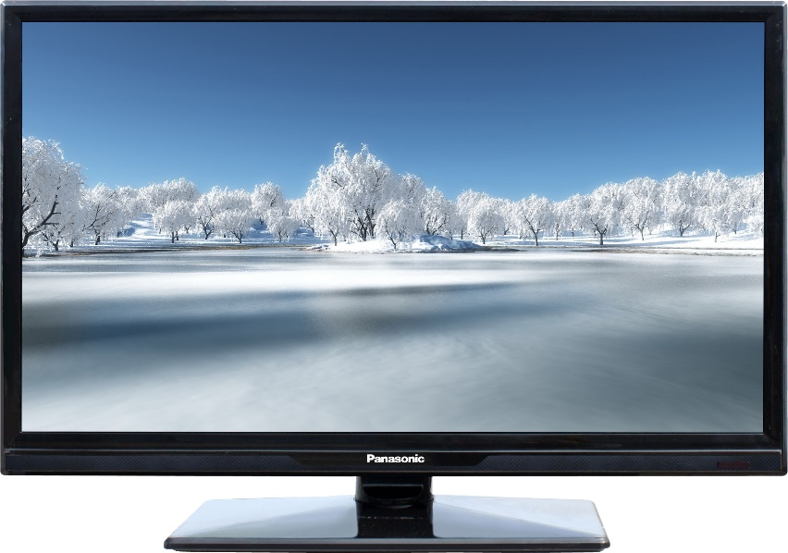Diamond Drum

Last Memory

Inverter Motor

Quick Wash

Smart Check

Spin Speed 1400 rpm

Super SpeedSmartphone App

**Media Player**

**Easy viewing of photos you took in a large size**

Content stored in a USB memory stick can easily be played back on Viera's large screen. Playy back music, photos and videos from USB

**Connect your HDMI devices**

Featuring multiple HDMI ports. Multiple devices such as a BD player and the newest game machines, can be simultaneously connected with HDMI Cables. This opens the door to advanced AV entertainment.

|  |  |  |  |
| --- | --- | --- | --- |
| **Weight** | | 40 kg | |
| **Screensize** | | [50 Inches](https://www.alfatah.com.pk/screensize/32-inches/) | |
| **Power Saving Mode** | | [Yes](https://www.alfatah.com.pk/power-saving-mode/yes/) | |
| **Resolution** | | [HD Ready (720p)](https://www.alfatah.com.pk/resolution/hd-ready-720p/) | |
|  | |
|  | |  | |
| The Smarter, Quietest Clean. | |  | |
| LG Hom-Bot is a truly intelligent robotic vacuum with wi-fi capabilities, giving users total control using a smartphone. And while Hom-Bot’s cleaning technology makes people take notice, thanks to an innovative design that absorbs vibrations and reduces noise, it’s the quietest robot vacuum on the market on non-carpeted floors.* | | [C onventional](https://www.alfatah.com.pk/technology/conventional/) | |
| The Smarter, Quietest Clean. | | [Wall Mounted Split](https://www.alfatah.com.pk/air-conditioner-type/wall-mounted-split/) | |

Harvel-Electric

Life is easy with harvel

Harvel - Electric