Harvel Electric

It is the best company which provides you the best electric appliances all over the world.

Our Products

Our products are geniune we import our products from malysia, nigerya, japan, indonesia, america & much more.

Claim Warranty

You can claim waranty at your nearest shop we provide our best make you satisfy for our products. Broken appliances will not be claimed.

Information Technology Solutions

Harvel-Electric

Life is easy with harvel

Harvel - Electric

GREE – AC 16CITH3

HSU1HNF

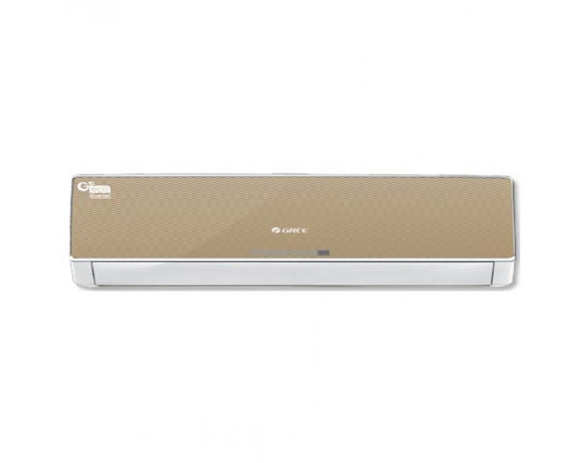

|  |  |
| --- | --- |
| **Weight** | 70 kg |
| **Air Conditioner Type** | [Wall Mounted Split](https://www.alfatah.com.pk/air-conditioner-type/wall-mounted-split/) |
| **Cooling Type** | [Heat & Cool](https://www.alfatah.com.pk/cooling-type/heat-cool/) |
|  |  |
|  |  |