Harvel Electric

It is the best company which provides you the best electric appliances all over the world.

Our Products

Our products are geniune we import our products from malysia, nigerya, japan, indonesia, america & much more.

Claim Warranty

You can claim waranty at your nearest shop we provide our best make you satisfy for our products. Broken appliances will not be claimed.

Information Technology Solutions

Harvel-Electric

Life is easy with harvel

Harvel - Electric

GREE – AC A12CHF

HSU1HNF

|  |  |
| --- | --- |
| FEATURES | **FEATURES** |
| * 1.5 TON | * Full Money Back in 1 Year |
| * Dual Air Relay | * Bigger Outdoor |
| * Compact Artistic Design | * 50 Feet long Air Throw |
| Key Features | * Low Voltage Operation (Startup at 140V) |
| * Inverter Compressor | * Heat and Cool |
| * Energy Saving | * R-410A Eco Friendly |

* .

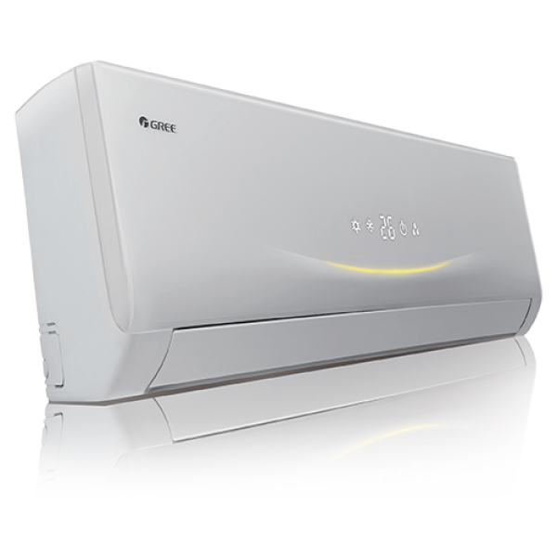

|  |  |
| --- | --- |
| **Weight** | 70 kg |
| **Cooling Capacity** | [1.5 Ton](https://www.alfatah.com.pk/cooling-capacity/1-5-ton/) |
| **Cooling Type** | [Heat & Cool](https://www.alfatah.com.pk/cooling-type/heat-cool/) |
| **Air Conditioner Type** | [Wall Mounted Split](https://www.alfatah.com.pk/air-conditioner-type/wall-mounted-split/) |
| **Technology** | [Inverter](https://www.alfatah.com.pk/technology/inverter/) |

In split ac category GREE ac range has undoubtedly got major market share due to its energy efficiency, new and improvised feature, environment and health friendly and price efficient as compare to any other ac price in Pakistan. With the passage of time we have bring innovations in our ac and now most of our AC have now both cool and heat function and can be used in both winters and summers.pressor.