Harvel Electric

It is the best company which provides you the best electric appliances all over the world.

Our Products

Our products are geniune we import our products from malysia, nigerya, japan, indonesia, america & much more.

Claim Warranty

You can claim waranty at your nearest shop we provide our best make you satisfy for our products. Broken appliances will not be claimed.

Information Technology Solutions

Harvel-Electric

Life is easy with harvel

Harvel - Electric

LG – AC A18CMH

HSU1HNF

|  |  |
| --- | --- |
| Key Features | **FEATURES** |
| * DUAL Inverter Compressor™ | * Wall mounted split type air-conditioner |
| * 70% Energy Saving | * Inverter technology |
| * 40% Faster Cooling | * Heat & Cool |
| Key Features | * Stylish flat panel |
| * DUAL Inverter Compressor™ | * Heat and Cool |
| * 70% Energy Saving | * R-410A Eco Friendly |

* .

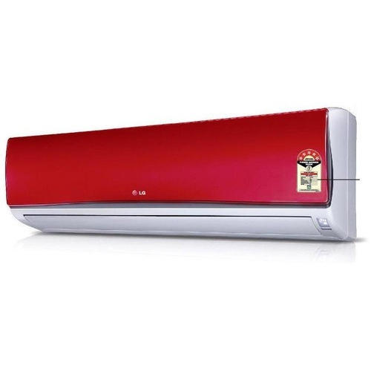

|  |  |  |
| --- | --- | --- |
| **Weight** | | 45 kg |
| **Technology** | | [Inverter](https://www.alfatah.com.pk/technology/inverter/) |
| **Air Conditioner Type** | | [Wall Mounted Split](https://www.alfatah.com.pk/air-conditioner-type/wall-mounted-split/) |
| **Cooling Capacity** | | [1.5 Ton](https://www.alfatah.com.pk/cooling-capacity/2-0-ton/) |
| **Cooling Type** | | [Heat & Cool](https://www.alfatah.com.pk/cooling-type/heat-cool/) |
| **Weight** | 70 kg |

### Stylish ARTCOOL Design

The LG Artcool air conditioner is designed to be harmonized with the interior of your home with minimal and basic style. The mirror glass on the front of the product reflects the surrounding environment to emphasize the interior and the integrity, and it delivers timeless beauty through the solidity of the glass material.