Harvel Electric

It is the best company which provides you the best electric appliances all over the world.

Our Products

Our products are geniune we import our products from malysia, nigerya, japan, indonesia, america & much more.

Claim Warranty

You can claim waranty at your nearest shop we provide our best make you satisfy for our products. Broken appliances will not be claimed.

Information Technology Solutions

Harvel-Electric

Life is easy with harvel

Harvel - Electric

DAWLANCE – AC FGRQ08L3T1

HSU1HNF

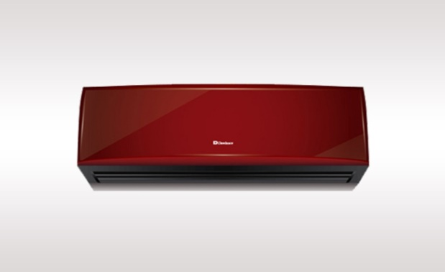

|  |  |
| --- | --- |
| **Brand** | dawlance |
| **Model ID** | GRQ09ln8 |
| **Product Code** | LAFfAIE5Y52 |
| **Type** | SPLIT AC |
| **Capacity** | 1.5 Ton |
| **Energy Rating** | 5 Star |
| **Inverter AC** | No |

* .

## Key Features

http://www.dawlance.com.pk/assets/images/icons/12.155-volts.png

Low voltage start up technology- runs perfectly on low voltage (155V).

http://www.dawlance.com.pk/assets/images/icons/13.-3-mode-operation.png

3 mode operation: sleep mode, soft dry operation mode, cool mode

http://www.dawlance.com.pk/assets/images/icons/4.Auto-Restart.png

Auto restart function

http://www.dawlance.com.pk/assets/images/icons/15.-turbo-mode-for-cooling.png

Turbo-mode for quick cooling

Voltage fluctuations and power shutdowns have become a daily occurrence. Our LVS air-conditioner helps you protect your appliances from heavy voltage fluctuations. Its smart technology is capable of operating at as low as 155V and saves you additional costs of buying stabilizers.