Air conditioners often use a fan to distribute the conditioned air to an occupied space such as a building or a car to improve thermal comfort and indoor air quality. Electric refrigerant-based AC units range from small units that can cool a small bedroom, which can be carried by a single adult, to massive units installed on the roof of office towers that can cool an entire building. The cooling is typically achieved through a refrigeration cycle, but sometimes evaporation or free cooling is used.

Harvel Electric

It is the best company which provides you the best electric appliances all over the world.

Our Products

Our products are geniune we import our products from malysia, nigerya, japan, indonesia, america & much more.

Claim Warranty

You can claim waranty at your nearest shop we provide our best make you satisfy for our products. Broken appliances will not be claimed.

|  |  |
| --- | --- |
| **Weight 70KG** | 70 kg |
| **Cooling Type COOL ONLY** | [Cool Only](https://www.alfatah.com.pk/cooling-type/cool-only/) |
| **Cooling Capacity 1.5 TON** | [1.5 Ton](https://www.alfatah.com.pk/cooling-capacity/1-5-ton/) |
| **Technology CONVENTIONAL** | [Conventional](https://www.alfatah.com.pk/technology/conventional/) |
| **Air Conditioner Type WALL MOUNTED SPLIT** | [Wall Mounted Split](https://www.alfatah.com.pk/air-conditioner-type/wall-mounted-split/) |

Information Technology Solutions

**FEATURES**

* Capacity 18K BTU
* Cool Only
* Four way Air Throw
* Healthy negative Ions
* Auto restart
* Sleep Mode
* Easy Clean Design
* Bacteria-killing medium
* Intelligent air flow
* Auto mode
* 24 Hour on/off
* LED Display

.

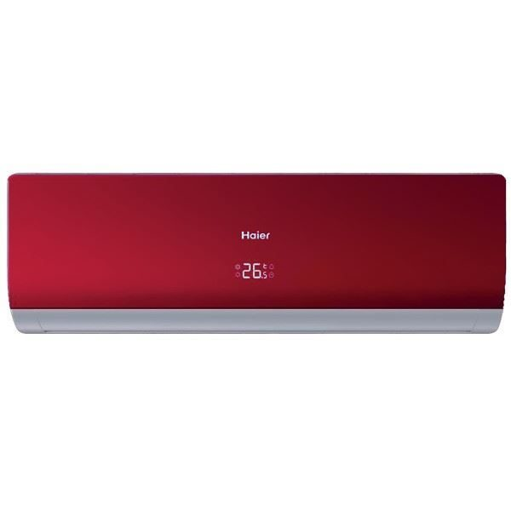

Harvel-Electric

Life is easy with harvel

Haier - AC 120f

Harvel - Electric