Harvel Electric

It is the best company which provides you the best electric appliances all over the world.

Our Products

Our products are geniune we import our products from malysia, nigerya, japan, indonesia, america & much more.

Claim Warranty

You can claim waranty at your nearest shop we provide our best make you satisfy for our products. Broken appliances will not be claimed.

Information Technology Solutions

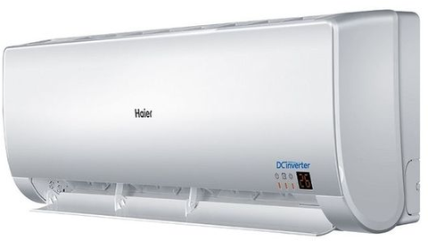

* Unlike most ACs, FGRQ08L3T1 the also has a vent that can mix in about 10 percent fresh, outdoor air, if you choose to open it. It’s a good idea to get new air into your home from time to time, so if you can’t open the window while the AC is installed, this is a fine workaround
* .

Harvel-Electric

Life is easy with harvel

Harvel - Electric

Haier – AC FGRQ08L3T1

|  |  |
| --- | --- |
| **Weight 40 KG** | 70 kg |
| **Cooling Type COOL ONLY** | [Cool Only](https://www.alfatah.com.pk/cooling-type/cool-only/) |
| **Cooling Capacity 2 TON** | [1.5 Ton](https://www.alfatah.com.pk/cooling-capacity/1-5-ton/) |
| **Technology CONVENTIONAL** | [Conventional](https://www.alfatah.com.pk/technology/conventional/) |
| **Air Conditioner Type SPLIT AC** | [Wall Mounted Split](https://www.alfatah.com.pk/air-conditioner-type/wall-mounted-split/) |

If you’re buying an air conditioner for your bedroom and don’t mind paying a little extra, treat yourself to the **Frigidaire Gallery FGRQ08L3T1**. It’s the quietest window AC we’ve tested over the past few years. It’s also easy to install, and it comes with plenty of extra foam for insulation. In cooling performance, it’s on a par with our pick and runner-up; in price, it’s usually higher than our pick by as much as $100. By June 2017, this model had sold out for the season, so you may need to act fast if you’re interested in it this year.

.