Harvel Electric

It is the best company which provides you the best electric appliances all over the world.

Our Products

Our products are geniune we import our products from malysia, nigerya, japan, indonesia, america & much more.

Claim Warranty

You can claim waranty at your nearest shop we provide our best make you satisfy for our products. Broken appliances will not be claimed.

Information Technology Solutions

Harvel-Electric

Life is easy with harvel

Harvel - Electric

ORIENT – AC GFQ50F

HSU1HNF

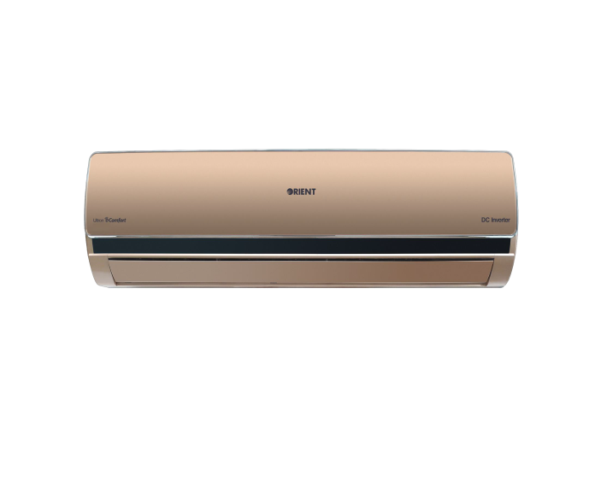

|  |  |
| --- | --- |
| **FEATURES** | **FEATURES** |
| * Factory installed Wi-Fi Kit | * Factory installed Wi-Fi Kit |
| * Built-in Energy Meter | * Built-in Energy Meter |
| * Electricity Consumption Management | * Electricity Consumption Management |
| * Online Control | * Online Control |
| * Schedule Management | * Schedule Management |
| * Biggest Indoor (Available in Market) | * Biggest Indoor (Available in Market) |

* .

|  |  |  |
| --- | --- | --- |
| **Weight** | | 70 kg |
| **Cooling Type** | | [Heat & Cool](https://www.alfatah.com.pk/cooling-type/heat-cool/) |
| **Cooling Capacity** | | [1.5 Ton](https://www.alfatah.com.pk/cooling-capacity/1-5-ton/) |
| **Technology** | | [Inverter](https://www.alfatah.com.pk/technology/inverter/) |
| **Air Conditioner Type** | | [Wall Mounted Split](https://www.alfatah.com.pk/air-conditioner-type/wall-mounted-split/) |
|  |  |

Keeping with our tradition to offer the very best in the consumer electronics market, we’re now letting you live a wonderfully smart life with the Ultron Classic Smart Edition! This all-new version of our Ultron Classic DC Inverter comes with an already installed Smart Wi-Fi Kit – which means that your AC is already online-powered. All you have to do is connect it with the MEVRIS app to begin tracking its consumption data in real time and for schedule management.