Harvel Electric

It is the best company which provides you the best electric appliances all over the world.

Our Products

Our products are geniune we import our products from malysia, nigerya, japan, indonesia, america & much more.

Claim Warranty

You can claim waranty at your nearest shop we provide our best make you satisfy for our products. Broken appliances will not be claimed.

Information Technology Solutions

Harvel-Electric

Life is easy with harvel

Harvel - Electric

ORIENT – AC QA956SIM

HSU1HNF

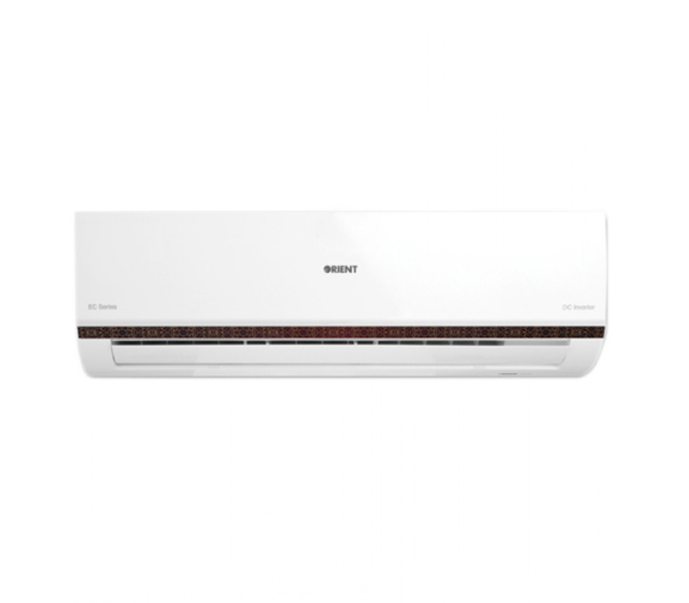

|  |  |
| --- | --- |
| **FEATURES:** | **FEATURES** |
| * Contemporary Black Patterned Design | * Full Money Back in 1 Year |
| * Full Money Back | * Bigger Outdoor |
| * R410 Environment friendly Refrigerant | * 50 Feet long Air Throw |
| * Low Voltage upto 150v | * Low Voltage Operation (Startup at 140V) |
| * Energy Saving Upto 60% | * Heat and Cool |
| * Double Layer Condenser | * R-410A Eco Friendly |

* .

|  |  |  |
| --- | --- | --- |
| **Weight** | | 70 kg |
| **Air Conditioner Type** | | [Wall Mounted Split](https://www.alfatah.com.pk/air-conditioner-type/wall-mounted-split/) |
| **Cooling Capacity** | | [1.5 Ton](https://www.alfatah.com.pk/cooling-capacity/1-5-ton/) |
| **Cooling Type** | | [Heat & Cool](https://www.alfatah.com.pk/cooling-type/heat-cool/) |
| **Technology** | | [Inverter](https://www.alfatah.com.pk/technology/inverter/) |
| **Weight** | 70 kg |

Keeping with our tradition to offer the very best in the consumer electronics market, we’re now letting you live a wonderfully smart life with the Ultron Classic Smart Edition! This all-new version of our Ultron Classic DC Inverter comes with an already installed Smart Wi-Fi Kit – which means that your AC is already online-powered. All you have to do is connect it with the MEVRIS app to begin tracking its consumption data in real time and for schedule management. In addition, it has everything you’ve come to expect from the typical Orient AC – reliability, efficiency, powerful heating/cooling, energy savings, international level technicalities and an exterior that will leave your guests feeling envious.