Harvel Electric

It is the best company which provides you the best electric appliances all over the world.

Our Products

Our products are geniune we import our products from malysia, nigerya, japan, indonesia, america & much more.

Claim Warranty

You can claim waranty at your nearest shop we provide our best make you satisfy for our products. Broken appliances will not be claimed.

Information Technology Solutions

Harvel-Electric

Life is easy with harvel

Harvel - Electric

|  |  |
| --- | --- |
| **FEATURES** | **FEATURES** |
| * Full DC Inverter | * Full Money Back in 1 Year |
| * Ultron Series | * Bigger Outdoor |
| * Heat & Cool | * 50 Feet long Air Throw |
| * Wall mounted split type air-conditioner | * Low Voltage Operation (Startup at 140V) |
| * Inverter technology | * Heat and Cool |
| * Double Layer Condenser | * R-410A Eco Friendly |

* .

ORIENT – AC FAS59K

HSU1HNF

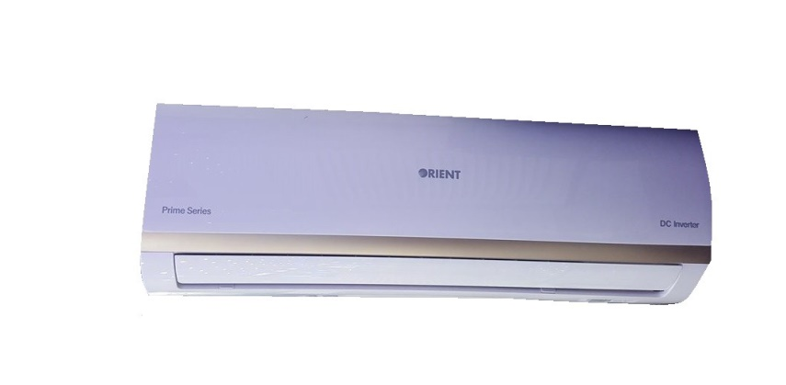

|  |  |  |
| --- | --- | --- |
| **Weight** | | 70 kg |
| **Air Conditioner Type** | | [Wall Mounted Split](https://www.alfatah.com.pk/air-conditioner-type/wall-mounted-split/) |
| **Technology** | | [Inverter](https://www.alfatah.com.pk/technology/inverter/) |
| **Cooling Capacity** | | [1.5 Ton](https://www.alfatah.com.pk/cooling-capacity/1-5-ton/) |
| **Cooling Type** | | [Heat & Cool](https://www.alfatah.com.pk/cooling-type/heat-cool/) |
| **Weight** | 70 kg |

Need an air conditioner that cools quicker, farther and wider than ever before? Orient presents the all-new Jupiter DC Inverter AC whose exceptional design is tailor-made for greater efficiency and dynamic cooling. Jupiter’s comfortable cooling system ensures that he temperature remains stable at precisely the number you want, preventing under-cooling as well as over-cooling. While using the minimum amount of energy, Jupiter ensures you enjoy a relaxed and pleasant atmosphere. Jupiter’s built to last a lifetime, with the AC’s interior and exterior units built from tough constituents that’re able to withstand wear and tear over time. Bring home Orient’s latest innovation and change your life for the better.