Harvel Electric

It is the best company which provides you the best electric appliances all over the world.

Our Products

Our products are geniune we import our products from malysia, nigerya, japan, indonesia, america & much more.

Claim Warranty

You can claim waranty at your nearest shop we provide our best make you satisfy for our products. Broken appliances will not be claimed.

Information Technology Solutions

Key Features

AddWash

Bubble Soak

Bubble technology

Child Lock

TOASTER-KENWOOD-TT-440

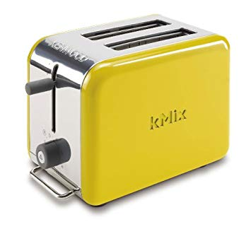Delay End

* This TWO-slice toaster from KENWOOD offers two separate heating mechanisms, so you can customize each person's toast based on personal preference.
* Automatic backlight adjustment for optimum image
* Hexa Chroma Drive processor for realistic and natural images

Diamond Drum

Last Memory

Inverter Motor

Quick Wash

Smart Check

Spin Speed 1400 rpm

Super SpeedSmartphone App

|  |  |  |  |
| --- | --- | --- | --- |
| **Weight** | | 3 kg | |
| **Power** | | [920W](https://www.alfatah.com.pk/power/920w/) | |
| **Weight** | | 20 kg | |
| **Power** | | [920W](https://www.alfatah.com.pk/power/920w/) | |
| **Weight** | |
|  | |  | |
| The Smarter, Quietest Clean. | |  | |
| LG Hom-Bot is a truly intelligent robotic vacuum with wi-fi capabilities, giving users total control using a smartphone. And while Hom-Bot’s cleaning technology makes people take notice, thanks to an innovative design that absorbs vibrations and reduces noise, it’s the quietest robot vacuum on the market on non-carpeted floors.* | | [C onventional](https://www.alfatah.com.pk/technology/conventional/) | |
| The Smarter, Quietest Clean. | | [Wall Mounted Split](https://www.alfatah.com.pk/air-conditioner-type/wall-mounted-split/) | |

**FEATURES**

* 2 slot 2 slice stainless steel toaster
* Variable width slots for toasting thick and thin slices, bagels, crumpets etc
* Coolwall body for added safety
* Hi-rise bread lift makes it easier to remove small slices, crumpets etc
* Mid cycle cancel button for added safety
* Safety auto stop switches machine off at end of cycle if bread becomes jammed
* Integral bun warmer
* Variable browning control dial with setting for bun warmer
* Slide out crumb tray for easy cleaning
* Made by Kenwood

Harvel-Electric

Life is easy with harvel

Harvel - Electric