Harvel Electric

It is the best company which provides you the best electric appliances all over the world.

Our Products

Our products are geniune we import our products from malysia, nigerya, japan, indonesia, america & much more.

Claim Warranty

You can claim waranty at your nearest shop we provide our best make you satisfy for our products. Broken appliances will not be claimed.

Information Technology Solutions

Key Features

AddWash

Bubble Soak

Bubble technology

Child Lock

WASHING MACHINE-LG-KHJ3556

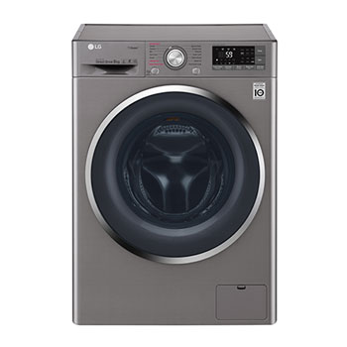Delay End

Features

* One touch operation ease of use
* Power resumption memory, which saves time and energy
* Supersonic technology for greater washing effect
* Customized wash option
* 2 steps clean
* Child safety lock
* Digital control technology

Diamond Drum

Last Memory

Inverter Motor

Quick Wash

Smart Check

Spin Speed 1400 rpm

Super SpeedSmartphone App

|  |
| --- |
| Key Features |
|  |  |
| I Novate – Dawlance Machine judge your clothes’ weight & material and provide appropriate washing state | [1.5 Ton](https://www.alfatah.com.pk/cooling-capacity/1-5-ton/) |
|  | [C onventional](https://www.alfatah.com.pk/technology/conventional/) |
| 3D Wash Action | [Wall Mounted Split](https://www.alfatah.com.pk/air-conditioner-type/wall-mounted-split/) |

The LG washing machine helps you save a huge amount of energy by washing large loads at low temperatures using its Eco Bubble™ technology. Before the normal cycle begins, the unique bubble generator starts working.

Harvel-Electric

Life is easy with harvel

Harvel - Electric