## Wash Cool, Save Energy

Save a huge amount of energy* by washing large loads at low temperatures using Eco Bubble™ technology. Bubbles activate detergent, so it quickly penetrates fabric and removes dirt easily – even in cool water (15 °C).

Harvel Electric

It is the best company which provides you the best electric appliances all over the world.

Our Products

Our products are geniune we import our products from malysia, nigerya, japan, indonesia, america & much more.

Claim Warranty

You can claim waranty at your nearest shop we provide our best make you satisfy for our products. Broken appliances will not be claimed.

Information Technology Solutions

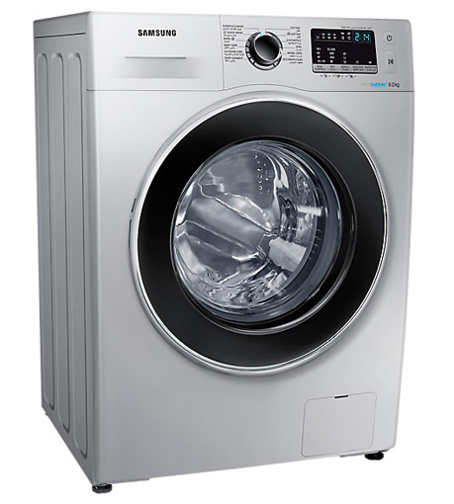

WASHING MACHINE-SAMSUNG-WW80J4260

|  |  |
| --- | --- |
| Specifications | 70 kg |
| **Type** | [Cool Only](https://www.alfatah.com.pk/cooling-type/cool-only/) |
| Automatic EcoBubble Technology | [1.5 Ton](https://www.alfatah.com.pk/cooling-capacity/1-5-ton/) |
| **Capacity 8KG** | [C onventional](https://www.alfatah.com.pk/technology/conventional/) |
|  | [Wall Mounted Split](https://www.alfatah.com.pk/air-conditioner-type/wall-mounted-split/) |

Key Features

* Wash Cool, Save Energy
* Intensive Stain Removal
* Beautifully elegant design
* Bubble technology
* EcoBubble
* Diamond Drum
* Easy Trouble-Shooting by Smart App
* Chemical-Free Drum Sanitization
* Quick Wash for Small Load
* Gentle Fabric Care

.

Harvel-Electric

Life is easy with harvel

Harvel - Electric