## Wash Cool, Save Energy

Save a huge amount of energy* by washing large loads at low temperatures using Eco Bubble™ technology. Bubbles activate detergent, so it quickly penetrates fabric and removes dirt easily – even in cool water (15 °C).

Harvel Electric

It is the best company which provides you the best electric appliances all over the world.

Our Products

Our products are geniune we import our products from malysia, nigerya, japan, indonesia, america & much more.

Claim Warranty

You can claim waranty at your nearest shop we provide our best make you satisfy for our products. Broken appliances will not be claimed.

Information Technology Solutions

Key Features

AddWash

Bubble Soak

Bubble technology

Child Lock

Delay End

Diamond Drum

Last Memory

WASHING MACHINE-SAMSUNGWW90K6410

Inverter Motor

Quick Wash

Smart Check

* Key Features
* AddWash
* Bubble Soak
* Bubble technology
* Child Lock
* Delay End
* Diamond Drum
* Last Memory
* Inverter Motor
* Quick Wash
* Smart Check
* Spin Speed 1400 rpm
* Super Speed
* Smartphone App

Spin Speed 1400 rpm

Super Speed

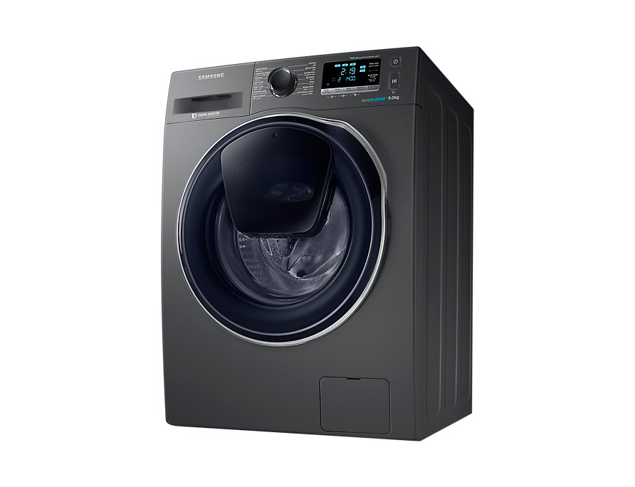Smartphone App

|  |  |
| --- | --- |
| Specifications | 70 kg |
| **Type** | [Cool Only](https://www.alfatah.com.pk/cooling-type/cool-only/) |
| Automatic EcoBubble Technology | [1.5 Ton](https://www.alfatah.com.pk/cooling-capacity/1-5-ton/) |
| **Capacity 10KG** | [C onventional](https://www.alfatah.com.pk/technology/conventional/) |
|  | [Wall Mounted Split](https://www.alfatah.com.pk/air-conditioner-type/wall-mounted-split/) |

Harvel-Electric

Life is easy with harvel

Harvel - Electric