Harvel Electric

It is the best company which provides you the best electric appliances all over the world.

Our Products

Our products are geniune we import our products from malysia, nigerya, japan, indonesia, america & much more.

Claim Warranty

You can claim waranty at your nearest shop we provide our best make you satisfy for our products. Broken appliances will not be claimed.

Information Technology Solutions

Key Features

AddWash

Bubble Soak

Bubble technology

Child Lock

Delay End

Diamond Drum

Last Memory

WASHING MACHINE-SAMSUNGWD906U4SAGD

Inverter Motor

Quick Wash

Smart Check

Features

* A cool way to clean your clothes
* Smaller Holes for Better Fabric Care
* Select your favourite settings with one touch
* Cycle through your laundry quicker
* Durable and less energy

Spin Speed 1400 rpm

Super Speed

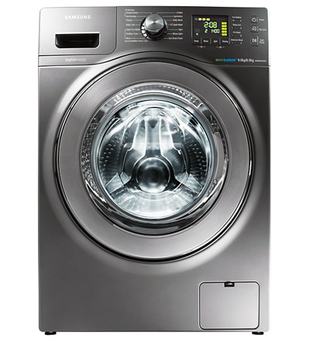Smartphone App

A washing machine that features a full-width door, with a Metal Double Hinge that opens wider, so it’s significantly easier to load and unload clothes. Its minimal frame allows it to fit perfectly within a modern style living space. Especially as its translucent Crystal Blue, created with Samsung’s unique Crystal Gloss design, refracts light to create a delightful spectrum of colours.

|  |  |
| --- | --- |
| Specifications | 70 kg |
| **Type** | [Cool Only](https://www.alfatah.com.pk/cooling-type/cool-only/) |
| Automatic EcoBubble Technology | [1.5 Ton](https://www.alfatah.com.pk/cooling-capacity/1-5-ton/) |
| **Capacity 8KG** | [C onventional](https://www.alfatah.com.pk/technology/conventional/) |
|  | [Wall Mounted Split](https://www.alfatah.com.pk/air-conditioner-type/wall-mounted-split/) |

Harvel-Electric

Life is easy with harvel

Harvel - Electric