Harvel Electric

It is the best company which provides you the best electric appliances all over the world.

Our Products

Our products are geniune we import our products from malysia, nigerya, japan, indonesia, america & much more.

Claim Warranty

You can claim waranty at your nearest shop we provide our best make you satisfy for our products. Broken appliances will not be claimed.

Information Technology Solutions

Key Features

AddWash

Bubble Soak

Bubble technology

Child Lock

WASHING MACHINE-SAMSUNGWD906U4SAGD

Delay End

Diamond Drum

Last Memory

Inverter Motor

Quick Wash

Smart Check

Features

* Active dual wash function
* Water jet function
* Wobble technology
* Magic detergent dispenser
* Smart service check
* Automatic restart function
* Diamond drum

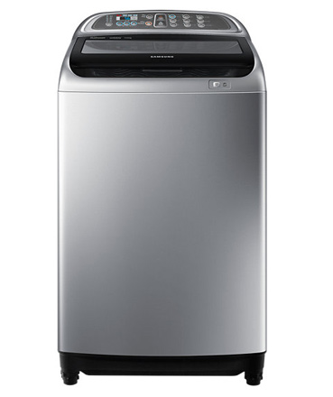Spin Speed 1400 rpm

Super Speed

Smartphone App

The Samsung washing machine helps you save a huge amount of energy by washing large loads at low temperatures using its Eco Bubble™ technology. Before the normal cycle begins, the unique bubble generator starts working.

|  |  |
| --- | --- |
| Specifications | 70 kg |
| **Type** | [Cool Only](https://www.alfatah.com.pk/cooling-type/cool-only/) |
| Automatic EcoBubble Technology | [1.5 Ton](https://www.alfatah.com.pk/cooling-capacity/1-5-ton/) |
| **Capacity 17 KG** | [C onventional](https://www.alfatah.com.pk/technology/conventional/) |
|  | [Wall Mounted Split](https://www.alfatah.com.pk/air-conditioner-type/wall-mounted-split/) |

Harvel-Electric

Life is easy with harvel

Harvel - Electric