now I want to change the approach, I want to have the server on server plafrom, not on the ardhuion, I will create a specific HTML save it there, and when I push the button on this html, it will send the information to my arduino and flip the led, I don't want the server to be on my arduino, what are the steps ?

This is a classic "IoT Architecture" shift. You are moving from a Local Server (Arduino does everything) to a Cloud-Client Model (Arduino is just a worker, and the web page lives on a professional server).
Since your Arduino is now a "Receiver" instead of a "Host," the logic changes. Here are the steps to set this up:

Step 1: Host the HTML on a Web Platform
Instead of the Arduino "reciting" the HTML from its memory, you put your .html file on a service like GitHub Pages, Netlify, or Vercel (which are often free).
- The File: Your HTML will now contain a JavaScript "Fetch" command.
- The Button: When clicked, the button doesn't ask the server for a new page; it sends a tiny "data packet" (a Request) directly to your Arduino's IP address.

Step 2: The "CORS" Challenge (Important!)
Browsers have a security feature called CORS (Cross-Origin Resource Sharing).
- The Problem: If your website is at myproject.netlify.app, the browser will block it from talking to a random IP address like 192.168.1.20 for security.
- The Fix: In your Arduino code, you must add a specific "Permission" line in the HTTP header to tell the browser: "It's okay, I trust this website."
  - client.println("Access-Control-Allow-Origin: *");

Step 3: Making the Arduino Reachable (Port Forwarding)
This is the trickiest part. If your HTML is on the "Real Internet" (the Cloud), it cannot see your Arduino because your home Router acts as a Shield.
- Local vs. Global: Your Arduino has a local IP (e.g., 192.168.1.20), but the internet only sees your Public IP.
- The Solution: You must go into your Router settings and set up Port Forwarding. You tell the router: "If any request comes from the internet on Port 80, send it straight to the Arduino at 192.168.1.20."

Step 4: Update the Arduino Code (The "Listener")
You can keep most of your current code, but you delete all the lines that print the HTML (the <style>, <body>, etc.).
- Your Arduino now only sends back a tiny confirmation message like {"status": "ok"} instead of a whole webpage.
- This makes the Arduino much faster because it’s sending 20 characters instead of 2,000.

Step 5: The JavaScript "Bridge"
In your HTML file saved on the platform, you will add a small script. It looks like this:
JavaScript
function toggleLED(state) {
// Replace with your Public IP address
fetch('http://YOUR_PUBLIC_IP/LED_BUILTIN/' + state)
.then(response => console.log("Success!"))
.catch(error => console.log("Error:", error));
}

Summary of the New Flow
- You: Open my-cool-site.com on your phone (hosted on a Cloud Platform).
- You: Click the ON button.
- The Web Page: Runs JavaScript to send a "GET" request to your Home Router.
- The Router: Sees the request and passes it to the Arduino.
- The Arduino: Sees /ON, flips the bit in the RAM Register, and the LED lights up.
One Wit-y Warning:
By opening a port in your router (Step 3), you are essentially leaving a "small window" open in your house's digital security. It’s perfectly fine for a hobby project, but it means anyone who finds your Public IP could potentially turn your LED on and off!
Would you like me to help you write the new, simplified Arduino code that only listens for the data without sending back the webpage?

yes, I want to setup a web page to control my arduion, but I don't Know the steps
Moving the server off your Arduino and onto a platform like Node.js is a professional way to build an IoT system. It allows your webpage to stay online even if your Arduino is unplugged, and it gives you a much "prettier" interface.
Here is the step-by-step roadmap to making this happen.

Step 1: The "Cloud" Web Page (The Remote Control)
Instead of the Arduino writing the HTML, you create a standard web project on your laptop.
- The Files: You’ll have an index.html (the buttons) and a style.css (the design).
- The JavaScript: Inside the HTML, you write a small script using the fetch() command. When you click a button, this script sends a "shout" over the internet to your Arduino's specific address.
- Hosting: You can upload these files to a free service like GitHub Pages or Netlify. Now, you can access your controller from any phone in the world.

Step 2: The "Gateway" (Your Router)
Since your Arduino is inside your home network, the "Cloud" page can't see it by default (your router blocks incoming strangers).
- Static IP: You must tell your router to always give your Arduino the same address (e.g., 192.168.1.20).
- Port Forwarding: You go into your router settings and "open a door." You tell it: "If a request comes from the internet for Port 80, send it directly to my Arduino."
- Public IP: You need to find your "Global" IP address (search "What is my IP" on Google). This is the address your web page will use to find your house.

Step 3: The "Worker" (Simplified Arduino Code)
You rewrite your Arduino code. It no longer needs to "recite" a whole webpage. It only needs to:
- Connect to Wi-Fi.
- Listen for a request.
- If it sees /LED/ON, it flips the RAM Register for the LED.
- Send back a tiny "OK" message (this uses much less memory).

Step 4: Adding Node.js (Optional but Recommended)
If you want to get fancy, you can put a Node.js server in the middle.
- The Flow: Web Page Node.js Server Arduino.
- Why? The Node.js server can act as a security guard. It can require a password so only you can control your lights, and it can keep a log of every time the LED was turned on.

How to start?
To get this moving, the very first thing you need is a simplified version of your Arduino code that acts as an "API" (a receiver) rather than a webpage host.
Would you like me to show you the "Simplified Receiver" code for your Arduino first, or would you prefer to start by creating the HTML file for your computer?

what is a API?
In the context of your Arduino project, an API (Application Programming Interface) is the "contract" or the "menu" that allows two different pieces of software—like your website and your Arduino—to talk to each other without needing to know how the other one works.
Think of it as a translator that sits between different systems.

1. The Restaurant Analogy (The Classic View)
Imagine you are at a restaurant:
- The User (Client): You are sitting at the table.
- The Kitchen (Server/Arduino): This is where the "work" happens (flipping the LED).
- The API (The Waiter): You don't go into the kitchen and turn on the stove yourself. Instead, you give an order to the waiter. The waiter takes that order to the kitchen, and the kitchen delivers the result back to you.

2. How it works in your Project
When you move your server to a platform like Node.js, your Arduino becomes an API Endpoint.
Instead of sending a whole webpage, the Arduino just waits for a very specific "command" (the API call).
- The Request: Your website sends a message: GET /api/led/on
- The API Logic: The Arduino sees this specific path and knows exactly which "function" to run in its code.
- The Response: Instead of sending 2,000 lines of HTML, the API sends a tiny piece of data back, like: {"status": "success"}.

3. Why use an API instead of a Web Page?
Using an API is much more powerful for a few reasons:
- Efficiency: As we discussed, the Arduino's RAM is small. Sending tiny "Data only" responses (JSON) is much easier for the hardware than building a full website.
- Universal Access: Once you have an API on your Arduino, you can control it from a Website, a Mobile App, or even another Arduino—all using the same "commands."
- Separation of Concerns: You can change the look of your website (the "Front-end") a hundred times, and you never have to touch the Arduino code (the "Back-end") because the API "contract" stays the same.

4. What does an API "Request" look like?
When your browser or Node.js server talks to an API, it usually sends four things:
- The URL: http://192.168.1.20/api/led
- The Method: GET (to ask for data) or POST (to change something).
- The Headers: "I am a browser, and I expect JSON data back."
- The Body: (Optional) Extra info, like "Set brightness to 50%."

Summary
An API is simply a set of rules. It tells the world: "If you send me a message in this specific format, I will perform this specific action and give you back this specific answer."
In your next step, we will turn your Arduino code into a "REST API." This means it will stop acting like a "Publisher" (sending magazines/webpages) and start acting like a "Vending Machine" (you press a button, and it delivers a specific result).
Does the concept of the "Waiter" (the middleman) help you see why we need an API to connect your Cloud Page to your home Arduino?

So the node.js is the API between my HTML and the arduino?
You've got the architecture exactly right! In this setup, Node.js acts as the Middleman (the API Gateway).
While you could have the HTML talk directly to the Arduino, putting Node.js in the middle is the "professional" way to do it. It creates a bridge between the wild, public internet and your private home hardware.

1. The "Chain of Command"
Here is how the data flows in your new setup:
- The User: You click a button on your HTML/JavaScript page (hosted on the web).
- The Request: The browser sends a message to your Node.js Server.
- The Brain (Node.js): Node.js receives the request. It checks if you are authorized (security) and then translates that click into a command.
- The Bridge: Node.js sends a "Private" request to your Arduino's IP address.
- The Action: The Arduino sees the command from Node.js and flips the LED Register.

2. Why put Node.js in the middle?
You might ask: "Why not just have the HTML talk to the Arduino directly?" * Security: If your HTML talks directly to the Arduino, you have to expose your Arduino to the whole internet. With Node.js, you can add a Login Page. Only people with the password can get past Node.js to reach your Arduino.
- Stability: If 100 people open your website at once, your tiny Arduino will "crash" trying to talk to all of them. Node.js can handle thousands of visitors and send only one clean command to the Arduino.
- Data Logging: Node.js can have a database. It can remember: "User 'Alex' turned on the light at 9:00 PM." The Arduino is too "forgetful" to do that.

3. What does the Node.js API look like?
In Node.js, you use a framework called Express. You write "Routes" that act as the API endpoints. It looks like this in code:
JavaScript
// This is the "Waiter" (Node.js) listening for the "Customer" (HTML)
app.get('/turn-on-led', (req, res) => {
// Node.js now calls the Arduino
fetch('http://YOUR_ARDUINO_IP/LED/ON');
res.send('Command sent to Arduino!');
});

4. Summary: The Roles
- HTML: The Interface (The steering wheel).
- Node.js: The API/Logic (The engine and computer).
- Arduino: The Actuator (The tires that actually move).
Your Next Step
To build this, you need to:
- Install Node.js LTS on your computer.
- Write a simple "Express" server script.
- Simplify your Arduino code so it only responds to the "Private" messages from Node.js.
Does this "Three-Layer" approach make sense to you, or does it feel like too many steps compared to the direct Arduino approach?

And this node.js where will be hosted?
That is a great question. Because Node.js is an actual application (unlike a simple HTML file), it needs a computer that can "run" its code 24/7. You generally have three main options for hosting it, depending on how "professional" or "local" you want to be.

Option 1: Your Own Laptop (The "Lab" Phase)
While you are developing the project, you host Node.js right on your own computer.
- How: You install Node.js LTS, run your script (e.g., node server.js), and your laptop becomes the server.
- The Catch: If you close your laptop or it goes to sleep, the "bridge" is broken, and your web page won't be able to talk to the Arduino anymore.
- Best for: Testing and learning.

Option 2: A Raspberry Pi (The "Smart Home" Phase)
If you want a permanent setup at home that doesn't require your laptop to be on, many people use a Raspberry Pi.
- How: It’s a tiny, $35 computer that stays plugged into your router. You install Node.js on it, and it runs your "bridge" code forever.
- The Benefit: It’s low-power and lives inside your house, so it can talk to your Arduino very fast without needing to go out to the "Big Internet."

Option 3: A Cloud Provider (The "Professional" Phase)
This is where you host the code on a server in a data center (like Amazon or Google).
- Services: Popular choices for Node.js are Render, Railway, or DigitalOcean.
- How it works: You upload your code to their "Cloud." Their computers stay on 24/7 and give you a public URL (like my-arduino-api.onrender.com).
- The Challenge: Since the Cloud server is "far away," you must set up Port Forwarding on your home router so the Cloud can "see" your Arduino sitting on your desk.

Summary: Where should you start?
Hosting Choice | Difficulty | Best Use Case
Your Laptop | Easy | Testing your code today.
Raspberry Pi | Medium | A permanent "Smart Home" hub.
Cloud (Render/Railway) | Harder | Controlling your LED from another city.
The "Hidden" Step
Regardless of where you host Node.js, remember this: The HTML page doesn't care where Node.js lives. It only cares about the URL or IP address of the Node.js server.
If you move Node.js from your laptop to the Cloud, you just change one line in your HTML (the URL in the fetch() command), and everything keeps working!
Which one sounds most interesting to you: keeping it local on your laptop for now, or trying to put it in the "Cloud" immediately?

This is a classic "IoT Architecture" shift. You are moving from a Local Server (Arduino does everything) to a Cloud-Client Model (Arduino is just a worker, and the web page lives on a professional server).
Since your Arduino is now a "Receiver" instead of a "Host," the logic changes. Here are the steps to set this up:

Step 1: Host the HTML on a Web Platform
Instead of the Arduino "reciting" the HTML from its memory, you put your .html file on a service like GitHub Pages, Netlify, or Vercel (which are often free).
- The File: Your HTML will now contain a JavaScript "Fetch" command.
- The Button: When clicked, the button doesn't ask the server for a new page; it sends a tiny "data packet" (a Request) directly to your Arduino's IP address.

Step 2: The "CORS" Challenge (Important!)
Browsers have a security feature called CORS (Cross-Origin Resource Sharing).
- The Problem: If your website is at myproject.netlify.app, the browser will block it from talking to a random IP address like 192.168.1.20 for security.
- The Fix: In your Arduino code, you must add a specific "Permission" line in the HTTP header to tell the browser: "It's okay, I trust this website."
  - client.println("Access-Control-Allow-Origin: *");

Step 3: Making the Arduino Reachable (Port Forwarding)
This is the trickiest part. If your HTML is on the "Real Internet" (the Cloud), it cannot see your Arduino because your home Router acts as a Shield.
- Local vs. Global: Your Arduino has a local IP (e.g., 192.168.1.20), but the internet only sees your Public IP.
- The Solution: You must go into your Router settings and set up Port Forwarding. You tell the router: "If any request comes from the internet on Port 80, send it straight to the Arduino at 192.168.1.20."

Step 4: Update the Arduino Code (The "Listener")
You can keep most of your current code, but you delete all the lines that print the HTML (the <style>, <body>, etc.).
- Your Arduino now only sends back a tiny confirmation message like {"status": "ok"} instead of a whole webpage.
- This makes the Arduino much faster because it’s sending 20 characters instead of 2,000.

Step 5: The JavaScript "Bridge"
In your HTML file saved on the platform, you will add a small script. It looks like this:

function toggleLED(state) { // Replace with your Public IP address fetch('http://YOUR_PUBLIC_IP/LED_BUILTIN/' + state) .then(response => console.log("Success!")) .catch(error => console.log("Error:", error)); }

Summary of the New Flow
- You: Open my-cool-site.com on your phone (hosted on a Cloud Platform).
- You: Click the ON button.
- The Web Page: Runs JavaScript to send a "GET" request to your Home Router.
- The Router: Sees the request and passes it to the Arduino.
- The Arduino: Sees /ON, flips the bit in the RAM Register, and the LED lights up.

can you read this folder : C:\Users\dalia\OneDrive\Documents\Arduino\402_ControlTheLEDFromTheInternet?
It contains a small full-stack project for controlling Arduino LED over internet:
- 402_ControlTheLEDFromTheInternet.ino: Arduino UNO R4 sketch that connects to Wi-Fi and polls GET /api/led every 2s, then turns built-in LED on/off.
- server.js: Express server with:
  - POST /api/login (returns token)
  - GET /api/led (returns current state)
  - POST /api/led (requires bearer token, sets state)
- Public/index.html: web UI with login/logout and ON/OFF buttons, using fetch calls to the API.
- README.md: setup, local run (npm install, npm start), Render deployment steps, and API docs.
- Also has node_modules + package-lock.json.
Quick note: I noticed one likely bug in the Arduino sketch: it declares char* password but uses WiFi.begin(ssid, pass) (uses pass, not password). If you want, I can fix that and do a quick sanity pass across this project.

I did this last time, but I don't remember how, I remember onbly that I needed to install a node.js server and a HTML, can you detail all the step?
here’s a full from-zero guide for your project (402_ControlTheLEDFromTheInternet) on Windows.
1) Install Node.js (for the web server)
- Go to https://nodejs.org
- Download LTS version.
- Install with default options.
- Verify in PowerShell:
node -v
npm -v
If both commands print versions, Node is ready.

what does node and npm do?
To understand Node.js and npm, think of them as a Construction Site. Node.js is the heavy machinery and engine that does the work, while npm is the massive warehouse of pre-built parts and tools you can borrow.

1. What is Node.js?
Normally, JavaScript only lives inside your web browser (Chrome, Safari). It’s "trapped" there to move images or handle clicks. Node.js is a "Runtime" that pulls JavaScript out of the browser and lets it run directly on your computer's operating system (Windows, Mac, or Linux).
- The Power: Because it's on your computer, JavaScript can now talk to your hard drive, manage your Wi-Fi, and control hardware like your Arduino.
- The Speed: It uses Google’s "V8" engine to turn JavaScript into machine code (the s and s the CPU understands) incredibly fast.
- The Role: It acts as the Server. It listens for requests from the internet and decides how to react.
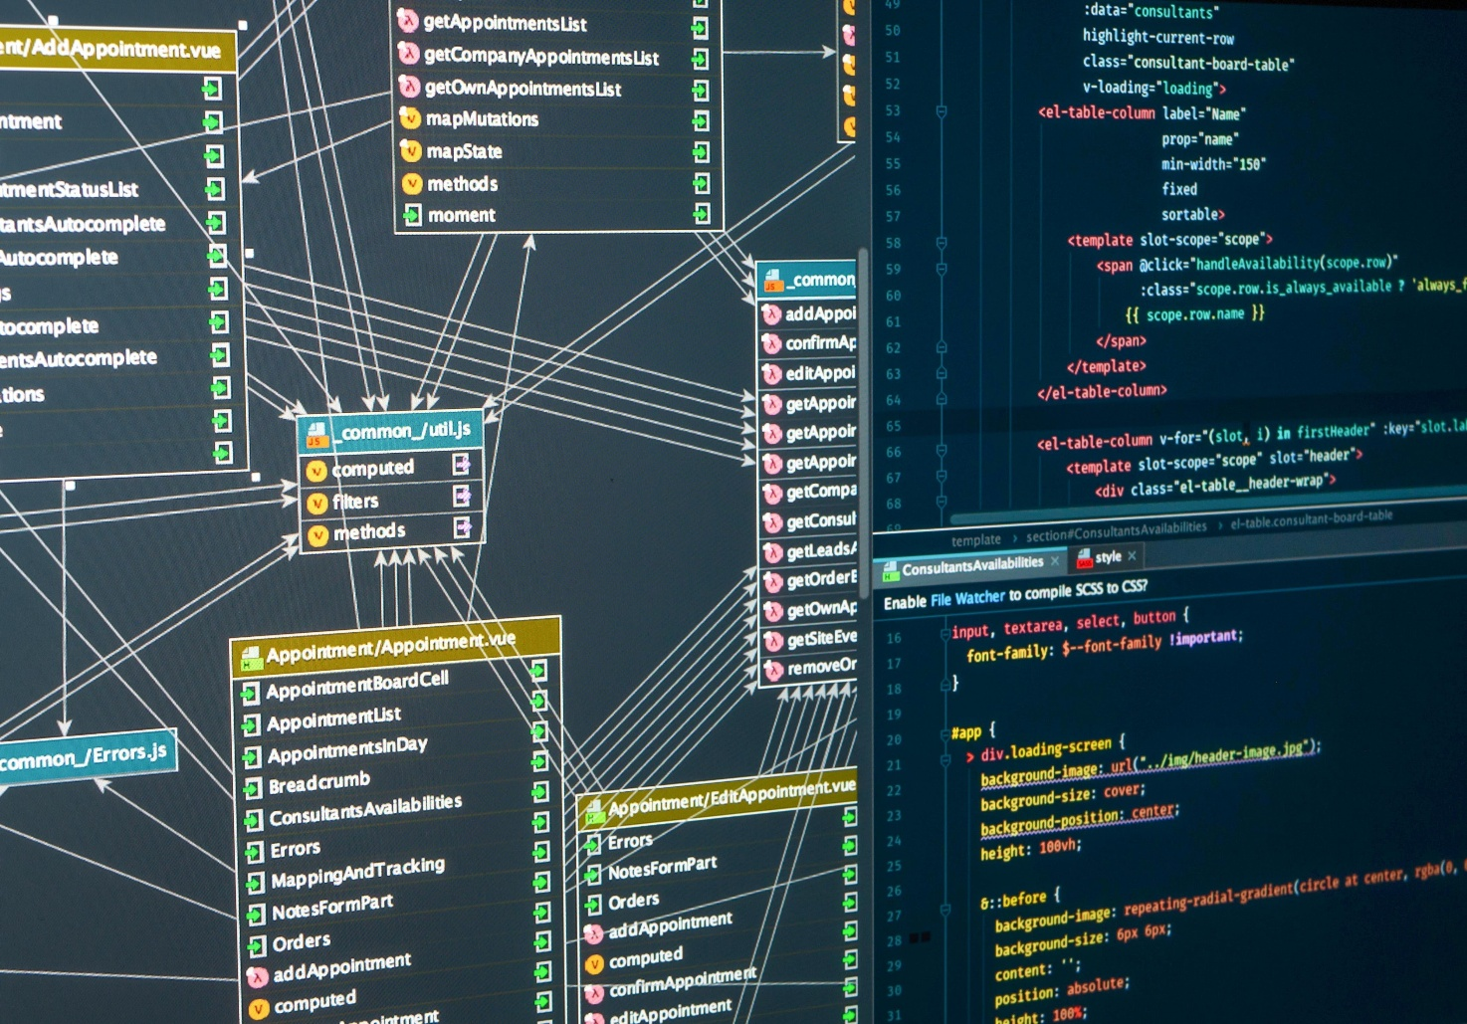
Shutterstock
Explorer

2. What is npm?
npm (Node Package Manager) is the world’s largest software registry. It is installed automatically when you install Node.js.
- The Warehouse: If you need a specific feature (like a way to handle "CORS," talk to a database, or format dates), you don't have to write it from scratch. Someone has already built a "Package" for it.
- The Assistant: You use the command line (like npm install express) to ask npm to go to the internet, find that tool, and download it into your project folder.
- Dependency Management: It keeps track of every tool your project needs in a file called package.json. If you move your project to a new computer, you just type npm install, and it rebuilds your entire "toolbox" automatically.

3. How they work together
Imagine you are building a smart-home controller:
- Node.js is the motor that stays running, waiting for you to click a button.
- npm is where you got the "Express" package to make your server and the "Cors" package to allow your phone to connect.
Summary Table
Feature | Node.js | npm
Category | Runtime Environment | Package Manager
Main Job | Executes JavaScript code | Manages libraries/tools
Analogy | The Engine | The Toolbox
Example Command | node server.js | npm install express

so when I installed node. js last time, I created he node_modules folder and the files inside it
Yes, exactly.
When you run npm install, npm creates:
- node_modules/ (all installed packages)
- updates/creates package-lock.json
That is expected behavior and means dependencies were installed.
Quick best practice:
- Keep package.json and package-lock.json in your project.
- Do not manually edit files inside node_modules.
- If node_modules is deleted, just run npm install again.

how my package.json and package-lock jason were created?
They’re created by npm commands:
- package.json is created when you run:
  - npm init (or npm init -y)
  - sometimes automatically when adding packages in a new folder.
- package-lock.json is created automatically when you run:
  - npm install
  - npm i <package>
In short:
- package.json = your project manifest (name, scripts, dependencies).
- package-lock.json = exact dependency tree versions for reproducible installs.
If you want, I can quickly explain the key fields in your current package.json line by line.

so these jason files should never change?
They can change, and that’s normal.
- package.json changes when you add/remove scripts or dependencies.
- package-lock.json changes when dependency versions/resolution changes (after npm install, npm update, adding/removing packages).
So: don’t treat them as “never change.”
Instead:
- let npm manage them,
- keep both committed to git,
- avoid manual edits to package-lock.json unless you know exactly why.

why do you mean by adding scripts or dependencies?
Great question:
- Dependencies = external libraries your project uses (like express).
  - Example command: npm install express
  - This adds express to package.json under dependencies.
- Scripts = shortcut commands in package.json you run with npm.
  - Example in package.json:
    - "start": "node server.js"
  - Then you can run: npm start
So “adding scripts or dependencies” means:
- installing/removing packages, or
- defining/changing npm commands like start, test, dev.
That’s why package.json changes over time.
okay, but if I Want to add functionnalities to my html, like read addtionnal data or send additonnal request, they should not change?
If you only edit HTML/CSS/JavaScript in your page, usually no—package.json and package-lock.json won’t change.
They change only if you also:
- install/remove npm packages (npm install ..., npm uninstall ...)
- modify npm scripts in package.json
So for adding UI features or extra fetch() requests to your existing API, you typically change only:
- public/index.html
- maybe server.js (if new endpoints needed)
No npm file changes required unless you add new libraries.
so okay every thing I want my arduino to do is inside server.js and html file?
Not exactly—it's split across 3 parts:
- 402_ControlTheLEDFromTheInternet.ino
What the Arduino physically does (read API, turn LED/motors/sensors on/off).
- server.js
Backend API logic (stores state, auth, endpoints like /api/led).
- public/index.html
Web interface (buttons/forms) that sends requests to server.js.
So:
- UI behavior -> index.html
- API/logic/state -> server.js
- Hardware actions -> .ino
If you add a new Arduino action, you usually update all three.
can you explain the backend and the frontend principle?
Think of the Frontend and Backend as a theater production. The Frontend is the stage, the actors, and the lighting—everything the audience sees. The Backend is the backstage crew, the scripts, and the electricity—the hidden machinery that makes the show possible.

1. The Frontend (The "Client-Side")
The Frontend is everything a user interacts with directly on their screen. It is interpreted by the Web Browser (Chrome, Safari).
- The Languages:
  - HTML: The structure (e.g., "This is a button").
  - CSS: The design (e.g., "Make the button blue and rounded").
  - JavaScript: The behavior (e.g., "When clicked, show a loading spinner").
- The Goal: To provide an intuitive, beautiful, and responsive interface. It doesn't know "how" to process data; it only knows how to display it and collect user input.
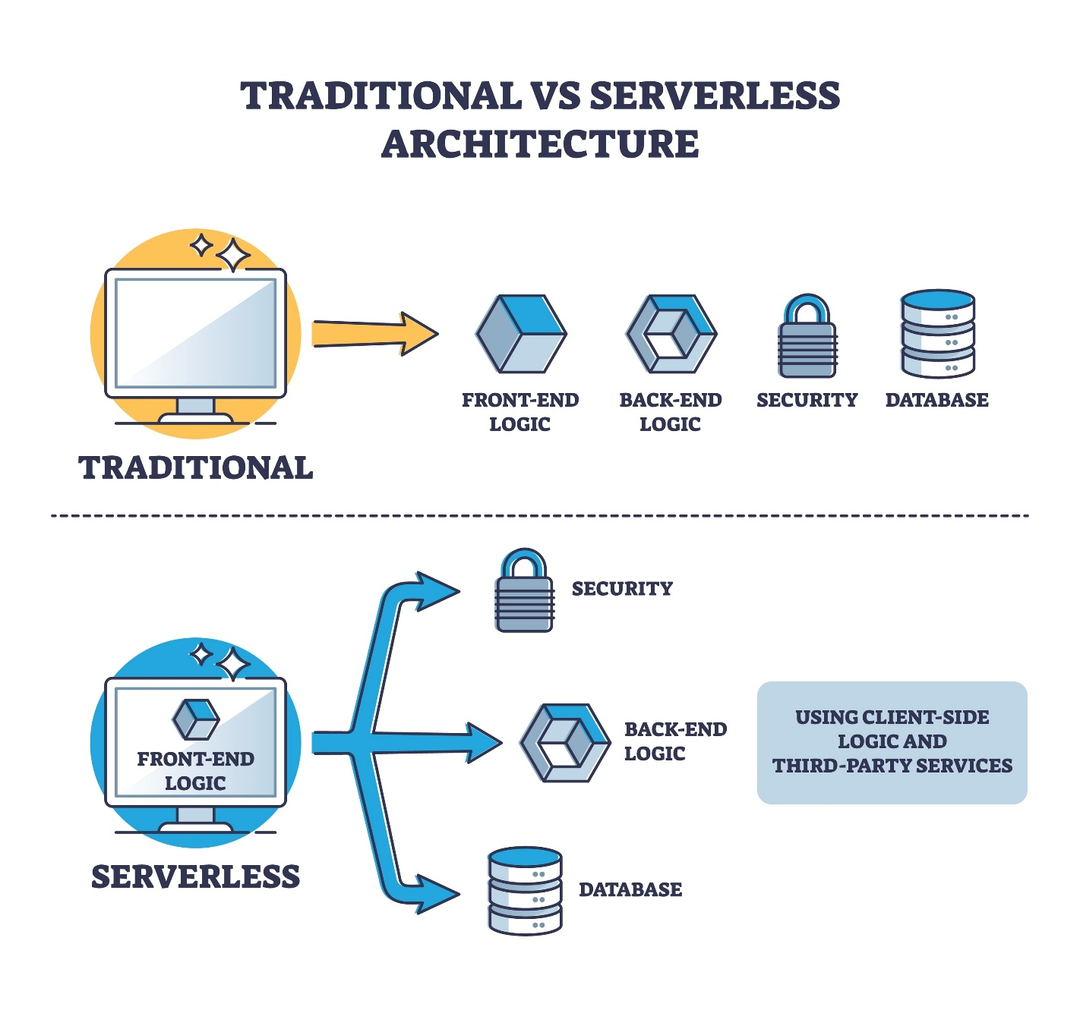
Shutterstock
Explorer

2. The Backend (The "Server-Side")
The Backend is the part of the application that lives on a server (like your laptop or a cloud computer). It is the "brain" of the operation.
- The Components:
  - The Server: A computer (running Node.js) listening for requests.
  - The Logic: The code that decides what to do (e.g., "Is this user logged in?", "Is the Arduino online?").
  - The Database: Where information is stored long-term (e.g., user profiles or temperature logs).
- The Goal: To handle heavy processing, security, and data storage. It acts as the "Source of Truth."

3. How they communicate (The Request-Response Cycle)
They talk to each other through the API we discussed earlier.
- Request: You click "ON" in the Frontend. The Frontend sends a digital letter (HTTP Request) to the Backend.
- Processing: The Backend receives the letter, verifies who sent it, and performs the action (in your case, talking to the Arduino).
- Response: The Backend sends a letter back to the Frontend (HTTP Response) saying "Success!"
- Update: The Frontend sees the success message and changes the button color to green.

Summary Table
Feature | Frontend | Backend
Where it runs | The User's Browser | A Remote Server / Laptop
Focus | User Experience & Design | Data, Security, & Logic
Tools | HTML, CSS, React, Vue | Node.js, Python, SQL
Analogy | The Steering Wheel | The Engine
In your project, the HTML file you created is the Frontend, and the Node.js script (server.js) is the Backend. The Arduino is a third piece—the Physical Hardware that the Backend controls.

2) Prepare the project folder
Your folder should include at least:
- server.js
- public/index.html (or Public/index.html depending on your setup)
- package.json / package-lock.json (or you can create package.json)
If package.json is missing, create it:
npm init -y
npm install express

- server.js
- public/index.html (or Public/index.html depending on your setup)
- package.json / package-lock.json (or you can create package.json)
Already done

3) Install dependencies and run server
Open PowerShell in:
C:\Users\dalia\OneDrive\Documents\Arduino\402_ControlTheLEDFromTheInternet
Then run:
npm install
npm start
If npm start is not configured, run:
node server.js
You should see something like:
Server running on port 3000

To see where the port is running
You already configured it correctly in server.js:
const PORT = process.env.PORT || 3000;
how I configure the port to 3000?
You already configured it correctly in server.js:
const PORT = process.env.PORT || 3000;
This means:
- use environment variable PORT if provided
- otherwise use 3000 (default)
So if you run locally with npm start, it uses 3000 automatically.
If you want to force a different port in PowerShell (example 4000):
$env:PORT=4000
npm start
To force 3000 explicitly:
$env:PORT=3000
npm start
For local use, you usually don’t need to set anything—default 3000 is enough.

but there is not any IP defined ?
Correct — in server.js you usually set port, not a specific IP.
- app.listen(PORT) means: listen on all network interfaces.
- So your server is reachable via:
  - http://localhost:3000 (same PC)
  - http://<your-PC-IP>:3000 (other devices on same Wi-Fi)
The IP comes from your machine/network, not from server.js.
Get it with:
ipconfig
Use the IPv4 address (Wi-Fi adapter) in Arduino as server.
So: no IP in Node code is normal.

4) Test the web page locally
Open browser:
http://localhost:3000
You should see your HTML page with Login / ON / OFF buttons.
Default login (from your README):
- username: admin
- password: admin123
or the username password like what you started the server with

5) Find your PC local IP (for Arduino)
In PowerShell:
ipconfig
Find your Wi-Fi adapter IPv4, e.g. 192.168.1.50.
Use this IP in Arduino code as server.

6) Update Arduino sketch
In 402_ControlTheLEDFromTheInternet.ino:
- Set your Wi-Fi SSID/password
- Set server to your PC IPv4
- Keep serverPort = 3000

7) Upload Arduino code
- Open Arduino IDE.
- Select board: Arduino UNO R4 WiFi.
- Select COM port.
- Upload.
- Open Serial Monitor at 115200.
You should see:
- Wi-Fi connected
- periodic HTTP responses
- LED -> ON or LED -> OFF based on server state

8) Test full flow
- Keep Node server running on PC.
- Open web page on phone/laptop (same Wi-Fi):
  - http://<your-pc-ip>:3000
- Login.
- Click ON/OFF.
- Arduino LED should follow within ~2 seconds.

9) If it doesn’t work, check these first
- PC firewall allows Node on port 3000.
- Arduino and PC are on same Wi-Fi.
- Correct IP in Arduino sketch.
- Server still running (terminal open).
- Serial Monitor shows response from /api/led.

10) Optional: run on internet (not only local Wi-Fi)
You can deploy server on Render (as your README says), but note:
- Your Arduino sketch currently uses WiFiClient (plain HTTP).
- Render URL is HTTPS, so for direct cloud use you usually need WiFiSSLClient + domain handling.
If you want, I can give you the exact cloud-ready Arduino version next (with secure HTTPS polling), step-by-step.

can you resume all these information from this discussion in three pages
Since we have covered everything from low-level hardware registers to high-level cloud architecture, I have organized this summary into three distinct "chapters" (pages). This follows the evolution of your project.

Page 1: The Local Web Server (The Current Setup)
In your current project, the Arduino UNO R4 WiFi acts as a "Stand-alone Host."

1. How the Hardware Works
- The "Poet" Model: The Arduino does not have a hard drive. It stores the HTML code in its Flash Memory. Every time you visit the IP address, the Arduino "recites" (streams) the HTML text line-by-line to your browser.
- The Listening Loop: The loop() function runs thousands of times per second. It "polls" the Wi-Fi chip to see if a browser has sent a "knock" (a request) to Port 80.
- The RAM & Registers: When you click "ON," the Arduino reads the incoming bits, stores them in an SRAM Buffer, and identifies the command. It then flips a specific bit in a GPIO Register from 0 to 1. This physically opens a transistor to send 3.3V to the LED.

2. The IP Address Logic
- 0.0.0.0 Error: This means the Arduino is "on" but hasn't received an address from the router's DHCP server.
- The Handshake: Connection happens in two steps: first, the Wi-Fi password check (Authentication), and second, the router giving the Arduino a "seat" at the table (Addressing).

Page 2: Web Fundamentals & The API Concept
To move the server off the Arduino, you must understand how the "Modern Web" communicates.

1. The Ingredients of a Webpage
- HTML: The "Bones" (structure/buttons).
- CSS: The "Skin" (colors/styling).
- JavaScript: The "Brain" (makes the buttons send data without refreshing the page).

2. The Browser's Journey (DNS & Packets)
When you type a name like www.google.com:
- DNS: A "Phonebook" translates the name into a numerical IP Address.
- TCP Handshake: Your laptop and the server do a quick "Are you there?" "Yes!" "Great!" digital greeting.
- Packets: The webpage is chopped into small 1500-byte boxes. Your browser reassembles them to show the page.

3. What is an API?
An API (Application Programming Interface) is a "Menu of Services." Instead of the Arduino sending a whole webpage, it becomes an API Endpoint. It waits for a tiny command like GET /LED/ON and sends back a tiny response like {"status":"ok"}. This is much more efficient for the Arduino's limited memory.

Page 3: The IoT Cloud Architecture (The Next Goal)
You are moving to a "Three-Tier" system: HTML → Node.js → Arduino.

1. The Role of Node.js (The Middleman)
- Why use it? It provides Security (passwords), Stability (handles many users), and Logic (remembers history/data).
- LTS Version: You use the "Long Term Support" version of Node.js because it is stable, secure, and won't break your code with experimental updates.

2. The Communication Flow
- Frontend: Your HTML/JS page is hosted on the web (e.g., Netlify). You click a button.
- Backend: The click sends a request to your Node.js Server (hosted on your laptop or in the Cloud).
- The Bridge: Node.js identifies you are allowed to control the light and sends a private request to your home Router.
- Port Forwarding: Your router sees the incoming request from Node.js and "forwards" it to the Arduino's Local IP.
- Execution: The Arduino flips the LED and tells Node.js "Done," which then tells your webpage "Done."

3. Hosting Options
- Local: Run Node.js on your laptop for testing.
- Private Cloud: Run Node.js on a Raspberry Pi inside your house.
- Public Cloud: Run Node.js on a service like Render or Railway to control your house from anywhere in the world.

Starting the web page + API

End-to-End Setup (Free Host + Arduino LED)
This is the full flow to get a public web page + API online, then control LED_BUILTIN on your UNO R4 WiFi.

1) Prepare your project files (already mostly done)
Create these files in one folder:
- package.json
- server.js
- public/index.html
You already have working versions, but here is the expected behavior:
- Web page has ON and OFF buttons
- POST /api/led sets state (on / off)
- GET /api/led returns current state

2) Test locally first
In that folder:
npm install
npm start
Open:
- http://localhost:3000 (page)
- http://localhost:3000/api/led (API)
Why: local test avoids deploying broken code.

3) Put project on GitHub
In terminal (inside project folder):
git init
git add .
git commit -m "Add LED control web app and API"
git branch -M main
git remote add origin https://github.com/<your-user>/<your-repo>.git
git push -u origin main
Why: Render deploys directly from GitHub.

4) Deploy on free Render web service
- Go to Render
- Create account and connect GitHub
- Click New + -> Web Service
- Select your repo
- Set:
  - Runtime: Node
  - Build command: npm install
  - Start command: npm start
- Deploy
You will get URL like:
- https://your-app.onrender.com
Now both are online:
- Web page: https://your-app.onrender.com
- API: https://your-app.onrender.com/api/led

5) Confirm API works online
From browser or Postman:
- GET https://your-app.onrender.com/api/led -> {"state":"off"} (or on)
- Send POST https://your-app.onrender.com/api/led with JSON: {"state":"on"}
Why: verifies cloud server is ready before Arduino step.

6) Prepare Arduino IDE for UNO R4 WiFi
Install/check:
- Board package for UNO R4 WiFi
- Libraries:
  - WiFiS3
  - ArduinoHttpClient (recommended)
Also update WiFi firmware in Arduino IDE (Firmware Updater) if HTTPS fails.

7) Upload Arduino sketch (poll API and control LED)
Use this template (replace placeholders):
#include <WiFiS3.h>
#include <ArduinoHttpClient.h>
const char* ssid = "YOUR_WIFI_NAME";
const char* pass = "YOUR_WIFI_PASSWORD";
const char* host = "your-app.onrender.com";
const int httpsPort = 443;
WiFiSSLClient wifi;
HttpClient client(wifi, host, httpsPort);
const int LED_PIN = LED_BUILTIN;
unsigned long lastPoll = 0;
const unsigned long intervalMs = 2000;
void connectWifi() {
while (WiFi.begin(ssid, pass) != WL_CONNECTED) {
delay(1000);
}
}
void setup() {
pinMode(LED_PIN, OUTPUT);
digitalWrite(LED_PIN, LOW);
Serial.begin(115200);
connectWifi();
}
void loop() {
if (WiFi.status() != WL_CONNECTED) {
connectWifi();
}
if (millis() - lastPoll >= intervalMs) {
lastPoll = millis();
client.get("/api/led");
int statusCode = client.responseStatusCode();
String body = client.responseBody();
client.stop();
if (statusCode == 200) {
if (body.indexOf("\"state\":\"on\"") >= 0) {
digitalWrite(LED_PIN, HIGH);
} else if (body.indexOf("\"state\":\"off\"") >= 0) {
digitalWrite(LED_PIN, LOW);
}
}
}
}

8) Test full system
- Open https://your-app.onrender.com on phone/laptop
- Click ON / OFF
- Arduino polls every ~2s and updates LED

Important notes
- Your current server stores state in memory; after server restart it resets to off (fine for prototype).
- Render free tier may “sleep”; first request can be slow.
- For security later, add an API key so random people can’t toggle your LED.

If you want, I can now give you a hardened v2:
- API key protection
- Arduino sends key header
- cleaner status model (desired vs lastSeen) for better UI feedback.

