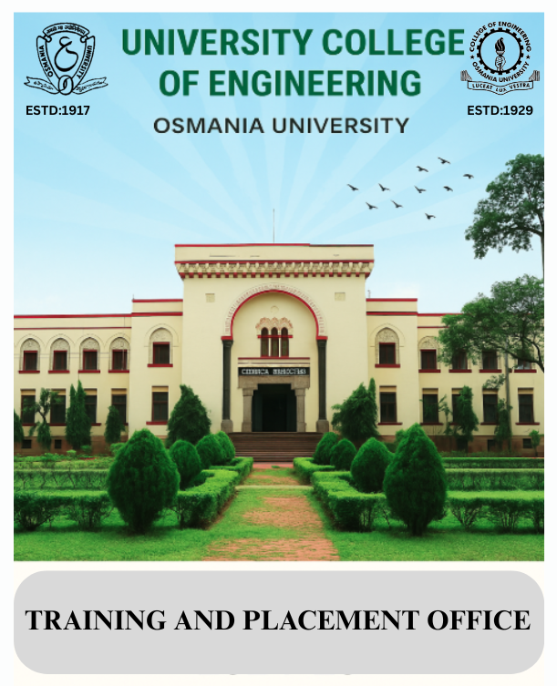

**Training and Placement Office**  
  
**1. Overview:** University College of Engineering, Osmania University, has a dedicated Training and Placement Office (TPO) that plays a pivotal role in preparing students for the competitive job market. The TPO’s primary objective is to bridge the gap between academia and industry, ensuring that students are equipped with the skills and knowledge necessary to secure best careers, and provide industry interaction for training/ Internship/ campus placements etc., counselling session for higher education and Entreprenurial opportunities.  
  
**2. Objectives of the Training and Placement Office (TPO)**

The primary objectives of the TPO at Osmania University are:

* **Student Career Development:** To enhance students' employability through skills training, industry exposure, and career counseling.
* **Industry-Academic Collaboration:** To foster partnerships with leading organizations for campus recruitment and internships.
* **Provide Placement Opportunities:** To facilitate the placement of students in reputable organizations across various industries.

#### **3. Organizational Structure**

The Training and Placement Office at Osmania University is well-organized, with an experienced Training and placement Officer, a dedicated team to ensure smooth functioning. The structure includes:

* **Training and Placement Officer**: Oversees the entire operations, strategic planning, and policy formulation.
* **Administrative Staff**: Responsible for the day-to-day administrative tasks of the TPO.
* **Student Placement Coordinators**: A group of selected students from various departments who assist the TPO with logistical arrangements, coordination with companies, and communication with other students.

**Training and Placement Office, staff details:**

|  |  |  |
| --- | --- | --- |
| **S. No.** | **Name** | **Designation** |
| 1. | Dr. D. Suman | Placement Officer |
| 2. | B. Murali Mohan | Placement Coordinator |
| 3. | A. Chandrika | Junior Assistant |
| 4. | M. Sriya | Junior Assistant |
| 5. | Jain Kumar | Clerk and Typist |

#### **4. Key Functions and Activities**

The TPO undertakes a range of activities to prepare students for employment and to ensure the university meets NBA accreditation standards. The key functions and activities include:

* **Pre-Placement Training Programs**: (Ref Appendix –1 for detailed list)
  + **Soft Skills Training:** Workshops and sessions focusing on communication, teamwork, leadership, and problem-solving.
  + **Technical Skills Enhancement:** Courses and certifications in coding, software development, data analysis, and other domain-specific skills.
  + **Mock Interviews and Group Discussions:** To help students get accustomed to the recruitment process.
  + **Resume Building Workshops:** To help students craft professional and impactful resumes.
  + **Achievers talk:** To give insights on key areas which helped to students to get a placement offer and guide their fellow students.
* **Industry Interaction and Networking**:
  + The TPO regularly organizes guest lectures, webinars, industry visits, and workshops where industry professionals share insights into the latest trends and practices in the job market.
  + **Alumni Networking**: Regular alumni interactions and webinars to provide insights into various career paths and industry trends.
* **Internship Programs**:
  + The office coordinates internships for students, ensuring that they gain valuable hands-on experience in their respective fields.
  + Internships are often arranged through collaborations with national and international organizations.
* **Placement Drives**:
  + The TPO organizes multiple recruitment drives throughout the year, with participation from leading companies across sectors like IT, engineering, finance, manufacturing, and more.
  + Major recruitment partners include global giants like TCS, Infosys, Amazon, Deloitte, and more.
* **Entrepreneurship Development**:
  + The TPO also supports students who wish to pursue entrepreneurial ventures by offering workshops and mentorship.

#### **5. Infrastructure and Facilities for Training and Placement Activities**

Osmania University provides comprehensive infrastructure to support its Training and Placement Office, ensuring efficient placement processes and aligning with NBA accreditation standards. Key facilities include:  
  
**5.1. Training and Placement Office Infrastructure**

* **TPO Building**: A dedicated, centrally located building with interview rooms, meeting areas, and administrative offices.
* **Interview & GD Rooms**: Air-conditioned rooms and spacious halls for personal interviews and group discussions, equipped with projectors, Wi-Fi, and video conferencing facilities.
* **Audio Visual Lab & Seminar Halls**: Spacious AV lab (200 seats) and a large seminar Hall (500 seats) for pre-placement talks and company presentations, with AV systems and PA systems.
* **Computer Labs & Online Test Facilities**: High-end labs with internet connectivity and software tools for online assessments, coding tests, and aptitude evaluations.
* **Waiting and Lounge Areas**: Comfortable waiting areas for students and recruiters, enhancing the overall placement experience.

##### **5.2. ICT Infrastructure**

* **Wi-Fi and LAN Connectivity**: High-speed internet across the campus to support online assessments and virtual recruitment drives.
* **Video Conferencing Facilities**: Used for remote interviews and company interactions, especially for international or outstation recruiters.
* **Digital Notice Boards and Placement Portal**:
  + A centralized **placement management system** that allows students to register, track job openings, submit resumes, and receive notifications.

##### **5.3. Computer Labs and Online Test Facilities**

* **Computer Labs with High-End Systems**: Equipped with systems capable of running online assessments, coding tests, and aptitude evaluations, providing uninterrupted power and network connectivity.
* **Online Test Labs**: Exclusive labs dedicated to conducting online tests for companies, with 100+ computers and high bandwidth internet.
* **Software Tools**: Programming environments (Python, Java, C++, MATLAB), database systems (MySQL, Oracle), and simulation tools are available in the labs for practical training.

These facilities ensure a seamless experience for both recruiters and students, enhancing the university’s placement capabilities and supporting NBA accreditation requirements.

#### **6. Placement Process**

The placement process at Osmania University is structured to provide students with a seamless transition from academia to the professional world. The process is as follows:

1. **Registration**: All eligible students must register with the TPO before the placement season begins on a dedicated placement portal. The TPO then collects the resumes and other details.
2. **Pre-Placement Talk**: Companies conduct pre-placement talks to introduce themselves, their work culture, and the roles they are offering.
3. **Shortlisting**: Based on the pre-placement talks and student resumes, companies shortlist candidates for written tests or interviews.
4. **Written Test/Group Discussion**: Candidates undergo a written test or group discussion, depending on the company’s selection process.
5. **Personal Interview**: Shortlisted candidates are then interviewed by company representatives to assess their technical skills, problem-solving ability, and cultural fit.
6. **Offer Letter**: Candidates who perform well in interviews are extended job offers.
7. **Final Placement**: Once a student accepts an offer, their placement is considered final, and they are relieved from further placement activities.

#### **7. Achievements and Placement Statistics** (Ref Appendix – 3 for detailed statistics)

Osmania University has seen impressive placement statistics in recent years, with a growing number of students securing positions in top companies across various industries. Some notable achievements include:

* **High Placement Rates**: Over 85% of eligible students have been placed in the last few academic years.
* **Top Recruiters**: The university has been successful in bringing major companies to the campus, including multinational corporations and leading Indian firms.
* **Internship Opportunities**: A significant number of students have successfully completed internships with leading organizations, which has enhanced their chances of securing full-time employment post-graduation.
* **Entrepreneurship Success**: Several students have gone on to launch their own start-ups with support from the TPO’s guidance and mentorship programs.

#### **8. Contribution to Bridging gap between Industry and Academia:**

The NBA accreditation process focuses on several key parameters, including the quality of the curriculum, teaching and learning processes, student support systems, and industry interaction. The Training and Placement Office plays a critical role in meeting these standards:

* **Curriculum Alignment with Industry Needs**: The TPO works closely with all departments to ensure that the curriculum is updated with industry-relevant skills. It also provides feedback from recruiters, ensuring that the courses offered are aligned with the latest trends and technologies.
* **Student Support and Development**: The pre-placement training programs contribute significantly to the holistic development of students, enhancing their employability and industry-readiness.
* **Industry Collaboration**: The TPO's continuous engagement with industry partners and employers strengthens the university’s industry links, ensuring that students have access to the best career opportunities.
* **Placement Performance**: Consistent placement success demonstrates the university's commitment to ensuring student employability, which is a critical component of NBA accreditation.

**9. Appendix:**

1. **Pre-Placement Training Activities conducted in AY 2023-24, AY 2024-25**
2. **List of Top Recruiters of AY 2021-22, AY 2022-23, AY 2023-24**
3. **Placement statistics of AY 2021-22, AY 2022-23, AY 2023-24**
4. **Branch wise Placement Data of AY 2021-22, AY 2022-23, AY 2023-24**

**\*AY = Academic Year**

**Appendix 1: Placement Training Programmes for the AY 2024-25**

|  |  |  |  |
| --- | --- | --- | --- |
| **Sl.No.** | **Training** | **Targeted Students** | **Schedule** |
| 1 | Four Days "Job Readings and Skills Enhancement Programme" Day 1 | B.E III Year VI – Semester | 03-02-2024 from 10.00 A.M to 5.00 P.M |
| 2 | Four Days "Job Readings and Skills Enhancement Programme" Day 2 | B.E III Year VI - Semester | 17-02-2024 from 10.00 A.M to 5.00 P.M |
| 3 | Four Days "Job Readings and Skills Enhancement Programme" Day 3 | B.E III Year VI - Semester | 27-04-2024 from 10.00 A.M to 5.00 P.M |
| 4 | 2 weeks “Graduate Employability Skills & Training” | B.E (CSE, AIML, EEE) 4th Year VII – Semester | 8th - 20th July, 2024 10.00 A.M to 5.00 P.M. |
| 5 | One Week “Graduate Employability Skills & Training” | B.E (ECE, Civil, BME, MECH, Mining) 4th Year VII – Semester | 15th - 20th July, 2024 10.00 A.M to 5.00 P.M. |
| 6 | 2 weeks “Graduate Employability Skills & Training” | B.E (CSE, Mining & Mech) 4th Year VII – Semester | 9th - 20th July, 2024 10.00 A.M to 5.00 P.M. |
| 7 | Tata Strive in Collaboration with Microsoft- Cyber Security Scholarship Program | BE VII Semester students | 24 August 2024 1.00 P.M |
| 8 | “Mock Coding Test” | B.E (CSE and AIML) 4th Year VII – Semester | 11/09/2024 from 9:00 A.M to 11:30 A.M |
| 9 | Training Program for LinkedIn and Resume Preparation | BE VII Semester students | 11/09/2024 at Assembly Hall |
| 10 | One day Workshop an IBM Skills Build Certification Program on | B.E 3rd and 4th Year students and M.E 1st Year and 2nd Year and students | 07/11/2024 (10.00 A.M to 5.00 P.M) |
| 11 | LinkedIn Career Kickstarter Program | B.E 2nd, 3rd and 4th Year, M.E 2nd Year and MCA students | 13/11/2024 from 2:00 P.M to 4:00 P.M |
| 12 | Tata Strive in Collaboration with Microsoft Cyber Security scholarship Program Day1 | B.E (CSE, AIML) | 24-11-2024 at 12.30 A.M |
| 13 | Four Days “Job Readings and Skills Enhancement Programme” Day-3 | B.E III Year VI - Semester | 27-11-2024  10.00 A.M to 5.00 P.M |
| 14 | Deloitte Impact Day | B.E 1st and 3rd Year (BME, MECH, ECE, EEE, CIVIL, CSE, AIML, MINING) students | 29/11/2024 8:00 A.M to 5:00 P.M |
| 15 | Training at SALESFORCE Company by United way of Hyderabad | (CSE, AIML) students | 6/12/2024, from 8.00 A.M to 5.00 P.M |
| 16 | “Career Assistance Training Programme” by upGrad | B.E 4th Year (CSE, AIML) students | 18/12/2024 from 5:00 P.M to 5:30 P.M |
| 17 | Seminar on Higher Education and Jobs in Germany | B.E 4th Year students | 23-01-2025 at 3.30 P.M |
| 18 | Three-day Placement Training Program “SAMANVAYA-2025” | B.E 3rd Year (BME, MECH, ECE, EEE, CIVIL, CSE, AIML, MINING) students | From 03/03/2025 to 05/03/2025 from 9:00 A.M to 5:00 P.M |
| 19 | Three-day Placement Training Program Training Topic “Job Readiness /Campus Recruitment Training” | B.E 2nd Year ((CSE, AIML, Mechanical, EEE, ECE, BME, CIVIL, MINING) | during 03/03/2025 to 05/03/2025 from 9:00 A.M to 5:00 P.M |
| 20 | “Hands on Training ON 3D Modeling” | B.E (Mechanical) 4th Year VIII – Semester students | 22nd February, 2025 at 9.00 A.M |
| 21 | YEXT Software Company - exposure visit for Organized by United Way of Hyderabad | 25 Female students of CSE, AIML B.E 4th Year VIII – Semester students | 19-03-2025 |
| 22 | Pre-Placement Training Program | B.E IIIrd Year all branches | 21st – 26th April, 2025 Session: 4:00 PM to 6:00PM |
| 23 | KISH academy collaboration with Training and Placement Office, UCE, OU - CAT Coaching | B.E 4th Year VIII – Semester students | Every Saturday 5.30 PM - 6.30 P.M |

**A Preview of Pre-Placement Training Programs in the AY 2024-25**

|  |  |  |  |
| --- | --- | --- | --- |
| **S. NO.** | **Programme Organised:** | **Targeted Students:** | **Schedule of the program:** |
| 1. | LinkedIn Career Kickstarter Program|| Academic year of 2024-2025 | B.E 2nd, 3rd and 4th Year, M.E 2nd Year and MCA. | **13/11/2024** from **2:00 P.M** to **4:00 P.M** |

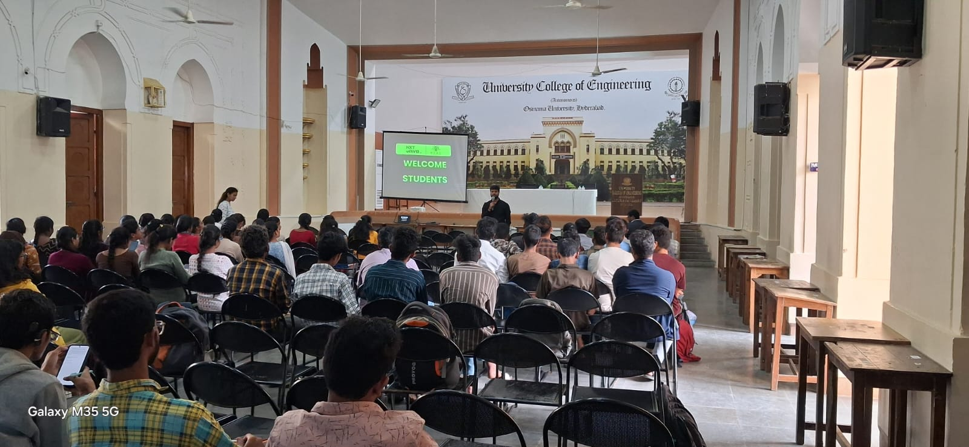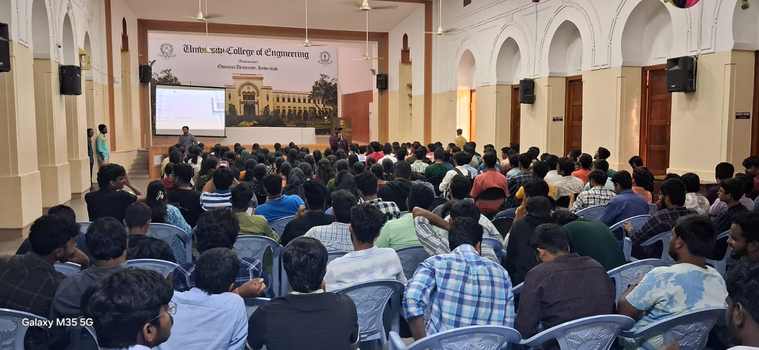

|  |  |  |  |
| --- | --- | --- | --- |
| **S. NO.** | **Programme Organised:** | **Targeted Students:** | **Schedule of the program:** |
| 2. | CRT In-campus Training Program by T.I.M.E. | B.E 3rdYear students | **21/04/2025** to **26/04/2025** from **4:00 P.M to 6:00 P.M** |

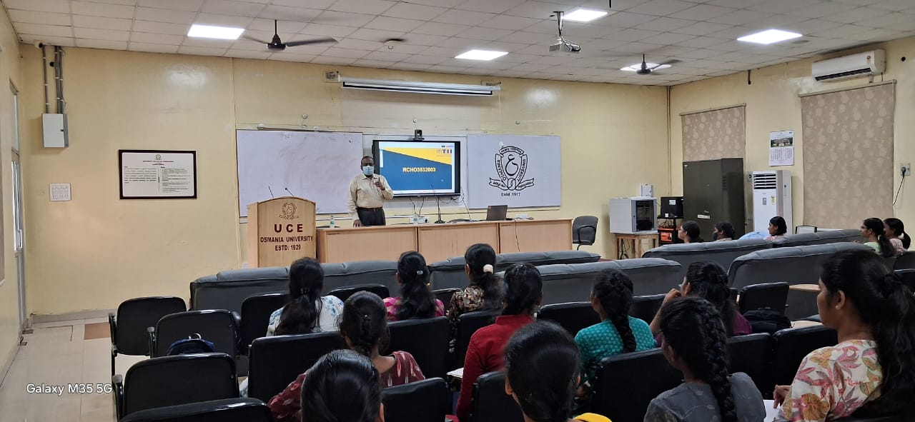

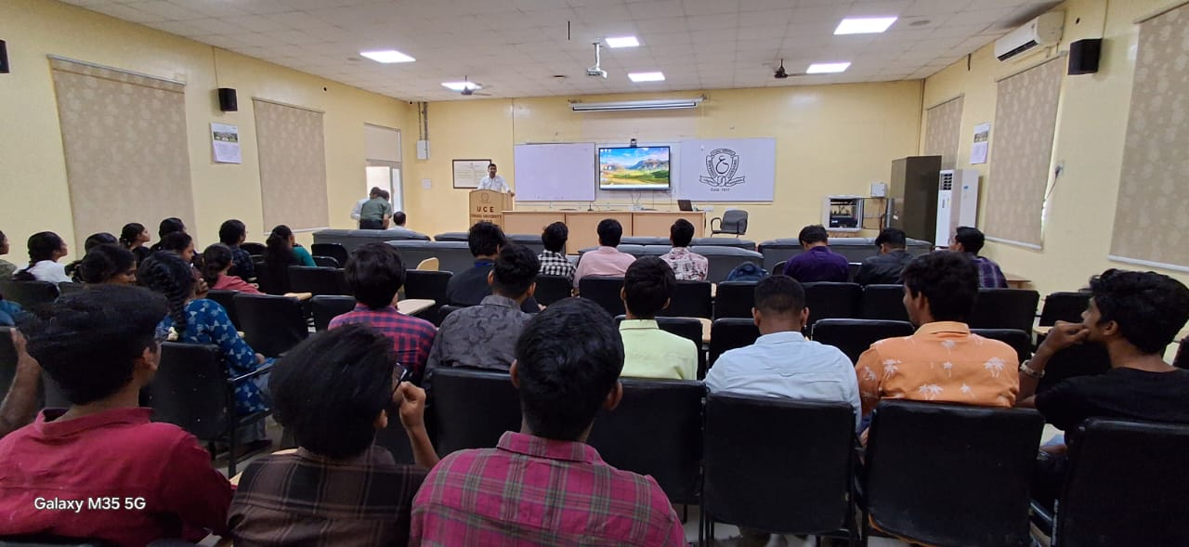

|  |  |  |  |
| --- | --- | --- | --- |
| **S. NO.** | **Programme Organised:** | **Targeted Students:** | **Schedule of the program:** |
| 3. | Three-day Placement Training Program “SAMANVAYA-2025” | B.E 3rdYear students | **03/03/2025** **to 05/03/2025** from **9:00 A.M** to **5:00 P.M** |

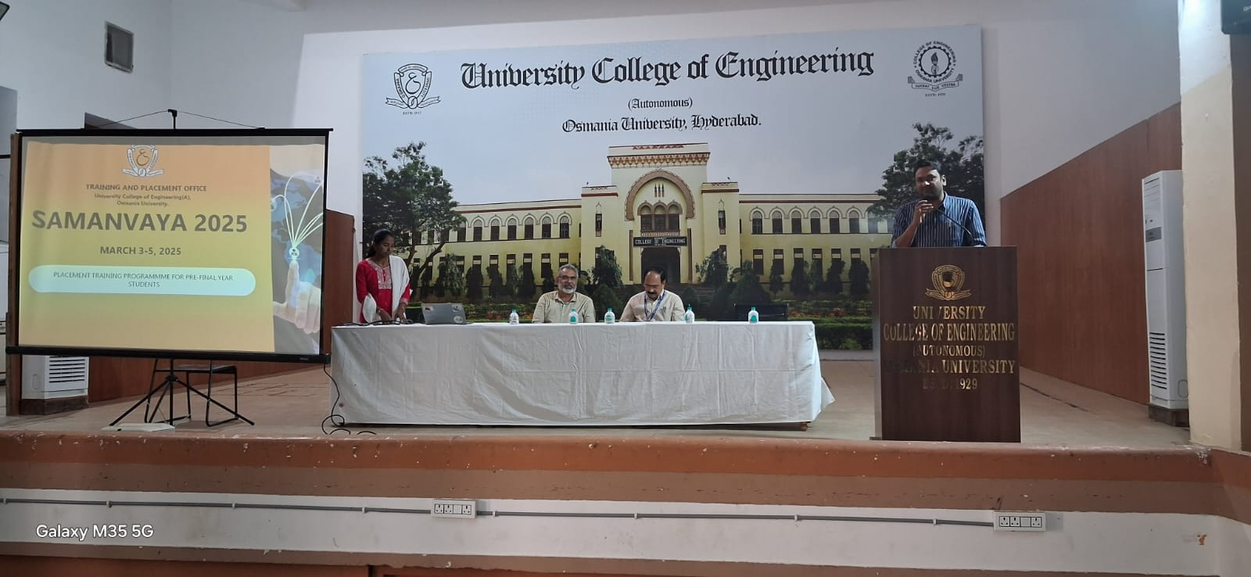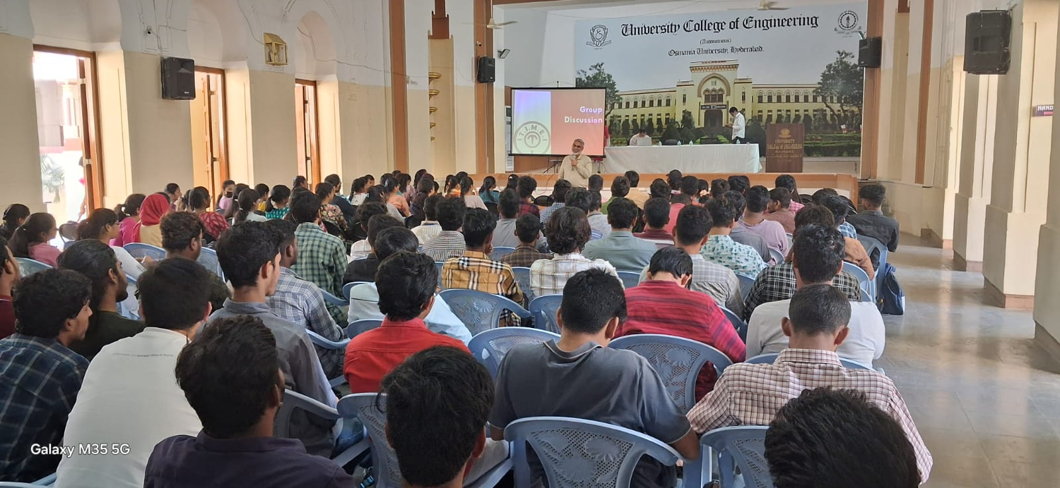

|  |  |  |  |
| --- | --- | --- | --- |
| **S. NO.** | **Programme Organised:** | **Targeted Students:** | **Schedule of the program:** |
| 4. | Three-day Placement Training Program on **“Job Readiness /Campus Recruitment Training”** | B.E 2nd Year students. | **03/03/2025** **to 05/03/2025** from **9:00 A.M** to **5:00 P.M** |

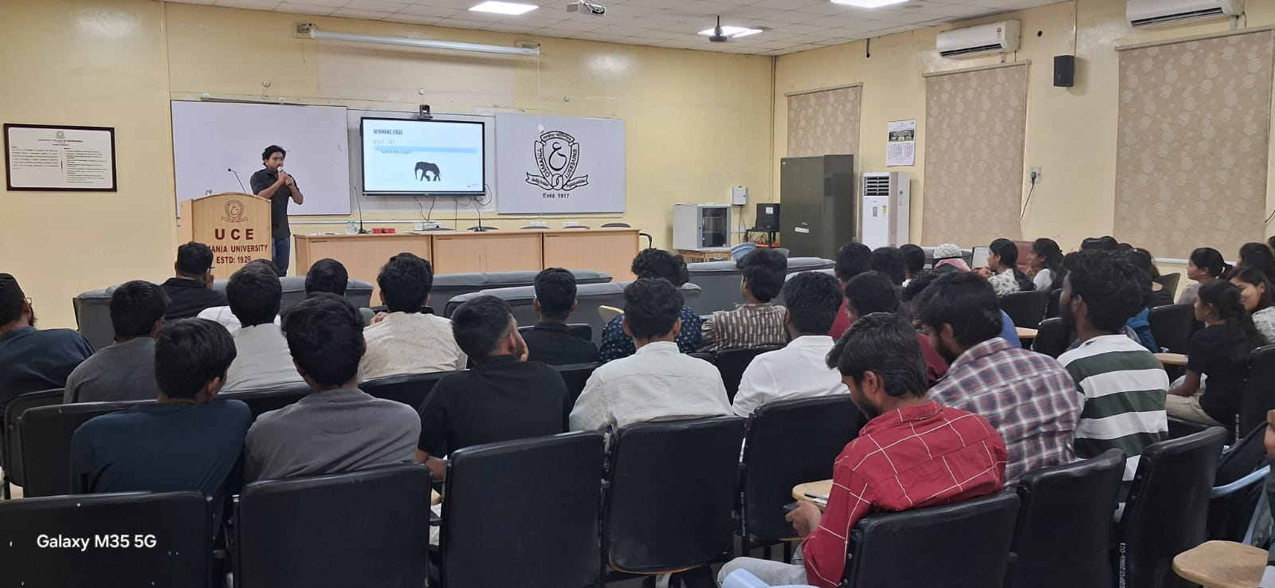

|  |  |  |  |
| --- | --- | --- | --- |
| **S. NO.** | **Programme Organised:** | **Targeted Students:** | **Schedule of the program:** |
| 5. | **Felicitation to students and Achievers Talk for guiding pre-final year students** | B.E 3nd Year students. | 19th April 2025,  **11:00 A.M to 1:00 P.M** |

Honorable Vice-chancellor, Prof.M.Kumar has felicitated the BE students placed in MNC’s   
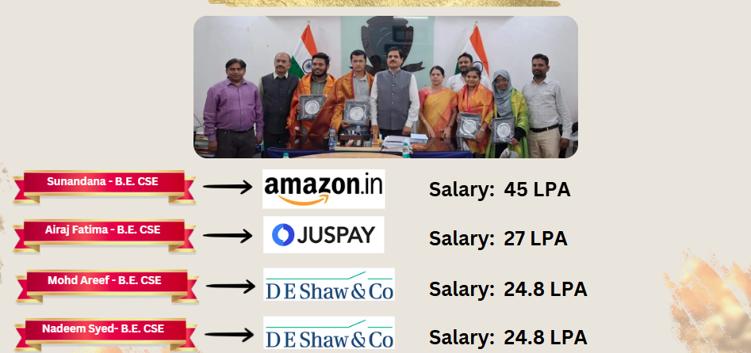

**APPENDIX - 2: LIST OF TOP RECRUITERS FOR AY 2021-22, AY 2022-23, AY 2023-24**

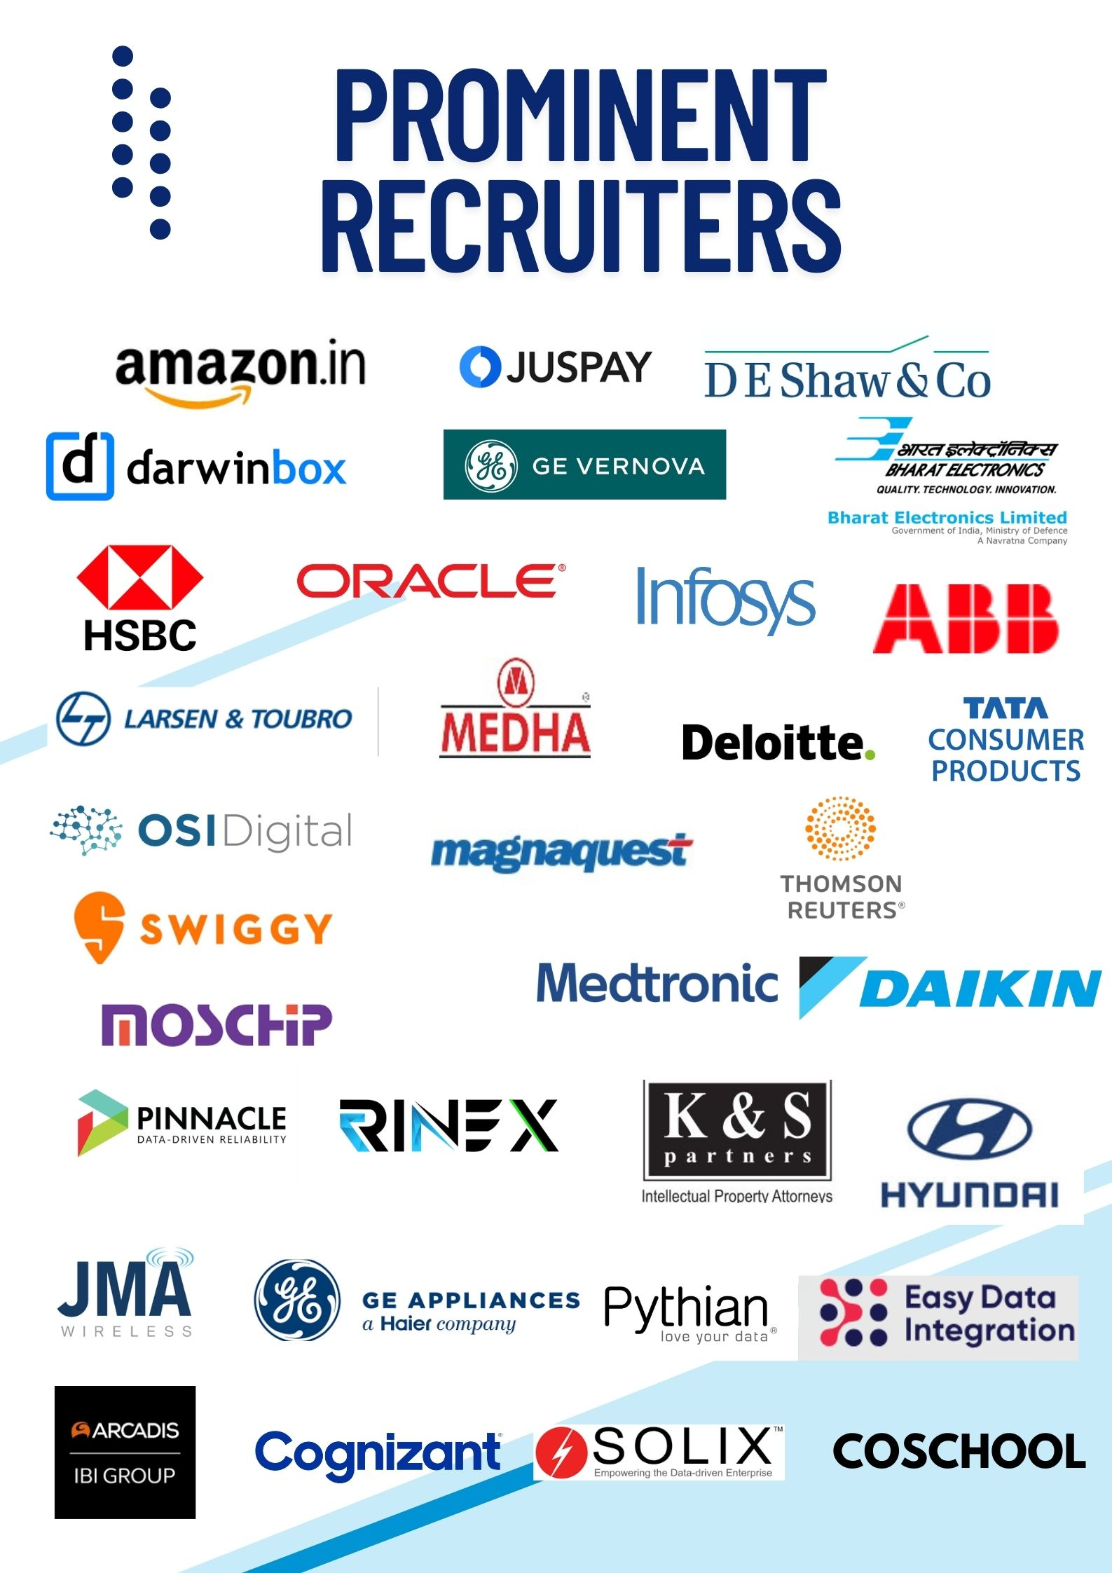

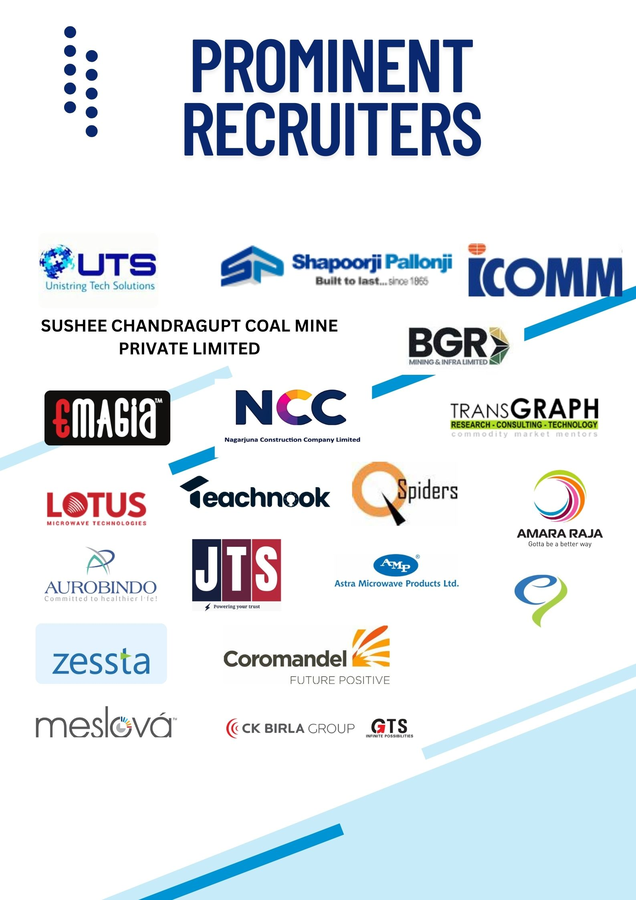

**Appendix- 2 (1): LIST OF TOP RECRUITERS FOR AY 2023-24**

|  |  |  |  |  |  |  |  |  |  |  |  |  |  |  |  |  |  |  |  |
| --- | --- | --- | --- | --- | --- | --- | --- | --- | --- | --- | --- | --- | --- | --- | --- | --- | --- | --- | --- |
|  |  | **BE/UG** | | | | | |  |  | **ME/PG** | | | | | | |  | **Overall** |  |
| **S No** | **Company** | **BME** | **CIVIL** | **CSE** | **ECE** | **EEE** | **Mech** | **Chem** | **Total Offers for UG** | **MCA** | **ME BME** | **ME Civil** | **ME ECE** | **ME EE** | **ME Mech** | **ME CSE** | **Total Offers for PG** | **UG+PG Total Offers** | **Pay Package**  **P/A in Lakhs** |
| **1** | **L&T** | **1** | **8** | **-** | **-** | **14** | **7** | **1** | **31** | **-** | **-** | **3** | **-** | **1** | **-** | **-** | **4** | **35** | **6.00** |
| **2** | **Adani** | **1** | **1** | **-** | **-** | **2** | **-** | **-** | **4** | **-** | **-** | **-** | **-** | **-** | **1** | **-** | **1** | **5** | **6.50** |
| **3** | **ARCADIS** | **1** | **-** | **-** | **-** | **-** | **-** | **-** | **1** | **-** | **-** | **-** | **-** | **-** | **-** | **-** | **0** | **1** | **5.50** |
| **4** | **Medtronic** | **4** | **-** | **-** | **-** | **-** | **-** | **-** | **4** | **-** | **1** | **-** | **-** | **-** | **-** | **-** | **1** | **5** | **25000 PM** |
| **5** | **Movidu** | **1** | **-** | **2** | **-** | **-** | **1** | **1** | **5** | **-** | **-** | **-** | **-** | **-** | **-** | **-** | **0** | **5** | **7.00** |
| **6** | **GRANTLEY** | **1** | **1** | **-** | **-** | **3** | **2** | **3** | **10** | **-** | **-** | **-** | **-** | **-** | **-** | **-** | **0** | **10** | **4.50** |
| **7** | **Rinex** | **1** | **1** | **-** | **-** | **-** | **1** | **-** | **3** | **-** | **-** | **-** | **-** | **-** | **-** | **-** | **0** | **3** | **4.20** |
| **8** | **ctrIS** | **1** | **11** | **-** | **-** | **4** | **2** | **-** | **18** | **-** | **-** | **-** | **-** | **-** | **-** | **-** | **0** | **18** | **4.60** |
| **9** | **SmartED** | **1** | **-** | **-** | **-** | **-** | **-** | **1** | **2** | **-** | **-** | **-** | **-** | **-** | **-** | **-** | **0** | **2** | **4.00** |
| **10** | **Shetty Medical Solulation** | **2** | **-** | **-** | **-** | **-** | **-** | **-** | **2** | **-** | **-** | **-** | **-** | **-** | **-** | **-** | **0** | **2** | **4.65** |
| **11** | **Amara Raja Group** | **-** | **2** | **-** | **-** | **-** | **-** | **-** | **2** | **-** | **-** | **-** | **-** | **-** | **-** | **-** | **0** | **2** | **4.00** |
| **12** | **HSBC** | **-** | **1** | **-** | **-** | **-** | **1** | **-** | **2** | **-** | **-** | **-** | **-** | **-** | **-** | **-** | **0** | **2** | **6.00** |
| **13** | **NCC** | **-** | **1** | **-** | **-** | **-** | **-** | **-** | **1** | **-** | **-** | **-** | **-** | **-** | **-** | **-** | **0** | **1** | **3.19** |
| **14** | **Accenture** | **-** | **1** | **3** | **1** | **-** | **1** | **-** | **6** | **-** | **-** | **-** | **-** | **-** | **-** | **-** | **0** | **6** | **4.60** |
| **15** | **Tata Consulting Engineers** | **-** | **2** | **-** | **-** | **-** | **-** | **6** | **8** | **-** | **-** | **-** | **-** | **-** | **-** | **-** | **0** | **8** | **4.50** |
| **16** | **PAL TECH** | **-** | **-** | **5** | **1** | **-** | **-** | **-** | **6** | **-** | **-** | **-** | **-** | **-** | **-** | **-** | **0** | **6** | **6.00 (20000 PM)** |
| **17** | **Deloitte Consulting India** | **-** | **-** | **4** | **-** | **-** | **-** | **-** | **4** | **-** | **-** | **-** | **-** | **-** | **-** | **-** | **0** | **4** | **7.60** |
| **18** | **Eastman** | **-** | **-** | **7** | **-** | **1** | **1** | **-** | **9** | **-** | **-** | **-** | **-** | **-** | **1** | **-** | **1** | **10** | **5.20** |
| **19** | **Digitalinterakt** | **-** | **-** | **9** | **-** | **-** | **-** | **-** | **9** | **-** | **-** | **-** | **-** | **-** | **-** | **-** | **0** | **9** | **7.00 (25000 PM)** |
| **20** | **Zessta** | **-** | **-** | **2** | **-** | **-** | **-** | **-** | **2** | **-** | **-** | **-** | **-** | **-** | **-** | **-** | **0** | **2** | **5.00** |
| **21** | **Omnicloud** | **-** | **-** | **6** | **2** | **-** | **-** | **-** | **8** | **-** | **-** | **-** | **-** | **-** | **-** | **-** | **0** | **8** | **5.00 (12500 PM)** |
| **22** | **Opt Culture** | **-** | **-** | **1** | **-** | **-** | **-** | **-** | **1** | **-** | **-** | **-** | **-** | **-** | **-** | **-** | **0** | **1** | **7.00** |
| **23** | **OSI Digital Pvt Ltd** | **-** | **-** | **7** | **2** | **-** | **-** | **-** | **9** | **-** | **-** | **-** | **-** | **-** | **-** | **-** | **0** | **9** | **5.00** |
| **24** | **Magnaquest** | **-** | **-** | **2** | **-** | **-** | **-** | **-** | **2** | **-** | **-** | **-** | **-** | **-** | **-** | **-** | **0** | **2** | **5.00** |
| **25** | **GE Appliances** | **-** | **-** | **1** | **-** | **-** | **-** | **-** | **1** | **-** | **-** | **-** | **-** | **-** | **-** | **-** | **0** | **1** | **25000 PM** |
| **26** | **ZOICX** | **-** | **-** | **2** | **-** | **1** | **-** | **-** | **3** | **-** | **-** | **-** | **-** | **-** | **-** | **-** | **0** | **3** | **25000 PM** |
| **27** | **Amazon** | **-** | **-** | **1** | **-** | **-** | **-** | **-** | **1** | **-** | **-** | **-** | **-** | **-** | **-** | **-** | **0** | **1** | **1.10 P.M** |
| **28** | **Darwinbox Digital Solutions** | **-** | **-** | **1** | **-** | **-** | **-** | **-** | **1** | **-** | **-** | **-** | **-** | **-** | **-** | **-** | **0** | **1** | **9.70 (25000 PM)** |
| **29** | **Darwinbox Digital Solutions** | **-** | **-** | **1** | **-** | **-** | **-** | **-** | **1** | **-** | **-** | **-** | **-** | **-** | **-** | **-** | **0** | **1** | **16.30** |
| **30** | **ABB** | **-** | **-** | **2** | **-** | **-** | **-** | **-** | **2** | **-** | **-** | **-** | **-** | **-** | **-** | **-** | **0** | **2** | **8.50** |
| **31** | **Unistring Tech Solutions** | **-** | **-** | **2** | **3** | **2** | **-** | **-** | **7** | **-** | **-** | **-** | **3** | **-** | **-** | **-** | **3** | **10** | **5.00** |
| **32** | **icsglobal** | **-** | **-** | **3** | **3** | **-** | **-** | **-** | **6** | **-** | **-** | **-** | **3** | **-** | **-** | **-** | **3** | **9** | **6.25 (25000 PM)** |
| **33** | **DeltaX** | **-** | **-** | **1** | **-** | **-** | **-** | **-** | **1** | **-** | **-** | **-** | **-** | **-** | **-** | **-** | **0** | **1** | **7.00** |
| **34** | **Tejas Network Ltd** | **-** | **-** | **2** | **-** | **-** | **-** | **-** | **2** | **-** | **-** | **-** | **-** | **-** | **-** | **-** | **0** | **2** | **10.00** |
| **35** | **Tata Consulting** | **-** | **-** | **-** | **-** | **-** | **-** | **-** | **0** | **-** | **-** | **-** | **-** | **-** | **-** | **2** | **2** | **2** | **5.50** |
| **36** | **Skill Intern** | **-** | **-** | **-** | **-** | **-** | **-** | **-** | **0** | **-** | **-** | **-** | **3** | **-** | **-** | **2** | **5** | **5** | **4.20 (16000 PM)** |
| **37** | **KodNest** | **-** | **-** | **-** | **-** | **-** | **-** | **-** | **0** | **-** | **-** | **-** | **-** | **-** | **-** | **1** | **1** | **1** | **3.50** |
| **38** | **Thomson** | **-** | **-** | **-** | **-** | **-** | **-** | **-** | **0** | **-** | **-** | **-** | **-** | **-** | **-** | **6** | **6** | **6** | **6.50 (30000 PM)** |
| **39** | **NCR Corporation** | **-** | **-** | **-** | **-** | **-** | **-** | **-** | **0** | **-** | **-** | **-** | **-** | **-** | **-** | **3** | **3** | **3** | **30000 PM** |
| **40** | **TransGraph** | **-** | **-** | **-** | **-** | **-** | **-** | **-** | **0** | **-** | **-** | **-** | **-** | **-** | **-** | **1** | **1** | **1** | **5.00** |
| **41** | **EdiGlobe** | **-** | **-** | **-** | **-** | **-** | **-** | **-** | **0** | **-** | **-** | **-** | **1** | **-** | **-** | **1** | **2** | **2** | **4.00** |
| **42** | **Infosys** | **-** | **-** | **1** | **-** | **-** | **-** | **-** | **1** | **-** | **-** | **-** | **-** | **-** | **-** | **-** | **0** | **1** | **9.50** |
| **43** | **K&S Partners** | **-** | **-** | **1** | **-** | **-** | **-** | **-** | **1** | **-** | **-** | **-** | **-** | **-** | **-** | **-** | **0** | **1** | **6.00 (25000 PM)** |
| **44** | **Medtronic** | **-** | **-** | **-** | **-** | **-** | **-** | **-** | **0** | **-** | **-** | **-** | **3** | **-** | **-** | **-** | **3** | **3** | **9.50 (45000 PM)** |
| **45** | **Astra** | **-** | **-** | **-** | **8** | **-** | **-** | **-** | **8** | **-** | **-** | **-** | **6** | **-** | **-** | **-** | **6** | **14** | **5.00 (15000 PM)** |
| **46** | **LOTUS** | **-** | **-** | **-** | **-** | **-** | **-** | **-** | **0** | **-** | **-** | **-** | **3** | **-** | **-** | **-** | **3** | **3** | **4.20** |
| **47** | **BEL** | **-** | **-** | **-** | **4** | **-** | **2** | **-** | **6** | **-** | **-** | **-** | **-** | **-** | **-** | **-** | **0** | **6** | **12.09** |
| **48** | **Ashok Leyland** | **-** | **-** | **-** | **2** | **-** | **-** | **-** | **2** | **-** | **-** | **-** | **-** | **-** | **-** | **-** | **0** | **2** | **5.00** |
| **49** | **ZOICX** | **-** | **-** | **-** | **1** | **-** | **-** | **-** | **1** | **-** | **-** | **-** | **-** | **-** | **-** | **-** | **0** | **1** | **6.00 (25000 PM)** |
| **50** | **KI-TECH** | **-** | **-** | **-** | **-** | **-** | **-** | **-** | **0** | **-** | **-** | **-** | **-** | **1** | **-** | **-** | **1** | **1** | **5.40 (45000 PM)** |
| **51** | **Teachnook** | **-** | **-** | **-** | **-** | **-** | **-** | **-** | **0** | **-** | **-** | **-** | **-** | **1** | **-** | **-** | **1** | **1** | **6.00 (25000 PM)** |
| **52** | **JR Seamless** | **-** | **-** | **-** | **-** | **-** | **-** | **-** | **0** | **-** | **-** | **-** | **-** | **1** | **-** | **-** | **1** | **1** | **27500 PM** |
| **53** | **Jai Tulsi** | **-** | **-** | **-** | **-** | **1** | **-** | **-** | **1** | **-** | **-** | **-** | **-** | **-** | **-** | **-** | **0** | **1** | **2.40** |
| **54** | **Medha Servo Drives Pvt. Ltd** | **-** | **-** | **-** | **-** | **1** | **-** | **-** | **1** | **-** | **-** | **-** | **-** | **-** | **-** | **-** | **0** | **1** | **4.80** |
| **55** | **LAXAI** | **-** | **-** | **-** | **-** | **1** | **2** | **-** | **3** | **-** | **-** | **-** | **-** | **-** | **-** | **-** | **0** | **3** | **4.00** |
| **56** | **GE Digital** | **-** | **-** | **-** | **-** | **2** | **-** | **-** | **2** | **-** | **-** | **-** | **-** | **-** | **-** | **-** | **0** | **2** | **17.30** |
| **57** | **Aurobindo Pharma Limited** | **-** | **-** | **-** | **-** | **3** | **8** | **-** | **11** | **-** | **-** | **-** | **2** | **-** | **-** | **-** | **2** | **13** | **4.50** |
| **58** | **Amara Raja Group** | **-** | **-** | **-** | **-** | **1** | **-** | **-** | **1** | **-** | **-** | **-** | **-** | **-** | **-** | **-** | **0** | **1** | **4.00** |
| **59** | **Moschip** | **-** | **-** | **-** | **-** | **1** | **-** | **-** | **1** | **-** | **-** | **-** | **-** | **-** | **-** | **-** | **0** | **1** | **4.00** |
| **60** | **ITC Limited** | **-** | **-** | **-** | **-** | **1** | **-** | **-** | **1** | **-** | **-** | **-** | **-** | **-** | **-** | **1** | **1** | **2** | **9.10** |
| **61** | **Pathian** | **-** | **-** | **-** | **-** | **1** | **-** | **-** | **1** | **-** | **-** | **-** | **-** | **-** | **-** | **-** | **0** | **1** | **15000 PM** |
| **62** | **Solix** | **-** | **-** | **-** | **-** | **1** | **-** | **-** | **1** | **-** | **-** | **-** | **-** | **-** | **-** | **-** | **0** | **1** | **3.60** |
| **63** | **Easy Data** | **-** | **-** | **-** | **-** | **-** | **-** | **-** | **0** | **-** | **-** | **-** | **-** | **-** | **1** | **-** | **1** | **1** | **4.50 (27000 PM)** |
| **64** | **HYUNDAI** | **-** | **-** | **-** | **-** | **-** | **-** | **-** | **0** | **-** | **-** | **-** | **-** | **-** | **5** | **-** | **5** | **5** | **5.50 (27000 PM)** |
| **65** | **ROLON SEALS** | **-** | **-** | **-** | **-** | **-** | **3** | **-** | **3** | **-** | **-** | **-** | **-** | **-** | **2** | **-** | **2** | **5** | **3.60** |
| **66** | **Cyient** | **-** | **-** | **-** | **-** | **-** | **4** | **-** | **4** | **-** | **-** | **-** | **-** | **-** | **2** | **-** | **2** | **6** | **4.20** |
| **67** | **DRDL (Contract)** | **-** | **-** | **-** | **-** | **-** | **-** | **-** | **0** | **-** | **-** | **-** | **-** | **-** | **1** | **-** | **1** | **1** | **26000 PM** |
| **68** | **Green Honda** | **-** | **-** | **-** | **-** | **-** | **-** | **-** | **0** | **-** | **-** | **-** | **-** | **-** | **1** | **-** | **1** | **1** | **26000 PM** |
| **69** | **Pinnacle Reliability** | **-** | **-** | **-** | **-** | **-** | **11** | **-** | **11** | **-** | **-** | **-** | **-** | **-** |  | **-** | **0** | **11** | **6.50 (25000 PM)** |
| **70** | **TATA Con Engg** | **-** | **-** | **-** | **-** | **-** | **2** | **-** | **2** | **-** | **-** | **-** | **-** | **-** | **-** | **-** | **0** | **2** | **4.50** |
| **71** | **Coromandel** | **-** | **-** | **-** | **-** | **-** | **2** | **-** | **2** | **-** | **-** | **-** | **-** | **-** | **-** | **-** | **0** | **2** | **4.80** |
| **72** | **TATA Electronics** | **-** | **-** | **-** | **-** | **-** | **1** | **-** | **1** | **-** | **-** | **-** | **-** | **-** | **-** | **-** | **0** | **1** | **7.00** |
| **73** | **DAIKIN** | **-** | **-** | **-** | **-** | **-** | **3** | **-** | **3** | **-** | **-** | **-** | **-** | **-** | **-** | **-** | **0** | **3** | **5.00** |
| **74** | **Metronic** | **-** | **-** | **-** | **-** | **-** | **1** | **-** | **1** | **-** | **-** | **-** | **-** | **-** | **-** | **-** | **0** | **1** | **25000 PM** |
| **75** | **Human Rights GENEVA** | **-** | **-** | **-** | **-** | **-** | **1** | **-** | **1** | **-** | **-** | **-** | **-** | **-** | **-** | **-** | **0** | **1** | **12000 PM** |
|  | **GRAND TOTAL** | **14** | **29** | **66** | **27** | **40** | **56** | **12** | **244** | **0** | **1** | **3** | **24** | **4** | **14** | **17** | **63** | **307** |  |

**Appendix- 2 (2): LIST OF TOP RECRUITERS FOR AY 2022-23**

|  |  |  |  |  |  |  |  |  |  |  |
| --- | --- | --- | --- | --- | --- | --- | --- | --- | --- | --- |
|  |  | **BE/UG** | | | | | |  |  | **Pay Package**  **P/A in Lakhs** |
| **S No** | **Company** | **BME** | **CIVIL** | **CSE** | **ECE** | **EEE** | **Mech** | **Chem** | **Total Offers for UG** |  |
| **1** | **MATHWORKS** | **1** | **-** | **-** | **-** | **-** | **-** | **-** | **1** | **24 L (58300 PM)** |
| **2** | **De SHAW** | **-** | **-** | **1** | **-** | **-** | **-** |  | **1** | **21.50** |
| **3** | **MATHWORKS** | **-** | **-** | **2** | **1** | **-** | **-** |  | **3** | **21 L (58300 PM)** |
| **4** | **Fanatics** | **-** | **-** | **2** | **-** | **-** | **-** |  | **2** | **18.00** |
| **5** | **ORACLE** | **-** | **-** | **1** | **-** | **-** | **-** |  | **1** | **18.26** |
| **6** | **GE DIGITAL** | **-** | **-** | **1** | **-** | **1** | **-** |  | **2** | **17.37** |
| **7** | **Darwinbox** | **-** | **-** | **2** | **-** | **-** | **-** |  | **2** | **16.30 (25000 PM)** |
| **8** | **Synopsys** | **-** | **-** | **-** | **-** | **-** | **1** | **-** | **1** | **17.00 (40000 PM)** |
| **9** | **OPTUM** | **-** | **-** | **27** | **10** | **2** | **-** | **1** | **40** | **10.00** |
| **10** | **NCR** | **-** | **-** | **2** | **-** | **-** | **-** | **-** | **2** | **14.00** |
| **11** | **FACTSET** | **-** | **-** | **2** | **-** | **-** | **-** | **-** | **2** | **10.50** |
| **12** | **Interactive Brokers** | **-** | **-** | **1** | **-** | **-** | **-** |  | **1** | **10.42** |
| **13** | **Maruti Suzuki** | **-** | **-** | **-** | **-** | **1** | **6** | **-** | **7** | **10.34** |
| **14** | **ADP** | **-** | **-** | **4** | **2** | **-** | **-** | **2** | **8** | **10.00** |
| **15** | **ORACLE-GBU** | **-** | **-** | **2** | **1** | **-** | **-** | **-** | **3** | **8.80** |
| **16** | **DBS BANK** | **-** | **-** | **3** | **-** | **-** | **-** | **-** | **3** | **8.50** |
| **17** | **VALUELABS** | **-** | **-** | **1** | **-** | **-** | **-** | **-** | **1** | **8.00 (35000 PM)** |
| **18** | **ICS GLOBAL** | **-** | **-** | **1** | **2** | **-** | **-** | **-** | **3** | **7.00** |
| **19** | **TechnipFMC** | **-** | **-** | **-** | **-** | **-** | **4** | **-** | **4** | **6.91** |
| **20** | **WIPRO TURBO** | **-** | **1** | **5** | **7** | **2** | **2** | **-** | **17** | **6.50** |
| **21** | **TTEC DIGITAL** | **-** | **-** | **1** | **1** | **4** | **-** | **-** | **6** | **6.30** |
| **22** | **L&T ECC** | **-** | **10** | **-** | **-** | **13** | **9** | **-** | **32** | **6.00** |
| **23** | **Ashok Leyland** | **-** | **-** | **-** | **-** | **-** | **3** | **-** | **3** | **5.00** |
| **24** | **FACEPREP** | **-** | **-** | **1** | **1** | **1** | **-** | **-** | **3** | **5.00 (21000 PM)** |
| **25** | **Rolon seals** | **-** | **-** | **-** | **-** | **-** | **17** | **-** | **17** | **3.60** |
| **26** | **BITSILICA** | **-** | **-** | **-** | **-** | **-** | **-** | **2** | **2** | **5.00** |
| **27** | **GMMCO-BIRLA** | **-** | **-** | **-** | **-** | **-** | **6** | **-** | **6** | **4.60** |
| **28** | **HIL-BIRLA** | **-** | **-** | **-** | **-** | **-** | **4** | **-** | **4** | **4.50** |
| **29** | **Medha Servo** | **-** | **-** | **-** | **-** | **1** | **1** | **-** | **2** | **4.50** |
| **30** | **Toshiba** | **-** | **-** | **-** | **-** | **3** | **3** | **-** | **6** | **4.50** |
| **31** | **Aarvee Associates** | **-** | **2** | **-** | **-** | **-** | **-** | **-** | **2** | **4.20** |
| **32** | **Cognizant-GenC** | **5** | **7** | **-** | **-** | **7** | **4** | **-** | **23** | **11.90** |
| **33** | **TechMahindra** | **-** | **-** | **-** | **1** | **1** | **-** | **-** | **2** | **3.50** |
| **34** | **Lifesign** | **9** | **-** | **-** | **-** | **-** | **-** | **-** | **9** | **2.69 (1000 P.M)** |
| **35** | **Medtronic (Job)** | **2** | **-** | **-** | **-** | **-** | **-** | **-** | **2** | **4.50** |
| **36** | **Medtronic (Internship)** | **2** | **-** | **1** | **1** | **-** | **-** | **-** | **4** | **2500 P.M** |
| **37** | **KIMS** | **2** | **-** | **-** | **-** | **-** | **-** | **-** | **2** | **4.00** |
| **38** | **IBI GROUP-Arcadis** | **1** | **-** | **-** | **-** | **-** | **-** | **-** | **1** | **4.00** |
| **39** | **VS Helth Tech** | **1** | **-** | **-** | **-** | **-** | **-** | **-** | **1** | **3.00** |
| **40** | **ALLIANCE** | **1** | **-** | **-** | **-** | **-** | **-** | **-** | **1** |  |
| **41** | **SCITECH** | **1** | **-** | **-** | **-** | **-** | **-** | **-** | **1** | **3.50** |
| **42** | **patansetu tech** | **2** | **-** | **-** | **-** | **-** | **-** | **-** | **2** | **4.00** |
| **43** | **ABBOTT** | **1** | **-** | **-** | **-** | **-** | **-** | **-** | **1** |  |
| **44** | **DRDO (Internship)** | **1** | **-** | **-** | **-** | **-** | **-** | **-** | **1** |  |
| **45** | **CCMB (Internsip)** | **1** | **-** | **-** | **-** | **-** | **-** | **-** | **1** |  |
| **46** | **De SHAW** | **-** | **-** | **1** | **-** | **-** | **-** | **-** | **1** | **21.50** |
| **47** | **GE APPLIANCE** | **-** | **-** | **2** | **-** | **-** | **-** | **-** | **2** | **6.30 (25000 PM)** |
| **48** | **Hugosave** | **-** | **-** | **2** | **-** | **-** | **-** | **-** | **2** | **25000 PM** |
| **49** | **Beautifulcode** | **-** | **-** | **3** | **-** | **-** | **-** | **-** | **3** |  |
| **50** | **ORACLE GBU** | **-** | **-** | **2** | **-** | **-** | **-** |  | **2** | **8.80** |
| **51** | **Arcesium** | **-** | **-** | **3** | **-** | **-** | **-** | **-** | **3** | **65000 PM** |
| **52** | **Dvara** | **-** | **-** | **1** | **1** | **-** | **-** | **-** | **2** | **25000 PM** |
| **53** | **Faceprep** | **-** | **-** |  | **1** | **-** | **-** | **-** | **1** |  |
| **54** | **ITC ABD** | **-** | **-** | **-** |  | **1** | **2** | **-** | **3** |  |
| **55** | **ITC-PSPD** | **-** | **-** | **-** | **-** | **3** | **3** | **-** | **6** | **7.40** |
| **56** | **MGNL** | **-** | **-** | **-** | **-** | **-** | **1** | **-** | **1** | **6.72** |
| **57** | **Hexagon** | **-** | **-** | **-** | **-** | **-** | **1** | **-** | **1** | **6.00** |
| **58** | **INTEL** | **-** | **-** | **-** | **-** | **-** | **-** | **-** | **0** | **45000 PM** |
| **59** | **AMD** | **-** | **-** | **-** | **-** | **-** | **-** | **-** | **0** | **17.34** |
| **60** | **NCR** | **-** | **-** | **-** | **-** | **-** | **-** | **-** | **0** | **30000 PM** |
| **61** | **ADP** | **-** | **-** | **-** | **-** | **-** | **-** | **-** | **0** | **7.00** |
|  | **GRAND TOTAL** | **30** | **20** | **74** | **29** | **40** | **67** | **5** | **265** |  |

**Appendix- 2 (3) : LIST OF TOP RECRUITERS FOR AY 2021-22**

|  |  |  |  |  |  |  |  |  |  |  |  |  |  |  |  |  |  |  |  |
| --- | --- | --- | --- | --- | --- | --- | --- | --- | --- | --- | --- | --- | --- | --- | --- | --- | --- | --- | --- |
|  |  | **BE/UG** | | | | | |  |  | **ME/PG** | | | | | | |  | **Overall** |  |
| **S No** | **Company** | **BME** | **CIVIL** | **CSE** | **ECE** | **EEE** | **Mech** | **Chem** | **Total Offers for UG** | **MCA** | **ME BME** | **ME Civil** | **ME ECE** | **ME EE** | **ME Mech** | **ME CSE** | **Total Offers for PG** | **UG+PG Total Offers** | **Pay Package**  **P/A in Lakhs** |
| **1** | **DXC** | **3** | **2** | **30** | **7** | **11** | **5** | **3** | **61** | **-** | **-** | **-** | **-** | **-** | **-** | **-** | **0** | **61** | **3.60** |
| **2** | **Mathworks** | **-** | **-** | **1** | **2** | **-** | **-** |  | **3** | **-** | **-** | **-** | **-** | **-** | **-** | **-** | **0** | **3** | **20.45** |
| **3** | **Factset** | **-** | **-** | **1** | **1** | **-** | **-** |  | **2** | **-** | **-** | **-** | **-** | **-** | **-** | **-** | **0** | **2** | **9.00** |
| **4** | **Magnaquest**  **(BE)** | **-** | **-** | **6** | **-** | **-** | **-** |  | **6** | **-** | **-** | **-** | **-** | **-** | **-** | **-** | **0** | **6** | **7.00** |
| **5** | **Infosys**  **(SP & DSE)** | **-** | **-** | **1** | **4** | **-** | **-** |  | **5** | **2** | **-** | **-** | **-** | **-** | **-** | **1** | **3** | **8** | **8 & 5** |
| **6** | **Oracle** | **-** | **-** | **3** | **3** | **-** | **-** |  | **6** | **-** | **-** | **-** | **-** | **-** | **-** | **-** | **0** | **6** | **17.25** |
| **7** | **Cognizant**  **(GenCNext)** | **-** | **-** | **3** | **3** | **-** | **-** |  | **6** | **-** | **-** | **-** | **-** | **-** | **-** | **-** | **0** | **6** | **6.75** |
| **8** | **Thomson Reuters** | **-** | **-** | **-** | **-** | **-** | **-** | **-** | **0** | **18** | **-** | **-** | **-** | **-** | **-** | **10** | **28** | **28** | **5.50** |
| **9** | **AMD** | **-** | **-** | **-** | **-** | **-** | **-** | **-** | **0** | **-** | **-** | **-** | **7** | **-** | **-** | **7** | **14** | **14** | **14.50** |
| **10** | **IBM GBS** | **-** | **-** | **6** | **1** | **3** | **-** | **-** | **10** | **1** | **-** | **-** | **1** | **-** | **-** | **2** | **4** | **14** | **4.65** |
| **11** | **NCR** | **-** | **-** | **5** | **-** | **-** | **-** |  | **5** | **-** | **-** | **-** | **-** | **-** | **-** | **-** | **0** | **5** | **14.00** |
| **12** | **Optum** | **-** | **-** | **11** | **-** | **-** | **-** |  | **11** | **1** | **-** | **-** | **-** | **-** | **-** | **-** | **1** | **12** | **11.59** |
| **13** | **Cognizant(GenC)** | **5** | **11** | **3** | **6** | **8** | **18** |  | **51** | **3** |  |  | **2** | **1** | **2** | **1** | **9** | **60** | **4.00** |
| **14** | **Deloitte** | **-** | **3** | **13** | **9** | **6** | **4** | **3** | **38** | **3** | **-** | **-** | **-** | **-** | **-** | **4** | **7** | **45** | **7.50** |
| **15** | **Cognizant (GenC E)** | **-** |  | **14** | **6** | **-** | **-** |  | **20** | **3** | **-** | **-** | **1** | **-** | **-** | **3** | **7** | **27** | **4\*** |
| **16** | **Wipro** | **2** | **4** | **8** | **9** | **3** | **2** |  | **28** | **-** | **-** | **-** | **-** | **-** | **-** | **-** | **0** | **28** | **5.50** |
| **17** | **Magnaquest**  **(MCA,M.Tech))** | **-** | **-** | **-** | **-** | **-** | **-** | **-** | **0** | **4** | **-** | **-** | **-** | **-** | **-** | **1** | **5** | **5** | **4.50** |
| **18** | **ACS Solutions** | **-** | **-** | **2** | **2** | **4** | **-** | **-** | **8** | **-** | **-** | **-** | **-** | **-** | **-** | **-** | **0** | **8** | **5.20** |
| **19** | **TCS\*** | **6** | **5** | **3** | **2** | **12** | **6** | **1** | **35** | **5** | **-** | **-** | **-** | **-** | **3** | **2** | **10** | **45** | **3.60** |
| **20** | **Accenture** | **3** | **3** | **4** | **6** | **4** | **5** | **1** | **26** | **6** | **-** | **-** | **-** | **-** | **1** | **1** | **8** | **34** | **6.5 & 4.5** |
| **21** | **IBM( GTS)** | **-** | **-** | **-** | **-** | **-** | **-** | **-** | **0** | **-** | **-** | **-** | **-** | **-** | **-** | **-** | **0** | **0** | **4.50** |
| **22** | **Infosys(SE)** | **3** | **5** | **5** | **3** | **7** | **7** | **7** | **37** | **3** |  |  | **3** | **1** | **2** | **1** | **10** | **47** | **3.60** |
| **23** | **Capillary** | **-** | **-** | **-** | **-** | **-** | **-** | **-** | **0** | **-** | **-** | **-** | **-** | **-** | **-** | **-** | **0** | **0** | **6.00** |
| **24** | **Merilytics** | **-** | **-** | **-** | **-** | **-** | **-** | **-** | **0** | **-** | **-** | **-** | **-** | **-** | **-** | **-** | **0** | **0** | **5.50** |
| **25** | **DeltaX** | **-** | **-** | **-** | **-** | **-** | **-** | **-** | **0** | **-** | **-** | **-** | **-** | **-** | **-** | **-** | **0** | **0** | **6.00** |
| **26** | **PWC AC** | **-** | **-** | **-** | **-** | **-** | **-** | **-** | **0** | **1** | **-** | **-** | **-** | **-** | **-** | **-** | **1** | **1** | **6.50** |
| **27** | **GE Appliance (intern)** | **-** | **-** | **4** | **-** | **-** | **-** | **-** | **4** | **-** | **-** | **-** | **-** | **-** | **-** | **-** | **0** | **4** | **20000PM** |
| **28** | **Loyalty** | **-** | **-** | **-** | **-** | **-** | **-** | **-** | **0** | **-** | **-** | **-** | **-** | **-** | **-** | **-** | **0** | **0** | **8(15000PM)** |
| **29** | **MTX** | **-** | **-** | **8** | **-** | **-** | **-** | **-** | **8** | **-** | **-** | **-** | **-** | **-** | **-** | **-** | **0** | **8** | **10.4 & 6.5** |
| **30** | **L&T Construction** | **-** | **6** | **2** | **5** | **12** | **11** | **5** | **41** | **-** | **-** | **3** | **-** | **5** | **1** | **-** | **9** | **50** | **6.50** |
| **31** | **ZL Tech\*** | **-** | **-** | **1** | **-** | **-** | **-** | **-** | **1** | **-** | **-** | **-** | **-** | **-** | **-** | **-** | **0** | **1** | **8.00** |
| **32** | **Sales Force** | **-** | **-** | **1** | **-** | **-** | **-** | **-** | **1** | **-** | **-** | **-** | **-** | **-** | **-** | **-** | **0** | **1** | **11.90** |
| **33** | **FIS** | **-** | **-** | **1** | **-** | **-** | **-** | **-** | **1** | **-** | **-** | **-** | **-** | **-** | **-** | **-** | **0** | **1** | **8.60** |
| **34** | **KPMG(Global Service)** | **-** | **-** | **3** | **-** | **-** | **-** | **-** | **3** | **-** | **-** | **-** | **-** | **-** | **-** | **-** | **0** | **3** | **5.00** |
| **35** | **Anvation Labs** | **-** | **-** | **-** | **-** | **-** | **-** | **-** | **0** | **-** | **-** | **-** | **-** | **-** | **-** | **2** | **2** | **2** | **4.25(20000PM)** |
| **36** | **OPTUM(M.Tech)** | **-** | **-** | **-** | **-** | **-** | **-** | **-** | **0** | **-** | **-** | **-** | **-** | **-** | **-** | **3** | **3** | **3** | **11.90** |
| **37** | **Zensar** | **-** | **-** | **1** | **-** | **-** | **-** | **-** | **1** | **-** | **-** | **-** | **-** | **-** | **-** |  | **0** | **1** | **6.50** |
| **38** | **Medcords** | **-** | **-** | **3** | **-** | **-** | **-** | **-** | **3** | **-** | **-** | **-** | **-** | **-** | **-** | **-** | **0** | **3** | **8.00** |
| **39** | **Valuefy** | **-** | **-** | **12** | **-** | **-** | **-** | **-** | **12** | **-** | **-** | **-** | **-** | **-** | **-** | **-** | **0** | **12** | **5(17000PM)** |
| **40** | **Synchrony** | **-** | **-** | **-** | **-** | **-** | **-** | **-** | **0** | **-** | **-** | **-** | **-** | **-** | **-** | **-** | **0** | **0** | **8.00** |
| **41** | **Medha Servo Drives\*** | **-** | **-** | **-** | **1** | **2** | **-** | **-** | **3** | **-** | **-** | **-** | **-** | **-** | **-** | **-** | **0** | **3** | **4.42** |
| **42** | **Hugo** | **-** | **-** | **3** | **-** | **-** | **-** | **-** | **3** | **1** | **-** | **-** | **-** | **-** | **-** | **-** | **1** | **4** | **18(20000PM)** |
| **43** | **Arcesium** | **-** | **-** | **3** | **-** | **-** | **-** | **-** | **3** | **-** | **-** | **-** | **-** | **-** | **-** | **-** | **0** | **3** | **25(75000PM)** |
| **44** | **Rifatcorp** | **-** | **-** | **-** | **-** | **-** | **-** | **-** | **0** | **-** | **-** | **-** | **-** | **-** | **-** | **1** | **1** | **1** | **20000PM** |
| **45** | **DEShaw** | **-** | **-** | **-** | **-** | **-** | **-** | **-** | **0** | **-** | **-** | **-** | **-** | **-** | **-** | **-** | **0** | **0** | **6.50** |
| **46** | **Singularity** | **-** | **-** | **-** | **-** | **-** | **-** | **-** | **0** | **-** | **-** | **-** | **-** | **-** | **-** | **-** | **0** | **0** | **4.50** |
| **47** | **Tata ELXI** | **-** | **-** | **1** | **-** | **1** | **-** | **-** | **2** | **2** | **-** | **-** | **-** | **2** | **-** | **-** | **4** | **6** | **4.00** |
| **48** | **Byjus (AS)** | **-** | **-** | **1** | **-** | **1** | **-** | **1** | **3** | **-** | **-** | **-** | **-** | **-** | **-** | **-** | **0** | **3** | **6.00** |
| **49** | **FMC Tech.** | **-** | **-** | **-** | **-** | **-** | **4** |  | **4** | **-** | **-** | **-** | **-** | **-** | **-** | **-** | **0** | **4** | **6.00** |
| **50** | **ZOHO** | **-** | **-** | **1** | **-** | **-** | **-** |  | **1** | **-** | **-** | **-** | **-** | **-** | **-** | **-** | **0** | **1** | **8.00** |
| **51** | **Target** | **-** | **-** | **1** | **-** | **-** | **-** | **-** | **1** | **-** | **-** | **-** | **-** | **-** | **-** | **-** | **0** | **1** | **13.30** |
| **52** | **Techmojo** | **-** | **-** | **-** | **-** | **-** | **-** | **-** | **0** | **-** | **-** | **-** | **-** | **-** | **-** | **-** | **0** | **0** | **8.00** |
| **53** | **JSW** | **-** | **1** | **-** | **1** | **-** | **5** | **-** | **7** | **-** | **-** | **-** | **-** | **-** | **-** | **-** | **0** | **7** | **8.00** |
| **54** | **Prodopt** | **-** | **-** | **2** | **-** | **-** | **-** | **-** | **2** | **-** | **-** | **-** | **-** | **-** | **-** | **-** | **0** | **2** | **7.50** |
| **55** | **ICS Ltd** | **-** | **-** | **-** | **-** | **-** | **-** | **-** | **0** | **-** | **-** | **-** | **3** | **-** | **-** | **-** | **3** | **3** | **6.50** |
| **56** | **Rise Time Technologies** | **-** | **-** | **-** | **-** | **-** | **-** | **-** | **0** | **-** | **-** | **-** | **4** | **-** | **-** | **-** | **4** | **4** | **3.00** |
| **57** | **Hyundai** | **-** | **-** | **-** | **-** | **-** | **-** | **-** | **0** | **-** | **-** | **-** | **2** | **-** | **-** | **-** | **2** | **2** | **25000PM** |
| **58** | **JUSPAY Technologies** | **-** | **-** | **-** | **-** | **-** | **-** | **-** | **0** | **-** | **-** | **-** | **-** | **-** | **-** | **-** | **0** | **0** | **30000PM(8-15LPA)** |
| **59** | **Zoxima** | **-** | **-** | **-** | **-** | **-** | **-** | **-** | **0** | **-** | **-** | **-** | **-** | **-** | **-** | **-** | **0** | **0** | **4.00** |
| **60** | **Samsung R&D Institute** | **-** | **-** | **6** | **3** | **-** | **-** | **-** | **9** | **-** | **-** | **-** | **-** | **-** | **-** | **1** | **1** | **10** | **14.5(30000PM)** |
| **61** | **Axtria** | **-** | **-** | **-** | **-** | **-** | **-** | **-** | **0** | **-** | **-** | **-** | **-** | **-** | **-** | **-** | **0** | **0** | **13.50** |
| **62** | **Pegasus** | **-** | **-** | **-** | **-** | **-** | **-** | **-** | **0** | **-** | **-** | **-** | **-** | **-** | **-** | **-** | **0** | **0** | **4.00** |
| **63** | **Verzeo** | **3** | **4** | **2** | **2** | **2** | **5** | **7** | **25** | **-** | **-** | **-** | **-** | **-** | **-** | **-** | **0** | **25** | **6.00** |
| **64** | **Medtronic** | **2** |  |  |  |  | **3** |  | **5** |  |  |  |  |  |  |  | **0** | **5** | **40000PM** |
| **65** | **Byjus(Teaching)** | **1** | **2** | **-** | **-** | **-** | **3** | **-** | **6** | **-** | **-** | **-** | **-** | **-** | **-** | **-** | **0** | **6** | **6.00** |
| **66** | **HP** | **-** | **-** | **-** | **-** | **-** | **-** | **-** | **0** | **-** | **-** | **-** | **1** | **-** | **-** | **-** | **1** | **1** | **13 (35000PM)** |
| **67** | **Aspire Systems** | **-** | **-** | **-** | **-** | **-** | **-** | **-** | **0** | **1** | **-** | **-** | **-** | **-** | **-** | **-** | **1** | **1** | **3.6** |
| **68** | **MSys Technologies** | **-** | **-** | **-** | **-** | **-** | **-** | **-** | **0** | **3** | **-** | **-** | **-** | **-** | **-** | **-** | **3** | **3** | **4.00** |
| **69** | **DeltaX** | **-** | **-** | **-** | **-** | **-** | **-** | **1** | **1** | **-** | **-** | **-** | **-** | **-** | **-** | **-** | **0** | **1** | **8.00** |
| **70** | **Maruti Suzuki** | **-** | **-** | **-** | **-** | **-** | **14** | **-** | **14** | **-** | **-** | **-** | **-** | **-** | **-** | **-** | **0** | **14** | **9.35** |
| **71** | **DeltaX DM Role** | **-** | **-** | **-** | **-** | **-** | **-** | **1** | **1** | **-** | **-** | **-** | **-** | **-** | **-** | **-** | **0** | **1** | **8.00** |
| **72** | **HIL** | **-** | **-** | **-** | **-** | **-** | **2** | **-** | **2** | **-** | **-** | **-** | **-** | **-** | **-** | **-** | **0** | **2** | **4.50** |
| **73** | **Creative Technologies** | **-** | **-** | **-** | **1** | **6** | **-** | **-** | **7** | **-** |  |  | **2** | **3** |  | **4** | **9** | **16** | **3.50** |
| **74** | **L1 Supply N/W** | **-** | **-** | **-** | **-** | **-** | **1** | **-** | **1** | **-** | **-** | **2** | **-** | **-** | **1** | **-** | **3** | **4** | **4.00** |
| **75** | **MindTree** | **-** | **2** | **-** | **-** | **-** | **2** | **-** | **4** | **1** | **-** | **1** | **-** | **1** | **3** | **-** | **6** | **10** | **4.00** |
| **76** | **Quest Global** | **-** | **-** | **-** | **-** | **-** | **-** | **-** | **0** | **-** | **-** | **-** | **-** | **-** | **-** | **-** | **0** | **0** | **3.25** |
| **77** | **ITC (Paper Board)** | **-** | **2** | **-** | **2** | **-** | **2** | **-** | **6** | **-** | **-** | **-** | **-** | **-** | **-** | **-** | **0** | **6** | **7.00** |
| **78** | **Daikin** | **-** | **-** | **-** | **-** | **-** | **1** | **-** | **1** | **-** | **-** | **-** | **-** | **-** | **-** | **-** | **0** | **1** | **5.50** |
| **79** | **Jaro** | **-** | **-** | **-** | **-** | **-** | **-** | **-** | **0** | **-** | **-** | **-** | **-** | **-** | **-** | **-** | **0** | **0** | **10.00** |
| **80** | **ASquare Infotech** | **-** | **1** | **-** | **-** | **-** | **1** | **-** | **2** | **-** | **-** | **-** | **-** | **-** | **-** | **-** | **0** | **2** | **2.40** |
| **81** | **cresen Sol.** | **-** | **-** | **-** | **-** | **-** | **-** | **-** | **0** | **-** | **-** | **-** | **-** | **-** | **-** | **-** | **0** | **0** | **5.00** |
| **82** | **DesiznIdeaz** | **-** | **6** | **-** | **-** | **-** | **-** | **-** | **6** | **-** | **-** | **-** | **-** | **-** | **6** |  | **6** | **12** | **4.50** |
| **83** | **IBM ISDL** | **-** | **-** | **2** | **-** | **-** | **-** | **-** | **2** | **-** | **-** | **-** | **-** | **-** | **-** | **-** | **0** | **2** | **11.50** |
| **84** | **FMC Tech.(Mech)** | **-** | **-** | **-** | **-** | **-** | **-** | **-** | **0** | **-** | **-** | **-** | **-** | **-** | **3** | **-** | **3** | **3** | **6.00** |
| **85** | **AdyanTech** | **-** | **-** | **-** | **-** | **-** | **-** | **-** | **0** | **1** | **-** | **-** | **-** | **-** | **-** | **-** | **1** | **1** | **3.30** |
| **86** | **ASquare**  **Infotech** | **-** | **1** | **-** | **-** | **-** | **1** | **-** | **2** | **-** | **-** | **-** | **-** | **-** | **-** | **-** | **0** | **2** | **2.40** |
| **87** | **Oracle** | **-** | **-** | **-** | **-** | **-** | **-** | **-** | **0** | **-** | **-** | **-** | **-** | **-** | **-** | **-** | **0** | **0** | **17.25** |
| **88** | **Xorient** | **-** | **-** | **-** | **-** | **-** | **-** | **-** | **0** | **-** | **-** | **-** | **-** | **-** | **-** | **-** | **0** | **0** | **5.00** |
| **89** | **ACL Digital** | **-** | **-** | **-** | **-** | **-** | **-** | **-** | **0** | **-** | **-** | **-** | **-** | **-** | **-** | **-** | **0** | **0** | **6 & 7.5** |
| **90** | **Welspun** | **-** | **-** | **-** | **-** | **-** | **-** | **-** | **0** | **-** | **-** | **-** | **-** | **-** | **-** | **-** | **0** | **0** | **5** |
| **91** | **BGL** | **-** | **-** | **-** | **-** | **2** | **1** | **-** | **3** | **-** | **-** | **-** | **-** | **-** | **-** | **-** | **0** | **3** | **5.50** |
| **92** | **Axiscades(BE)** | **-** | **-** | **-** | **-** | **-** | **3** | **-** | **3** | **-** | **-** | **-** | **-** | **-** | **-** | **-** | **0** | **3** | **3.2(8000PM)** |
| **93** | **Axiscades**  **(M.Tech)** | **-** | **-** | **-** | **-** | **-** | **-** | **-** | **0** | **-** | **-** | **-** | **-** | **2** | **-** | **-** | **0** | **2** | **6 (20000PM)** |
| **94** | **Meeami Technologies** | **-** | **-** | **1** | **1** | **1** | **-** | **-** | **3** | **-** | **-** | **-** | **-** | **-** | **-** | **-** | **0** | **3** | **20000PM** |
| **95** | **Kfintech** | **-** | **-** | **-** | **-** | **-** | **-** | **-** | **0** | **-** | **-** | **-** | **-** | **-** | **-** | **-** | **0** | **0** | **2.20** |
| **96** | **Beautiful code** | **-** | **-** | **3** | **-** | **-** | **-** | **-** | **3** | **-** | **-** | **-** | **-** | **-** | **-** | **-** | **0** | **3** | **10.00** |
| **98** | **ITC(AGGRI)** | **-** | **-** | **-** | **-** | **-** | **-** | **-** | **0** | **-** | **-** | **-** | **-** | **-** | **-** | **-** | **0** | **0** | **5** |
| **99** | **FMC ASIA** | **3** | **-** | **-** | **-** | **1** | **-** | **-** | **4** | **-** | **-** | **-** | **-** | **-** | **-** | **-** | **0** | **4** | **4.50** |
|  | **GRAND TOTAL** | **31** | **58** | **181** | **80** | **86** | **106** | **30** | **572** | **59** | **0** | **6** | **26** | **15** | **22** | **44** | **170** | **737** |  |

**APPENDIX – 3: Placement Statistics of Last 3 Academic Years**

|  |  |  |  |  |  |  |  |  |  |  |
| --- | --- | --- | --- | --- | --- | --- | --- | --- | --- | --- |
| **Placements Statistics for the Year 2023-24** | | | | | | | | | | |
| **S.No** | **Branch** | **Total Strength** | **Not Placed** | **% Students Placed** | **Single Jobs** | **Two Jobs** | **Three Jobs** | **Four Jobs** | **Interships** | **Overall Offers Received** |
| **1** | **BE/BME** | **32** | **23** | **28.1** | **9** | **2** | **0** | **0** | **5** | **11** |
| **2** | **BE/Civil** | **52** | **30** | **42.3** | **22** | **7** | **0** | **0** | **0** | **29** |
| **3** | **BE/CSE** | **77** | **20** | **74.0** | **57** | **4** | **1** | **0** | **36** | **62** |
| **4** | **BE/ECE** | **50** | **25** | **50.0** | **25** | **4** | **1** | **0** | **15** | **30** |
| **5** | **BE/EEE** | **58** | **25** | **56.9** | **33** | **6** | **0** | **0** | **2** | **39** |
| **6** | **BE/Mech** | **62** | **10** | **83.9** | **52** | **3** | **1** | **0** | **7** | **56** |
| **Total UG** | | **331** | **133** | **59.8** | **198** | **26** | **3** | **0** | **65** | **227** |

|  |  |  |  |  |  |  |  |  |  |  |
| --- | --- | --- | --- | --- | --- | --- | --- | --- | --- | --- |
| **Placements Statistics for the Year 2022-23** | | | | | | | | | | |
| **S.No** | **Branch** | **Total Strength** | **Not Placed** | **% Students Placed** | **Single Jobs** | **Two Jobs** | **Three Jobs** | **Four Jobs** | **Interships** | **Overall Offers Received** |
| **1** | **BE/BME** | **34** | **2** | **92.3** | **24** | **2** | **0** | **0** | **12** | **26** |
| **2** | **BE/Civil** | **69** | **31** | **36.7** | **18** | **2** | **0** | **0** | **0** | **20** |
| **3** | **BE/CSE** | **87** | **24** | **71.4** | **56** | **7** | **0** | **0** | **15** | **63** |
| **4** | **BE/ECE** | **56** | **22** | **53.2** | **25** | **3** | **0** | **0** | **3** | **28** |
| **5** | **BE/EEE** | **67** | **18** | **65.4** | **34** | **4** | **0** | **0** | **0** | **38** |
| **6** | **BE/Mech** | **71** | **5** | **90.9** | **50** | **16** | **0** | **0** | **1** | **66** |
| **Total UG** | | **384** | **102** | **67.0** | **207** | **34** | **0** | **0** | **31** | **241** |

|  |  |  |  |  |  |  |  |  |  |  |  |
| --- | --- | --- | --- | --- | --- | --- | --- | --- | --- | --- | --- |
| **Placements Statistics for the Year 2021-22** | | | | | | | | | | | |
| **S.No** | **Quali/Branch** | **Total Strength** | **Registered** | **No Job** | **% Students Placed** | **Single Jobs** | **Two Jobs** | **Three Jobs** | **Four Jobs** | **Interships** | **Overall Offers Received** |
| **1** | **BE/BME** | **35** | **35** | **14** | **60.0** | **21** | **10** | **2** | **0** | **6** | **33** |
| **2** | **BE/Civil** | **56** | **56** | **25** | **55.4** | **31** | **19** | **4** | **1** | **10** | **54** |
| **3** | **BE/CSE** | **73** | **68** | **0** | **100.0** | **68** | **55** | **36** | **17** | **41** | **159** |
| **4** | **BE/ECE** | **54** | **54** | **11** | **79.6** | **43** | **29** | **6** | **2** | **20** | **78** |
| **5** | **BE/EEE** | **61** | **61** | **10** | **83.6** | **51** | **23** | **10** | **2** | **11** | **84** |
| **6** | **BE/Mech** | **64** | **64** | **13** | **79.7** | **50** | **32** | **16** | **6** | **18** | **98** |
| **Total UG** | | **343** | **338** | **73** | **78.7** | **264** | **168** | **74** | **28** | **106** | **506** |

**GRAPH- 1: Percentage of Students placed in AY 2021-22, 2022-23, 2023-24**

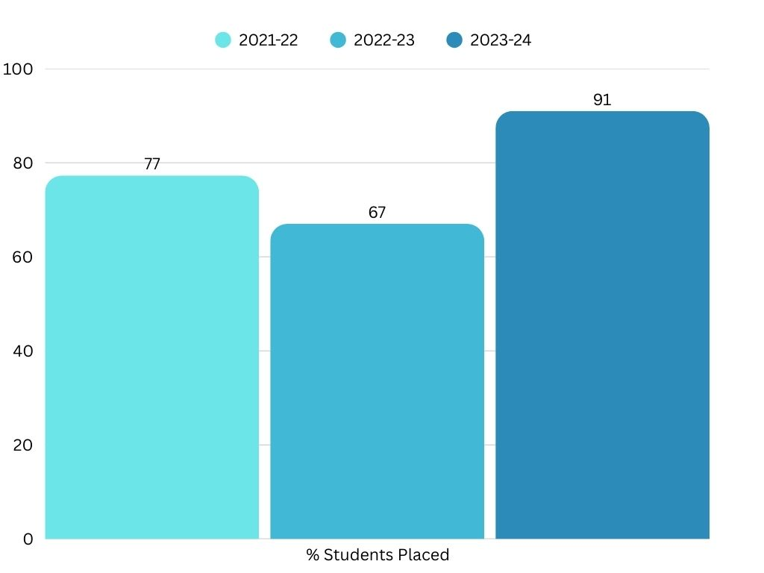

**GRAPH- 2: Percentage of Students placed with multiple jobs in AY 2023-24**

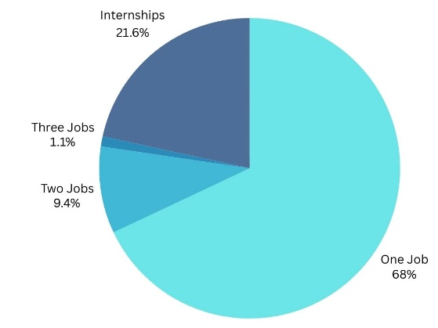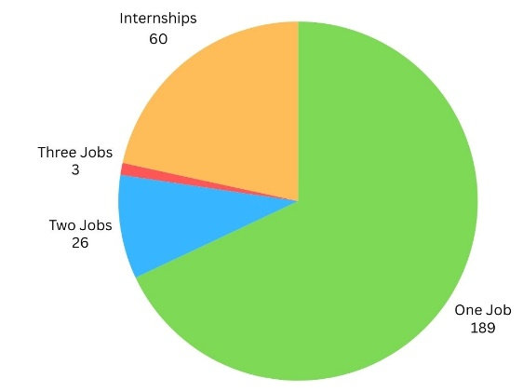

Total Number of Placement Offers Received = 218

**GRAPH- 3: Percentage of Students placed with multiple jobs in AY 2022-23**

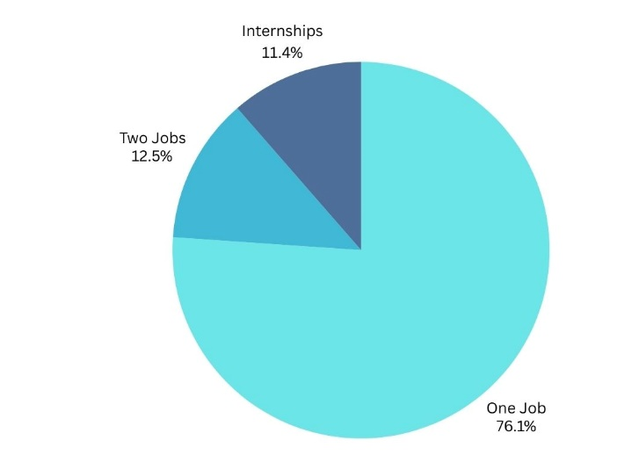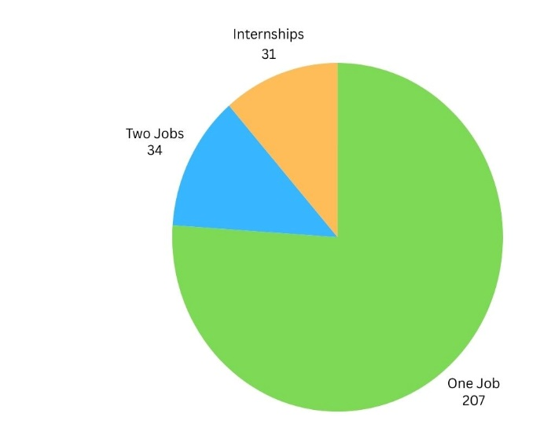

Total Number of Placement Offers Received = 241

**GRAPH- 4: Percentage of Students placed with multiple jobs in AY 2021-22**

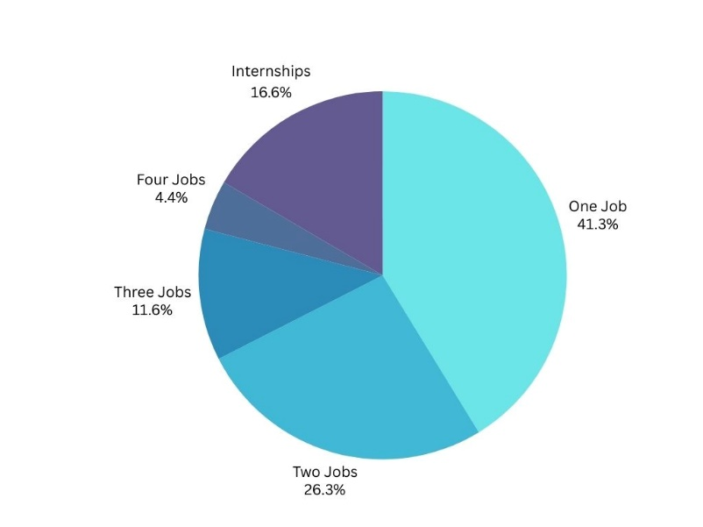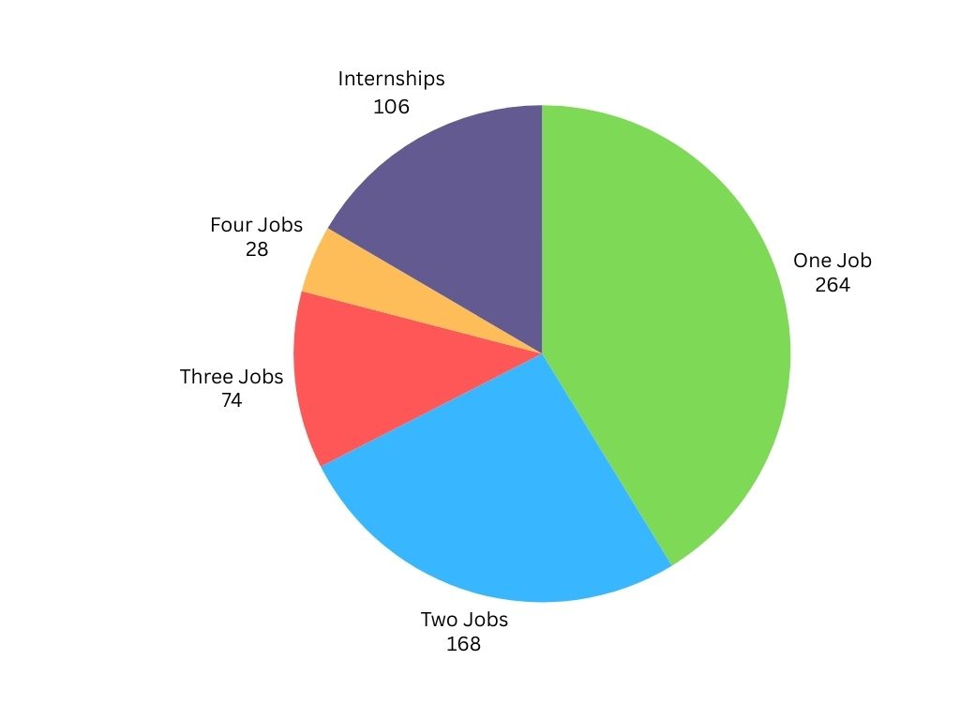

Total Number of Placement Offers Received = 506

**APPENDIX –4: Branch- Wise Placement Statistics (2024-25)**

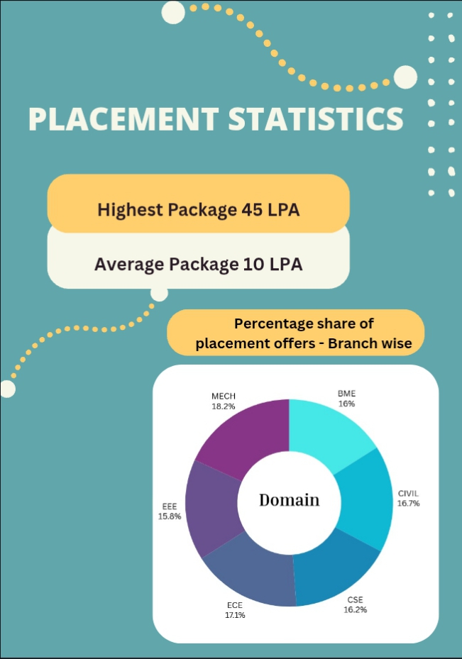

**GRAPH - 5: Branch wise Registered to placed student's ratio for AY 2023-24**

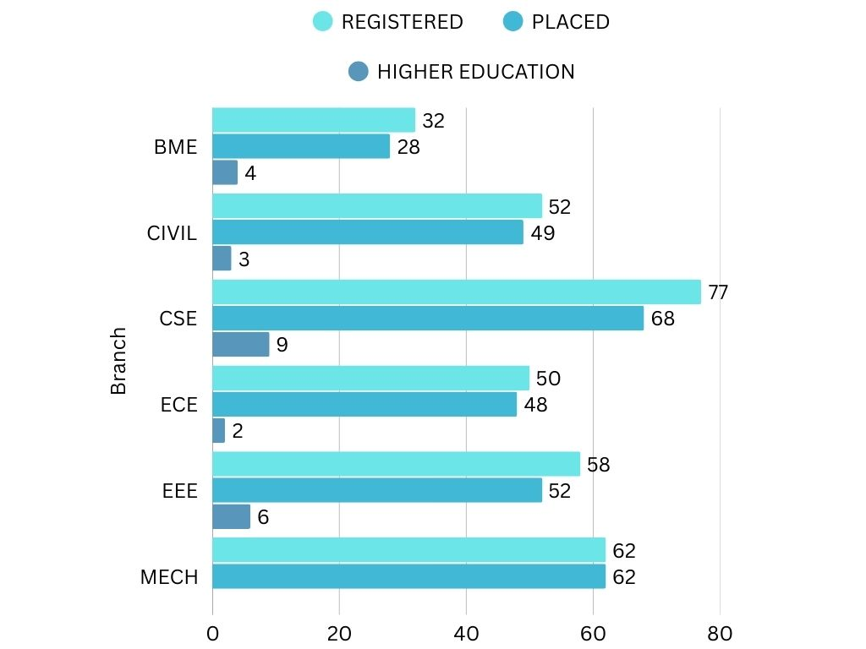

Number of Students

**GRAPH - 6: Branch wise Registered to placed student's ratio for AY 2022-23**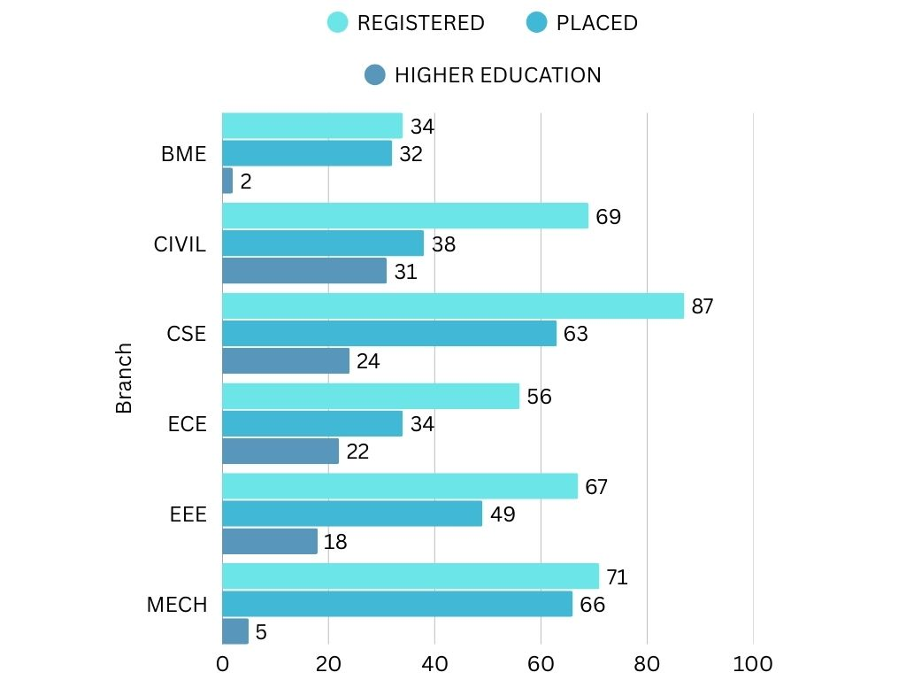

Number of Students

**GRAPH - 7: Branch wise Registered to placed student's ratio for AY 2021-22**

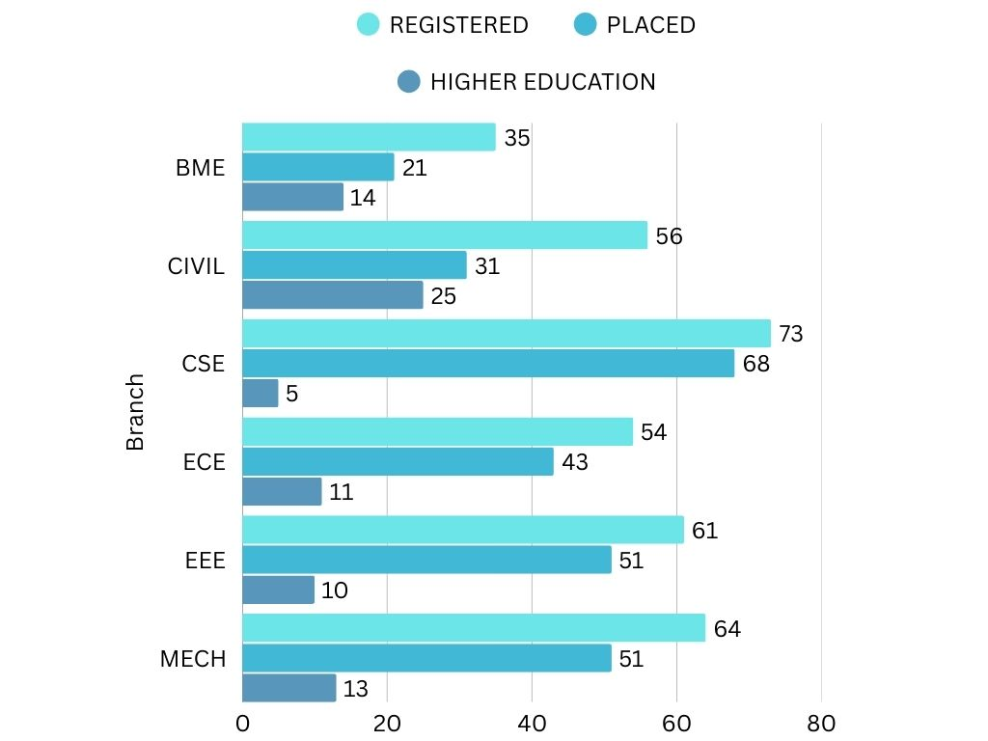

Number of Students