# Alim Saidkhodjaev

# CMSC203 Prep Lab

Class: CMSC203 CRN 31648

 Program: Prep Lab/Assignment 0

Instructor: Gary Thai

 Due Date: 02/03/2023

 Integrity Pledge: I pledge that I have completed the programming assignment independently.

 I have not copied the code from a student or any source.

**Part1: Setup GitHub:** Provide the screen shots of your GitHub account with Assignment 0 file is uploaded on GitHub:

**Part 2 -Install JDK, Test java Application from Command Line**

Provide the screen shots from Step 1 and 2 here:

**Part 3 - Install Eclipse, Test Eclipse Java Application**

Provide the screen shots from Step 1 and 2 here:

**Part 4 - Install, Setup, Test Junit Program.**

Provide the screen shots showing:

* 1. Eclipse with working JUnit Test example
  2. Project screenshot
  3. Running example screenshot

**Part 5 - Install, Setup, and Test JavaFX Application.**

Provide the screen shots showing:

1. JavaFX Project screenshot
2. Running example screenshot
3. Java Source Code File

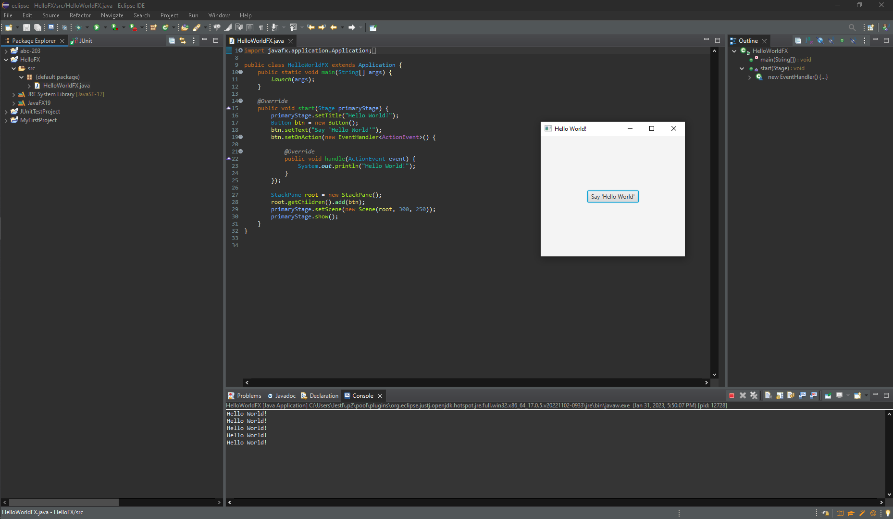

**Lessons Learned** <Provide answers to the questions listed below>**:**

Write about your Learning Experience, highlighting your lessons learned and learning experience from working on this assignment.

What have you learned?

**I learned how to use Eclipse and Junit testing. I also learned java command line arguments that I did not know before. Set up JavaFX.**

What did you struggle with?

**I had an issue with setting up the path variable for Java initially so the Hello World App wouldn’t find the class, but I managed to fix the issue.**

What parts of this assignment were you successful with, and what parts (if any) were you not successful with?

**I was successful with all parts of this assignment.**

Provide any additional resources/links/videos you used to while working on this assignment.

[**https://medium.datadriveninvestor.com/java-classpath-know-it-and-use-it-correctly-2cf6e4dc87ee**](https://medium.datadriveninvestor.com/java-classpath-know-it-and-use-it-correctly-2cf6e4dc87ee)

**Check List:** <Provide answers to the column Y/N or N/A >**:**

|  |  |  |  |
| --- | --- | --- | --- |
| **#** |  | **Y/N** | **Comments** |
|  | **Assignment files:** |  |  |
|  | * FirstInitialLastName_Assignment0.docx/pdf | **Yes or No** |  |
|  | * Source java files | **Yes or No** |  |
|  | **Program compiles** | **Yes or No** |  |
|  | **Program runs with desired outputs related to a Test Plan** | **Yes or No** |  |
|  | **Documentation file: Screenshots of** |  |  |
|  | * Part1: Setup GitHub | **Yes or No** |  |
|  | * Part 2 -Install JDK, Test java Application from Command Line | **Yes or No** |  |
|  | * Part 3 - Install Eclipse, Test Eclipse Java Application | **Yes or No or N/A** |  |
|  | * Part 4 - Install, Setup, Test Junit Program | **Yes or No or N/A** |  |
|  | * Part 5 - Install, Setup, and Test JavaFX Application. | **Yes or No or N/A** |  |
|  | * Lessons Learned | **Yes or No** |  |
|  | * Checklist is completed and included in the Documentation | **Yes or No** |  |