- a correlated sub query is a sub query that refer to the outer query
this sub query will be executed for every row in the table while uncorrelated subquery will be executed only once per query
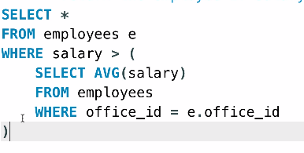
- the exists operator returns once it find a row that meets the condition
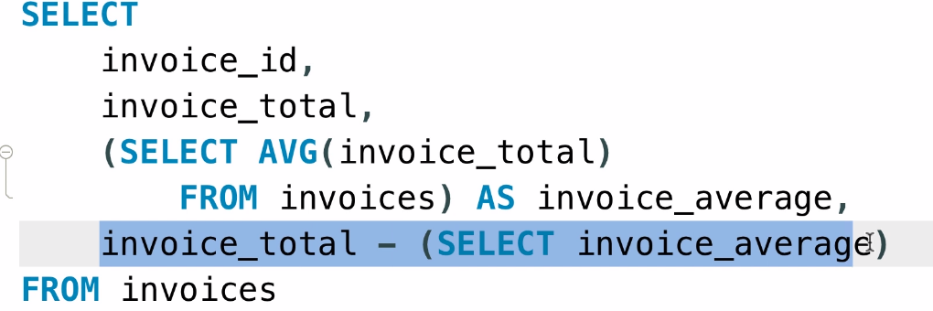
- if you used subquery in the select clause and gave it an alias, you can’t use that alias in the same select clause
but you can use a another subquery to select it
- String functions:
  - left(‘string’, 3) => ‘str’, right(string, int), substring(string, start, count)
  - length(string)
  - locate(substring, string)
  - concat(str, str, str, …)
  - replace(string, substring, newsubstring)
  - ltrim(str), rtrim(str), trim(str)
- Date Functions
  - now() → time and date
  - currdate(), currtime()
  - year, month, day, hour, minute, second(now())
  - monthname(now()), dayname(currdate())
  - extract( year from date)
- Date and time formats
  - date_format(date, ‘date_codes’)
date Codes: %m, %M, %d, %D, %y, %Y
  - time_format(time, ‘time_codes’)
time_codes: %H, %i, %p(pm)
- Date Arithmatics
  - date_add(date1, Interval 1 day),
date_add(date1, interval 1 year),
  - date_sub(date1, interval 11 month)
  - datediff(date1, date2) → the diff in days
  - time_to_sec(‘09:00’) → will return the number of the second since ‘00:00’
- null functions
  - ifnull(‘if this is null’, ‘this will be returned’)
  - coalesce(val1, val2, val3) this will return the first non null value
- create or replace view view_name as <select clause>
this will create the view, if it exists it will replace the old select clause with the new select clause
- updatable views
if the view doesn’t have :
  - distinct
  - aggregate function
  - group by / having
  - union
then this view is updatable which means that you can delete and update rows in this view
- if you updated a view row such that it is not confined to the view conditions then this row will be excluded from the view
- with check option: this will prevent updates that will exclude some rows from the views
- Procedures are like programming functions for sql you store the query and then call it either from a programming language or from sql
DELIMITER $$
create procedure proc()
BEGIN
SELECT * FROM XXX;
END$$
DELIMITER ;
- to drop a procedure → drop procedure if exists proc
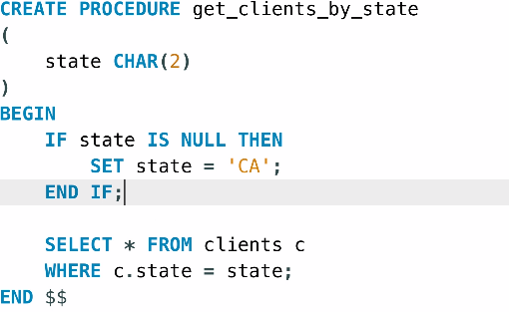
- to add default values to the parameters
- you can validate your parameter using if and signal
IF p1 <=0 THEN
SIGNAL SQLSTATE ‘22003’
SET MESSAGE_TEXT = ‘invalid input’;
END IF;
- to define output parameter you simply add the keyword out before the parameter delcaration
and in your query you (select x into out_param from whatever_table)
- when you call that procedure you must pass user defined variable to hold the output value
set @Var = 21;
call proc(244, @Var)
the user defined variable will stay in memory until the user session ends
- local variables only holds in memory until the function or the procedure is finished
these variable are declared directly after the begin statement in the procedure
CREATE PROCEDURE XXX()
BEGIN
DECLARE local_var DECIMAL(9,2) DEFAULT 0;
SELECT COUNT(*) FROM X
INTO local_var
FROM XX
SET local_var= …;
END
- sql functions is user declared aggregate functions
CREATE FUNCTION get_risk_factor( client_id int )
RETURNS INT
DETERMINISTIC
READ SQL DATA
MODIFIES SQL DATA
BEGIN
<SELECT QUERY>
END
- Triggers are code that is executed before or after an insert, delete or update statement
we can use triggers to persist the consistency of the database
DELIMITER $$
CREATE TRIGGER trigger_name
AFTER/BEFORE INSERT/DELETE/UPDATE ON table_name
FOR EACH ROW(if 5 rows are updated trigger 5 times)
BEGIN
update another_table
set <attr> = <attr> + new/old.attr
END $$
DELIMITER ;
the new/old refere to the new row added or the old row that will be deleted
- SHOW TRIGGERS to see the triggers declared
show triggers like ‘table_name%’
use the convention ‘table_name_(after/before)_(insert/delete/update)
- triggers could be used for logging
- Events: it is a block of code that is executed according to a schedule
for an event to run the event scheduler must be turned on
to check the status of a variable you simply
SHOW Variables like ‘event%’
DELIMITER $$
CREATE EVENT <event_name>
ON SCHEDULE
AT ‘2020-09-1’ (to execute once)
EVERY 2 YEAR/MONTH/HOUR… START ‘date’ Ends’date’
DO BEGIN
<SQL CODE>
END $$
DELIMITER ;
- Alter event event_name disable/enable
- Common concurrency problems
  - lost updates
if two transaction tries to update the same data at the same time, the later one will overwrites the former one
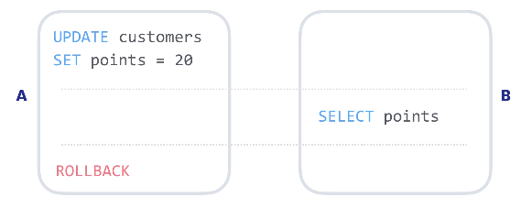
  - dirty reads
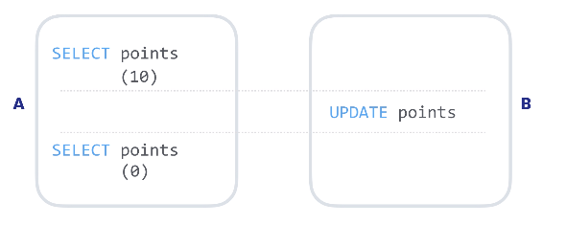
  - non-repeating reads
  - phantom reads
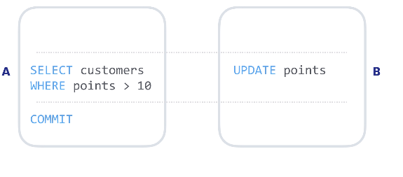

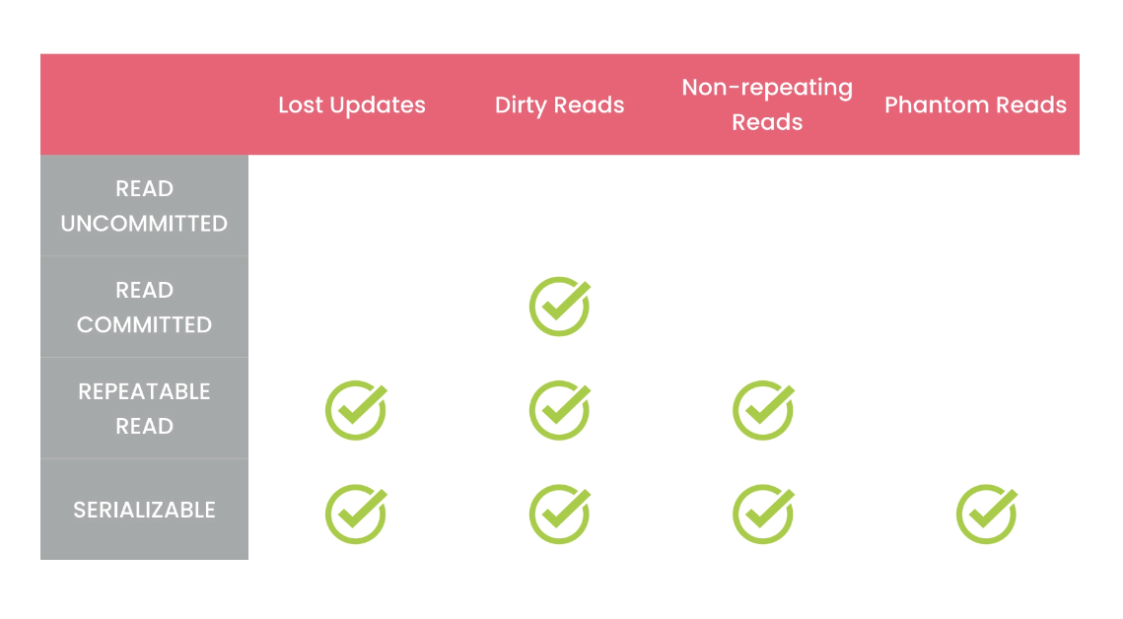
- to change the isolation level
set transaction level serializable/repeatable-Read ….
you can add session/Globaly after set keyword
- Data types
- there are four categories in data types
  - String
  - Numeric
  - Date and time
  - Blob
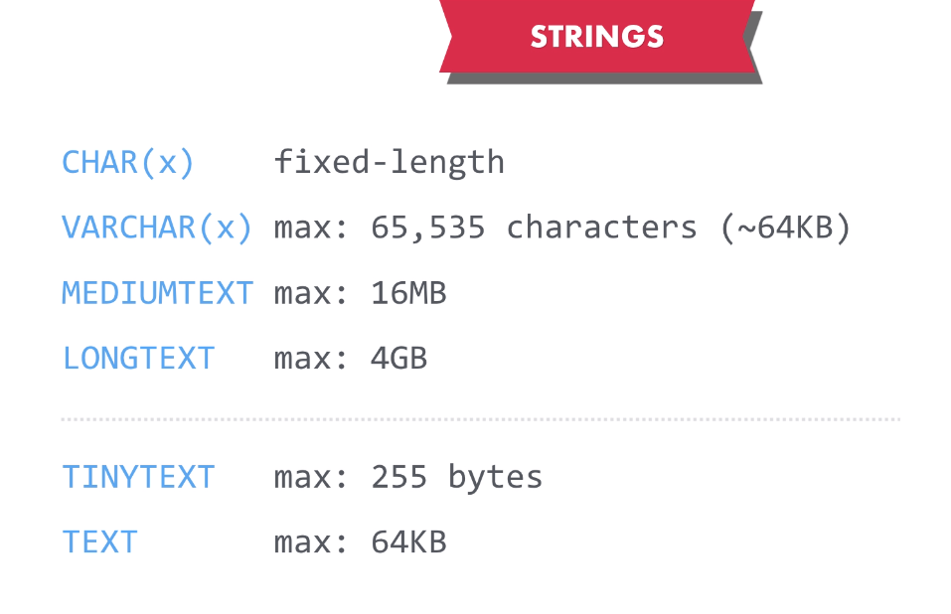
- String

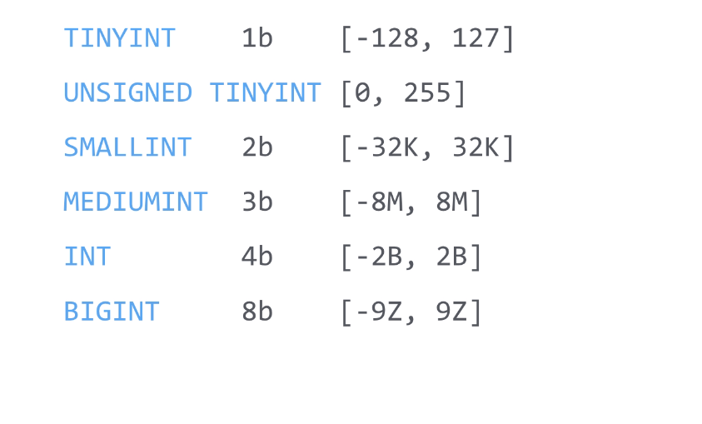
- Integer Types

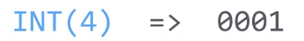
Zero fill =>
- Rationals
Decimal(8,3)
float, double
- Boolean
bool or boolean
- Enums
enum(‘a’,’b’)
- Date and time
date
time
datetime
timestamp (4b up to 2038)
year
- Blob types
tinyblob (255b)
blob (65kb)
mediumblob (16mb)
longblob (4GB)
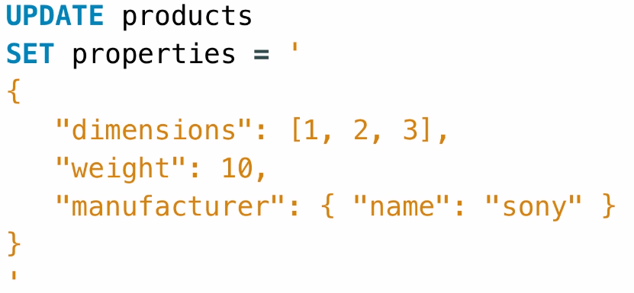
- JSON

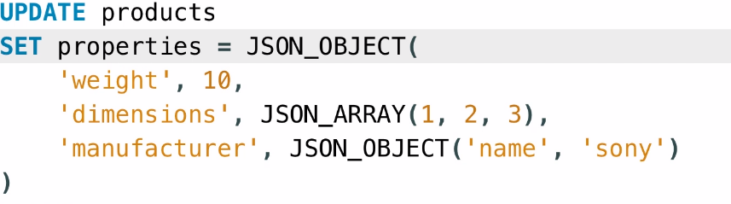

this will generate “sony”
this will generate sony

- set attr = JSON_SET(obj, ‘$.weight’, 10)
- set attr = JSON_remove(obj, ‘$.age’)

Normalization
- 1NF: each cell should have single value and we cannot have repeated columns
- 2NF: each table should describe only one entity, and every column in that table should describe that entity
- 3NF: no column can be derived from another column

Indexing
- Indexes are used to find rows with specific values very quickly, otherwise mysql will have to scan the whole table to fin the result
- to create an index →
create index <index_name> on table(col1, col2, …)
- to show the available indexes on a table →
show index in <table_name>
- when creating an index mysql will store the value of the indexed column for every row in an ascending order and the location of it so it can find it quickly
- when creating an index on a string valued column then the cost of the index might be huge
to minify that you can create a preindex by create index on <table_name>(<string_column>(int))
in this way you create an index on the first few character of the column value instead of the whole value while getting an approximate performance
- to check what is the most proper value to choose you can check the cardinality of varius choices
→ select
count(distinct left(<column>, 1)),
count(distinct left(<column>, 5)),
…
- full-text indexes are used when you want to search for a word in the middle of the string value or any other place that is not the front
create fulltext index on <table_name>(<col_name>)
now to use the index you must do the following
select * from <table_name>
where match(<col_name>) against (‘value’)
- use EXPLAIN <query> to see how mysql run the query
- use show status like ‘last_query_cost’ to see the cost of the last query

