- Build tools are tools used to build software projects, they are like bash scripts that simply do the “javac x.java” work for you, and make it effeciently
- Build tools examples: Make, Ant, Maven, Gradle
- Make tool
- make is a dependency description language, it depends on the project description file which is normally named Makefile.
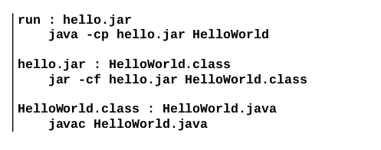
- In the above makefile, we have three targets: run, hello.jar, HelloWorld.class
- to create HelloWorld.class you type
make HelloWorld.class
- a rule format can be like this:
- Maven
- maven have forced some rquirements for the project to build
  - the source files must be in the src directory
  - operational codes are in src/main
  - test codes are in src/test
  - Java files are in src/main/java , src/test/java
  - resources files are in src/main/resources , src/test/resources
- to build a project with maven => mvn compile
- the build configuration file of maven is an xml file and named pom, which stands for project object model
- you can now run commands like mvn compile, mvn package, …

