Chapter 1

- Streams: allows you to specify what you want to be done with data not how to do it.
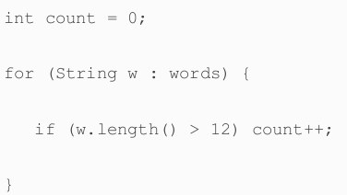
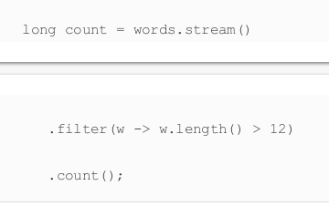
Using Iteration:
Using Streams:

Stream Creation

- you can turn any collection into a stream by calling .stream() on it
- if you have an array then use Stream.of(arr), or Arrays.stream(arr, from, to)
- Stream.empty() to make an empty stream;
- Stream.generate( () -> “echo” ) : this will generate a stream that will return the string “echo” every time it is asked for value, it could result in infinite loop;
- Stream.iterate(0, predicate, generator);
- Stream.ofNullable to make a stream of an object;
- Files.lines(path) returns a stream of all lines in a file

Stream Functions
- Str.filter(<predicate>)
- str.map(<function>)
- flatMap(<function>) → if you have a stream of streams
- str.limit(n) → truncate all elements after the n-1 element
- str.skip(n) → truncate the first n elements
- str.takeWhile(<predicate>)
- str.dropWhile(<predicate>)
- Stream.concate(str1, str2)
- str.distinct()
- str.sorted(<comparator>)
- str.peek(<consumer>)
- str.count()
- str.max()
- str.min()
- str.findFirst()
- str.findAny()
- str.anyMatch(<predicate>)
- str.allMatch(<predicate>)
- str.nonMatch(<predicate>).

Optional Type

To use optional effictivly, use it with a method that produces an alternative if the value is not present, or consumes the value only if it is present
- String result = optionalString.orElse(“”)
- optionalString.orElseGet(()→…)
- optionalString.orElseThrow()

- optionalValue.ifPresent(v→process v)
- optionalValue.ifPresetOrElse(<consumer>, <function>)

