- Window Functions: the window function perform an aggregate-like operation, but it doesn’t produce a single row as a result, instead it returns the result for every row in the query.
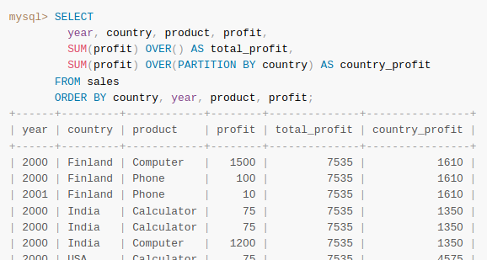
- The OVER clause specifies how to partition query rows into groups for processing by the window function.
- The window functions are only permitted in the select list or order by clause.
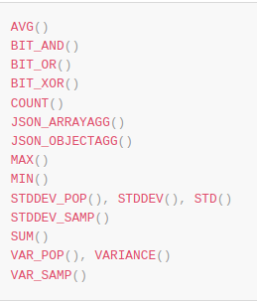
- The result is determined from the FROM clause after the processing of WHERE, GROUP BY, HAVING clauses and before the processing of ORDER BY, LIMIT, SELECT DISTINCT
- the aggregate functions can be used as window functions when used with the over clause
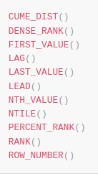
- window only functions must be used with over clause
- the over clause has two forms:
  - OVER window_name; and then you can specify the window else where in the query like so:
WINDOW window_name as (window_spec)
  - OVER window_spec; you can specify the window spec as follows:
([window_name] [partition clause] [order clause] [frame clause])
- renaming comes after the over clause

