Chapter 13

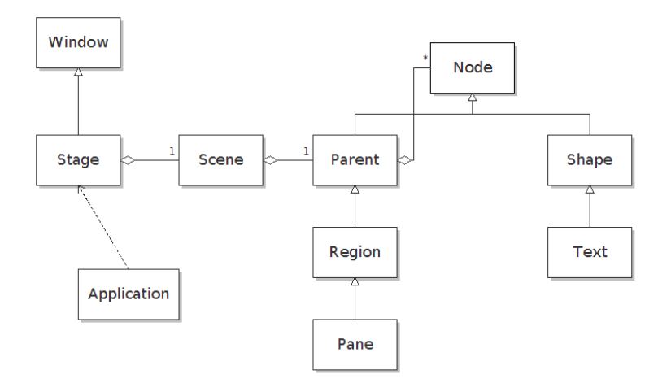

- Root pane: you should put your nodes inside a root pane and pass that pane to a scene, and the scene to a stage, and then show the stage.
- Shapes: Rectangles, Circle, Line, Ellipse
- Shapes’ Methods: setFill(Color.color), setStroke(Color.color)
- Font Factory: you can construct a font by Font.font(fontName: string, FontWeight.Bold, FontPsture.Italic, fontSize: int)
- Bounds of the node: node.getBoundsInParent() this method takes into consideration the stroke width and other effects.
- ImageView: new ImageView(“image URL”);
- EventHandler<ActionEvent>: it is a functional interface with a single method handle(T event);
- Button: Button b = new Button(“OK”), b.setOnAction(event→{…});
- Event Methods: e.getSource(): returns the object fires the event, e.consume(): cancels the action.
- More than one eventHandler: b.addEventHandler(javafx.event.ActionEvent.ACTION, event→{...})
- Event Examples: onMouseEntered(), onMouseDragged(), onKeyPressed()
- you can get the focus of the keyboard by event.requestFocus()
- Panes: VPane, Hpane, GridPane, …
- to load fxml file :
try{
Parent root = FXMLLoader.load(getClass().getResource(“dialog.fxml”));
Scene sc = new Scene(root);
} catch(...){...};
- to access the ui you first give an attribute to the fxml element you want to access, then look it up as follows: TextField username = (TextField) root.lookup(“#id”). Or you can inject it using the @fxml notation and the controller class, but you must give the fx:id=”..” property to the element and it must be the same as the variable name in the controller class, and finally in the root element you have to declare the fx:controller=”ControllerClass”.
- The controller class must implements the Initializable interface and in the initialize method you assign the even handlers to the elements.
- Javafx Text Controls: TextField, TextArea, JpasswordField
- Javafx Text Controls Methods: getText, setText, appendText, setPrefColumnCount, setWrapText(true), setEditable(true), setPromptText(“text”)
- Text node is a shape while Label node is a control.
- CheckBoxes: new CheckBoxe(“…”), setSelected(true)
- to make a radio buttons: first create the radio buttons object by new RadioButton(“label”), no you have to put these objects in the same toggle group by: ToggleGroup tg = new ToggleGroup(); then set the toggle group of the radio buttons to this object by: rb.setToggleGroup(tg);
- you can attach data to the radio buttons so you don’t need to condition on which buttons fired the event: rb.setUserData(3); now in a shared event handler you just retreive the data and use it tg.getSelectedToggle().getUserData();
- ComboBox<String> families = new ComboBox<>();
familie.getItems().addAll(Font.getFamilies())
- all the control elements have setOnAction(EventHandler) method.
- Menus
- to construct a menu: Menu m= new Menu(“File”)
- to construct a menu item: MenuItem mi = new MenuItem(“Save”, <optional> new ImageView(...));
- menu.getItems().addAll(menuItem, menuItem)
- MenuBar mb = new MenuBar(menu, menu, menu)
- checkMenuItem ,radioMenuItem
- saveMenuItem.setAccelerator(KeyCombination.KeyCombination(“Shortcut + S”)
- KeyBoardMnemonics: to make a menuitem be mnemnoic you but an underscore before the letter you want it to be used with on construction: new MenuItem(“_help”)
- ContextMenu: it appears when you right click on a control that has the context menu set, and it appears on the same node
- Simple Dialog: Alert alert =new Alert(Alert.AlertType.INFORMATION, “label”)
alert.showAndWait();
- the alert of type confirmation returns an Optional<ButtonType>, and you can test it like that: if(alert.showAndWait().get() == ButtonType.OK) …
- Alert alert = new Alert(Alert.AlertType.NONE,"Now what?",ButtonType.NEXT, ButtonType.PREVIOUS, ButtonType.FINISH);
- alert.setHeader(“…”), alert.setGraphic(new ImageView(“…”), alert.getDialogPane().setExpandableContent(textObject).
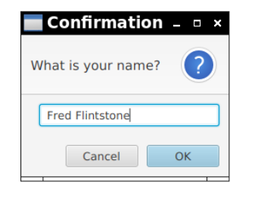
- TextInputDialog: accepts text from user and the stopAndWait method returns Optional<String> and if the user canceled it is empty
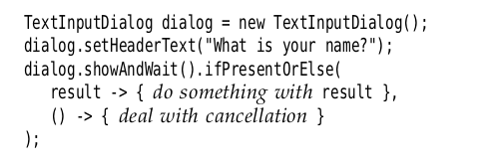
- choiceDialog: it accepts the choice of a user and returns an Optional that contains the selected Items or empty if the user pressed cancel
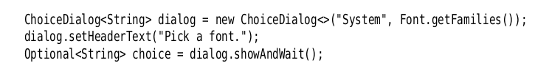
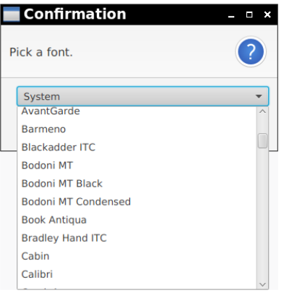

- FileChooser:
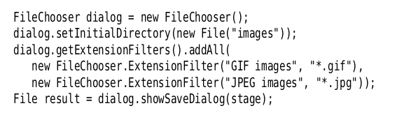
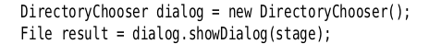
- DirectoryChooser

- Charts
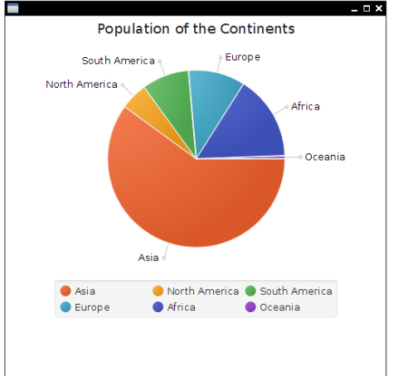
- PieChart p = new PieChart();
p.getData().addAll(
new PieChart.Data(“Asia”, 1212.1),
new PieChart.Data(“Africa, 12244.1),
…);

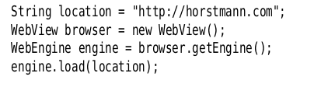
- if you want to display a webPage from a java Application you can use WebView:
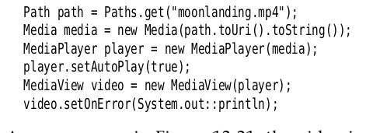
- MediaPlayers: to show videos or audio in java:

- Properties: StringProperty, IntegerProperty, ListProperty, MapProperty …
- Methods: .set(), .get(), .addListener(…)
- Listeners:
1. invalidation Listeners
2. change Listeners
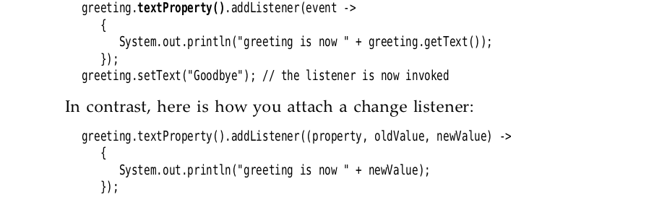
- Bindings:
x.yProperty().bind(a.bProperty())
now whenever one property changes the other will change automatically,
to unbind you can call x.yProperty.unbindBidirecitional()
- x.yProperty.bind(Bindings.divide(a.bProperty(), 2)
now whenever b changes the y will be b/2
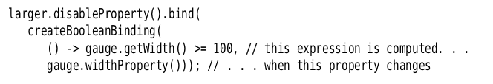
- instead of using the Bindings methods you can make lambda

