Web development

- Web tier: the web tier consists of three layers
  - web layer: consists of servlets and jsp
  - Service layer: the layer that has the bussiness logic
  - Data Access Layer: consists of jdbc and jpa
- All machines on the internet can be classified into two types: Server(provide data) and client(request data)
- the server and the client use HTTP protocol to communicate
- the http protocol is request-response, stateless protocol
stateless means that the server sees every request as new request
- when the client request resource the identification of the resource must be located inside the request in the form of URI(uniform resource identifier)
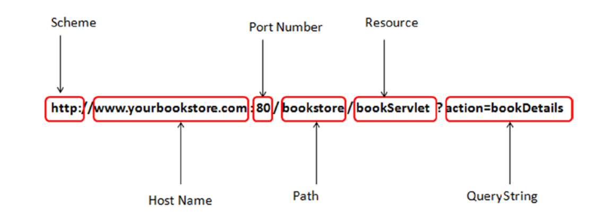
- the URI is an abstraction its implementation is URL(U.R. Locator) and has the following syntax:
scheme://hostName:portNumber/path/resource?query string.

- The host name and the port number are termed together as authority
- A web Application is a collection of components that work together to provide a specific functionality on the web
these components are either Servlets or Java Server Page
- the web Application and its components are managed and executed inside a web container(Servlet Container)
- when a client sends a request to the web server asking for a specific functionality that a specific component can provide, the server passes this request to the servlet container that has the component, and then it goes to the servlet
- Servlets are the central processing unit of a java web application.
Servlet is a java class that implements the javax.servlet.Servlet interface

- the web.xml is called a deployment descriptor because it descripes the deployed servlets to the web container
- inside the web.xml file you specify the servlet name and the associated class inside the servlet tags
<servlet>
<servlet-name>xxx</servlet-name>
<servlet-class> pack.servletClass </servlet-class>
</servlet>
then you specify the url pattern to the servlet inside servlet mapping tag
<servlet-mapping>
<servlet-name> … </..>
<url-pattern>/hello</url-pattern>
- the javaEE web application run within a context root, context root: it is the first string in the url after the server name and the port
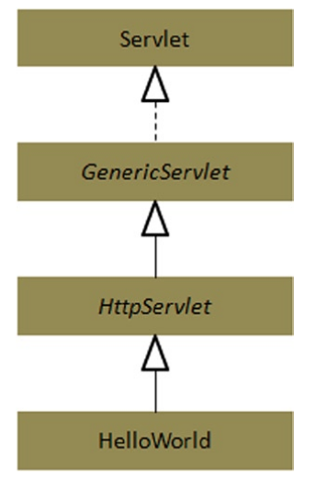

- if you want to create a servlet class then you have to implement the servlet interface and override its 5 methods,
especially the service method which gets called whenever the web container recieves a request for that servlet
the HTTPServlet abstract class implements the servlet interface and the methods, but you have to implements one of the methods required by it, for example: doGet(), doPost()
- Servlet Methods
first the container calls this function, which delegates to the HTTP’s service method, which then delegates to the appropriate doXxx method that you have defined in the class tha extended the HTTPServlet.
  - Init(): the super class of your servlet contains two init methods init() and init(servletConfiguration), the second one calls the no-arg one so you have to only override the first one.
The init() methods gets called directly after the construction of the servlet instance and before any calls to the service() method
  - service(): the web container calls this method, it determines which method from doGet or doPost to call based on the request method, you shouldn’t override this method you only override the doGet and doPost methods.
  - Destroy(): this method is called before serlvelt instance destruction, the servlet get to release any acquired resources in this method.
- The servlet can have three types of parameters
  - Request parameters
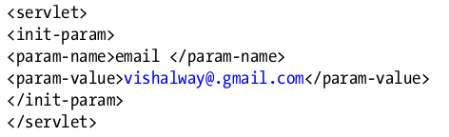
  - initialization(init) parameters : are in web.xml
when you extend the HTTPServlet your class inherits getServletConfig() which returns the ServletConfig reference, that you can call getInitParam() on.

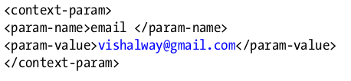
  - Context-initialization (context-init) parameters: it is the same as init parameters but the context params are available to the whole web app while init params are available only to the servlet.
GetServletContext().getInitParameter(“email”);

- there are two ways to alter the request flow.
  - To redirect: the request is redireceted a completely different URL. Response.sendRedirect().
Redirects are done on the client side by the browser
  - To dispatch: the request is dispatched to another component in the web app.
You can either get a RequestDispatcher from servletRequest or ServletContext
you pass the path to which the request is forwarded, if the path begins with / then it is absolute path starting from the root of the web app, if it doesn’t then the path is relative to the original request.
After you get the request dispatcher then you can call forward on it
- JSP: java server pages allow devlopment of dynamic web-based content throug the JSP elements
  - JSP Directives: they are instruction to the jsp container that will be processed during the page translation process
<%@ directive {attribute = “value”}* %>
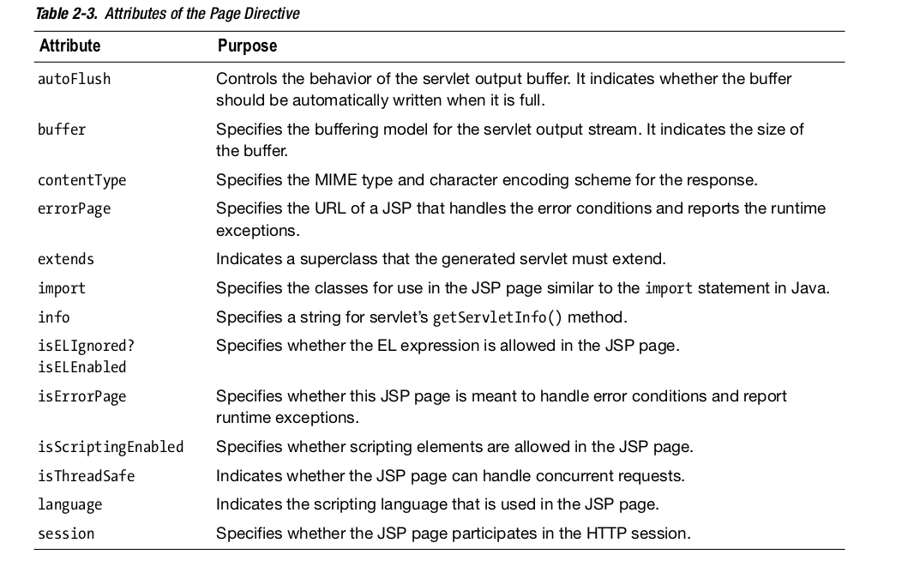
    - Page Directives: provide instruction about the a specific jsp page
<%@ page attribute = “value” %>
    - Include Directives: specify the static resources that should be included within the current jsp page
<%@ include file=”relative url” %>
    - Tablib Directives: used to define a prefix and a location to a tag library
<%@ taglib uri=”uri” prefix=”tagPrefix” %>
    - Declarations:
    - Expressions: it evaluates java expression and return the result.
<%= expression %>
    - Scriptlets: they are java code that create dynamic content
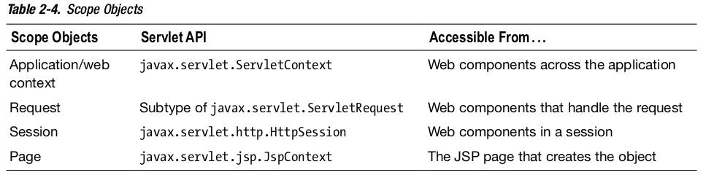
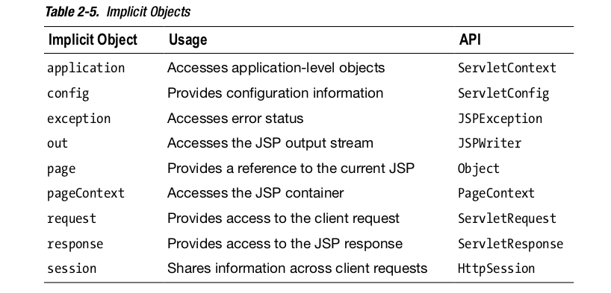
  - Implicit Objects: in a web application multible web components collaborate with each other and share information by objects that are maintained as attributes of four scope objects.
The implicit objects are the objects that you can access through the page scope object, and they are:

