


Cairo University
Faculty of Engineering
AeroSpace Dept.

Project on
performance of airplanes

Prepared by: أحمد صلاح حماد أحمد
Section 1 BN 4

To: د/هشام البنا
م/ أحمد حافظ

لله الفضل والمنة

Table of Contents
Very Important Notes 3
1. F-16A 4
1.1. Table of information 4
1.2. Table of performance parameters 5
1.3. Images of the airplane 5
2. Embraer 120 6
2.1. Table of information 6
2.2. Table of performance parameters 6
2.3. Images of the airplane 7
7
4. Data sheet 8
1. Jet Engines 8
1. Analytical 8
1.1. Maximum velocity 8
1.2. Minimum velocity 8
1.3. Stall velocity 8
1.4. Rate of Climb 8
1.5. Range 8
1.6. Endurance 8
1.7. Required thrust 8
1.8. Minimum Angle of Gliding 9
2. Piston Propeller engine 9
1. Analytical 9
1.1. Maximum velocity 9
1.2. Minimum velocity 9
1.3. Stall velocity 9
1.4. Rate of Climb 9
1.5. Range 10
1.6. Endurance 10
1.7. Required power 10
1.8. Minimum Angle of Gliding 10
4.2. Graphical 10
References 14

Very Important Notes
- This is a report of determining some aircrafts performance parameters, I chose five airplanes to determine theirs, and I have made some assumptions in this report:
- The oswald efficiency factor of each aircraft is approached to the plane I see most alike in this report (Estimating oswald efficiency factor from basic aircraft geometrical parameters, M. Nita and D. Scholz, Hamburg university)
- All aerodynamics properties are obtained at reynold’s number = 3.0 * 10⁶
- The values of absolute ceiling, service ceiling, range and endurance are not good for most aircrafts, even though their equations are taken from the reference and should have given accurate answers, but anyway I believe the fault is not mine.
- I had so much more to do but didn’t have time, maybe I can show the new version later...

1. F-16A

1.1. Table of information
# | Characteristic | Description or Value  S.I. Units
1 | A/C Name | F-16A
2 | A/C Type | Fighter
3 | A/C Length | 15.1
4 | A/C Height | 5.08
5 | Airfoil Section and Wing Data | Unknown
6 | b | 9.9568
7 | S | 37.17669984
8 | AR= b2/S | 2.666666667
9 | W (Max Takeoff) | 166,600
10 | WE (Empty) | 72,422
11 | W/S | 4481.30148
12 | W/b | 16732.28346
13 | CD0 | 0.01
14 | K | 0.147365688
15 | e=1/(∏KAR) | 0.81
16 | L/D max | 13.02482258
17 | High Lift Device(s) | Don't Know
18 | (CL)max [Cruise] | 1.5
19 | Engine Name | PW F100-PW-200
20 | Engine Type & Number | One Jet engine
21 | (TA)max @Sea-Level | 106000
22 | (PA/W)max Or( TA/W)max | 0.636254502
23 | Variation of Power /Thrust w Altitude | Don't Know
24 | Varition of Power /Thrust w Speed | Probably no variation
25 | Fuel Weight (Capcity) WF | 94,178
26 | TSFC | 0.001988438
27 | Analysis h | 1406.846646
28 | vcruise | 257.942

1.2. Table of performance parameters
Parameter | Real | Calculated
Top speed km/h | 2164.568 | 2451.727178
Stall speed km/h | 79 | 251.4235220
Min speed km/h | -------------------------------------- | 148.4667211
Max R/C m/s | -------------------------------------- | 164.3575833
Angle at max R/C degrees | -------------------------------------- | 24.5196
Max angle of climb m/s | -------------------------------------- | 34.01970732
L/D max | -------------------------------------- | 13.02482258
Min angle of gliding degrees | -------------------------------------- | 4.390355151
Range km | 2264.347 | 824.9339327
Endurance h | -------------------------------------- | 1.086201810
Service ceiling km | 7.62 | 1.406846646
Time to climb to serv ceil. s | -------------------------------------- | 49.62243029

1.3. Images of the airplane
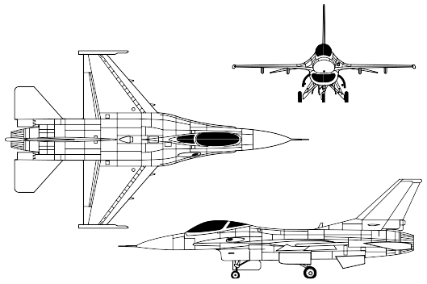Figure 1: Public Domain, https://commons.wikimedia.org/w/index.php?curid=1167332

2. Embraer 120

2.1. Table of information
# | Characteristic | Description
1 | A/C Name | EMBRAER 120
2 | A/C Type | twin-turboprop commuter airliner
4 | A/C length | 20
5 | A/C height | 6.35
6 | Airfoil Section and Wing Data | NACA 23012
7 | b | 19.78
8 | S | 39.4
9 | AR= b2/S | 9.93016243654822
11 | WE (Empty) | 69286
10 | W (Max Takeoff) | 112700
12 | W/S | 292.848020434
13 | W/b | 748.612471433
14 | CD0 | 0.01
15 | K | 0.043297747605475
16 | e (span efficiency) | 0.81
17 | (L/D)max | 24.52849924
18 | High Lift Device(s) | Flaps
19 | (CL)max | 1.25
20 | Engine Name | Pratt & Whitney Canada PW118 / Pratt & Whitney Canada PW118A / Pratt & Whitney Canada PW118B turboprop engines
21 | Engine Type & Number | Two , turboprops
22 | (PA)max@sea-Level | 2680000
23 | (PA/W)max | 11.8899733806566
24 | Variation of thrust with altitude | Don’t know
25 | Variation of thrust with velocity | Probably no variation
26 | Fuel name and Specific gravity
27 | Fuel Weight (Capacity) WF | 43414
28 | PSFC | 4.25*10^-5
29 | vcruise | 153.333333333333

2.2. Table of performance parameters

Parameter | Real | Calculated
Top speed km/h | 608 | 780.6686795
Stall speed km/h | 162 | 220.0433737
Min speed km/h | -------------------------------------- | 27.97958431
Max R/C m/s | -------------------------------------- | 20.37403225
Angle at max R/C degrees | -------------------------------------- | 16.3561
Max angle of climb m/s | -------------------------------------- | 49.85402370
L/D max | -------------------------------------- | 24.52849924
Min angle of gliding degrees | -------------------------------------- | 2.334593191
Range km | 1,750 | 150.8077741
Endurance h | -------------------------------------- | 0.3092960682
Service ceiling km | 9.085 | 0.8435092067
Time to climb to serv ceil. s | -------------------------------------- | 156.7421070

2.3. Images of the airplane
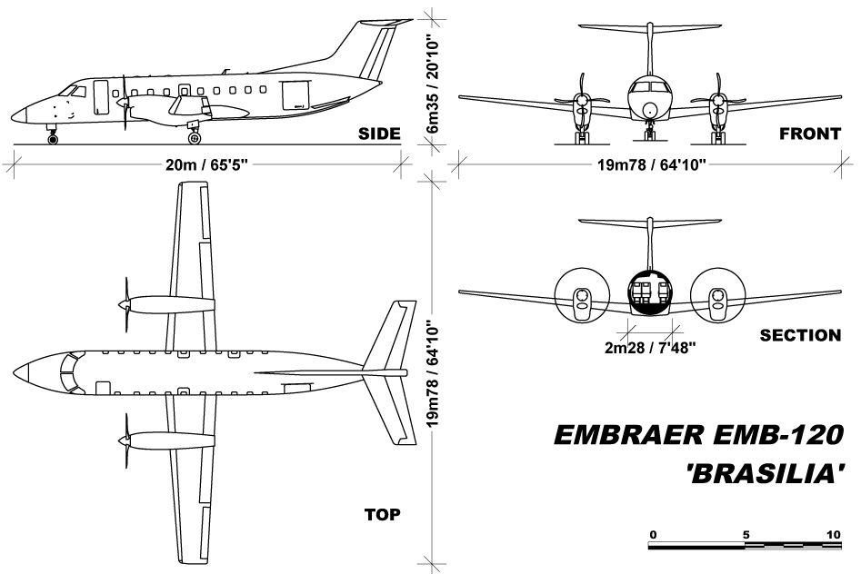Figure 2: By Julien.scavini - Own work, CC BY 3.0, https://commons.wikimedia.org/w/index.php?curid=20555164

4. Data sheet

1. Jet Engines

1. Analytical

1.1. Maximum velocity
(Equation 1)

1.2. Minimum velocity
(Equation 2)

1.3. Stall velocity
(Equation 3)

1.4. Rate of Climb
(Equation 4)
(Equation 5)
(Equation 6)
(Equation 7)

1.5. Range
(Equation 8)

1.6. Endurance
(Equation 9)

1.7. Required thrust
(Equation 10)

1.8. Minimum Angle of Gliding
(Equation 11)

2. Piston Propeller engine

1. Analytical
First, consider these parameters to make the equation look better: a, b, c, d, e and t.
AR = ; ; ; ;
a=; ; ;
; ;

1.1. Maximum velocity
(Equation 1)

1.2. Minimum velocity
(Equation 2)

1.3. Stall velocity
(Equation 3)

1.4. Rate of Climb
(Equation 4)
(Equation 5)
(Equation 6)
(Equation 7)

1.5. Range
(Equation 8)

1.6. Endurance
(Equation 9)

1.7. Required power
(Equation 10)

1.8. Minimum Angle of Gliding
(Equation 11)

4.2. Graphical
Velocity
We notice the intersection of the two curves: the required thrust curve and the available thrust of the engine, so the max velocity is determined directly, while true minimum speed is:

The required thrust curve is deduced from the addition of these two curves in the graph, let those two curves be A and B, where:

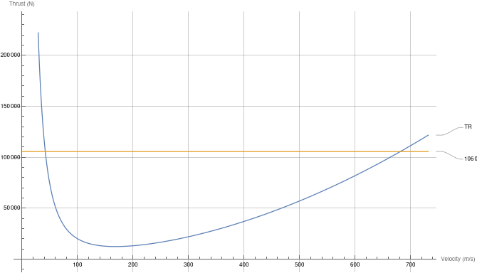

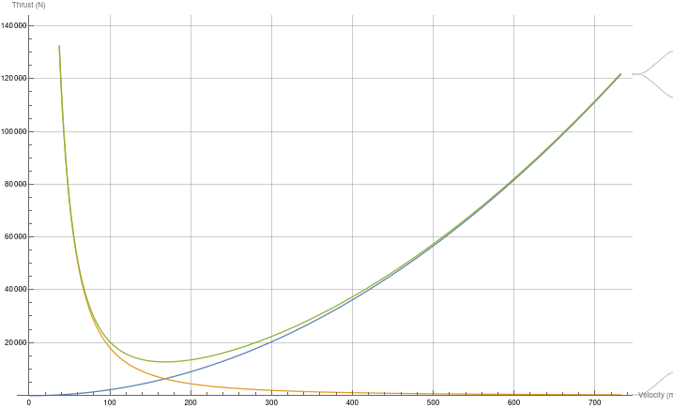
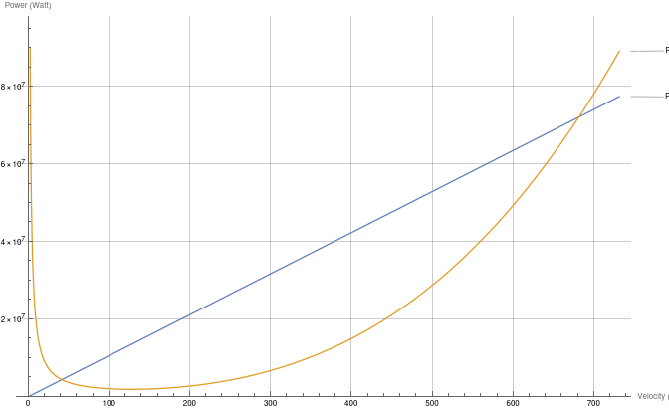
R/C

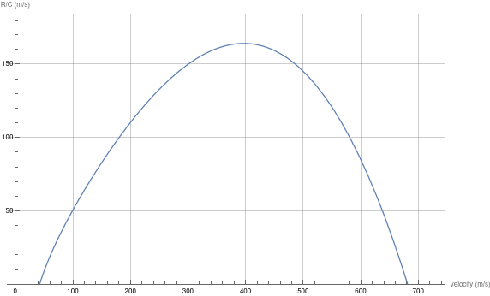

Service ceiling
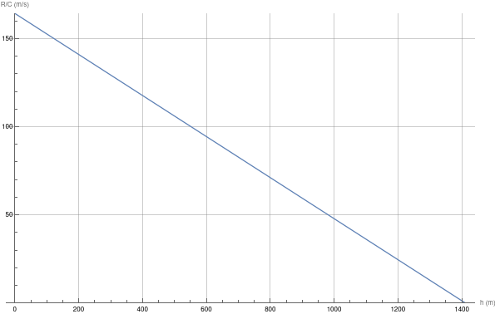
Time to climb to service ceiling
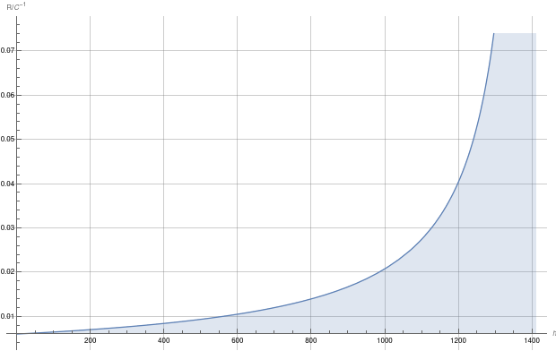

References
- Summary of airfoil data, war-time report, naca March 1945
- Commercial Airplane Design Principles, 2014 <https://www.sciencedirect.com/topics/engineering/lift-to-drag-ratio>
- FlightMechanics4Pilots (c) Agostino De Marco, Università degli Studi di Napoli Federico II
<https://agodemar.github.io/FlightMechanics4Pilots/mypages/thrust-power-required/>
- General Aviation Aircraft Design, 2014
<https://www.sciencedirect.com/topics/engineering/specific-fuel-consumption>
- <https://www.saloodo.com/logistics-dictionary/gross-weight/>
- <https://www.google.com/url?sa=t&rct=j&q=&esrc=s&source=web&cd=&cad=rja&uact=8&ved=2ahUKEwjO5quF37L3AhU3hf0HHYo8B2MQFnoECAcQAw&url=https%3A%2F%2Fcode7700.com%2F1986_maximum_range.htm&usg=AOvVaw23brH3R3liN3yS5IXy8BWS>
- <https://www.aircraftflightmechanics.com/AircraftPerformance/RangeandEndurance.html>
- <https://ocw.mit.edu/ans7870/16/16.unified/propulsionS04/UnifiedPropulsion4/UnifiedPropulsion4.htm#:~:text=For%20a%20vehicle%20in%20steady,climb%20(increasing%20potential%20energy).>
- International Journal of Naval Architecture and Ocean Engineering, Aerodynamic characteristics of NACA 4412 airfoil section with flap in extreme ground effect
via science direct: <https://www.sciencedirect.com/science/article/pii/S2092678216303776>
- <https://www.stratosjets.com/blog/cruise-speed/>
- <https://www.statista.com/statistics/614178/cruising-speed-of-most-common-airliners/>
- (article: specific fuel consumption, Layton, J. Preston, 2014)
- (artice: FUEL CONSUMPTION DUE TO SHAFT POWER OFF-TAKES FROM THE ENGINE, Dieter Scholz, Ravinka Seresinhe, Ingo Staack, Craig Lawson2)
- (article: Breguet's Formulas for Aircraft Range & Endurance: An Application of Integral Calculus, Colonel Kip P. Nygren, Major Robert R. Schulz, United States Military Academy)
- <https://museumofaviation.org/portfolio/f-16a-fighting-falcon/#:~:text=PERFORMANCE%3A,Cruising%20speed%3A%20577%20mph.>
- <https://en.wikipedia.org/wiki/General_Dynamics_F-16_Fighting_Falcon_variants>
- <https://en.wikipedia.org/wiki/Cessna_152>
- <https://en.wikipedia.org/wiki/Embraer_EMB_120_Brasilia>
- (Introduction to flight, anderson)

<https://www.fzt.haw-hamburg.de/pers/Scholz/OPerA/OPerA_PUB_DLRK_12-09-10.pdf>

